ACT 5 : Poetry - Onomatopoeia and Rhythm

Summary of Act 5:

Viola and Antonio
‘Cesario’ and Orsino go to visit Olivia and Antonio is brought in by officers. Orsino recognises Antonio as a pirate but ‘Cesario’ recognises him as the man who tried to help during the fight with Sir Andrew. Antonio still thinks that ‘Cesario’ is Sebastian.

Confusion
Olivia arrives and Orsino is angry that she is not interested in him and is more interested in his servant (‘Cesario’). Orsino directs his anger towards ‘Cesario’ and ‘Cesario’ responds by saying that he would die ‘a thousand deaths’ for Orsino. This shocks Olivia as, to her, she has just married this ‘man’. The priest is called and confirms that they were married only two hours ago.

The Twins Reunite
Sebastian comes and everyone is shocked to see Sebastian and ‘Cesario’. Finally the truth is revealed that both twins were saved from the sea and that ‘Cesario’ is in fact Viola, a woman!

Malvolio
Malvolio is released and shows Olivia the letter written by Maria. Olivia realises that the letter is a forgery. Malvolio vows that he will get revenge on the ones who tricked him. Olivia, Sebastian, Orsino and Olivia look forward to their joint wedding.

Week 5 - Lesson 1: Drama - Performing Poetry
Learning Intention | To perform a poem with rhythm
Key Vocabulary | poetry, rhythm, expression, beat
Activities/  Lesson | Warm Up  Poetry Ping Pong  - Read the poem Sick by Shel Silverstein (see resources) to the children. The class teacher should read this poem modelling changes in intonation, tone, volume and use actions.  - Tell the children that to warm up we are going to play a game called Poetry Ping Pong.  - Write the line ‘I’m going blind in my right eye!’ on the board.  - Explain that for this game they have to work in pairs. Explain that they have to take it in turns to say the same line, batting it back and forth like ping pong.  - Tell the children that they cannot change the words or the order of the words. The challenge is that they have to say the line differently each and every time.  - Model saying the line ‘I’m going blind in my right eye!’ angrily then happily.  - Tell the children that they could think about how fast or slow they say the line or think about putting in pauses.  - Model varying the tone of your voice when saying the line and suggest that they could even say the line using different accents.  - Suggest that they could read the line in a specific role. E.g. saying the line like a newsreader or as though you’re telling a secret.  - Now ask the children for their ideas on how they could say the line.  - Allow the children to play poetry ping pong for 5 minutes. After the time is up, ask if any of the pairs would like to show their poetry ping pong to the class.  Main Teaching  - Explain that today we will be exploring rhythm in poetry.  - Play the poem Walking with My Iguana by Brian Moses:  https://childrens.poetryarchive.org/poem/walking-with-my-iguana/  - Show the children the words to the poem and play the poem again. This time ask them to join in clapping the drum beat/rhythm while the poem is played.  - Once the children are familiar with the beat, split the children into groups.  - Give them time to rehearse a performance of the poem 'I'm Walking with My Iguana’. Appoint a child from each group to clap/use percussion to keep the rhythm as the others perform.  - Depending on the class, they can perform the whole poem within their group or the class teacher could assign a section of the poem to each group and the class can perform the complete poem as a team.
Notes for Teachers | - The children will need to be in a large space for this lesson.
Resources | - Sick by Shel Silverstein (see resources)  - ‘Walking with My Iguana’ by Brian Moses. https://childrens.poetryarchive.org/poem/walking-with-my-iguana/  - Drums/percussion instruments

Week 5- Lesson 2: Kennings
Learning Intention | To write a Kenning
Key Vocabulary | kenning, topic, noun, hyphen
Activities/  Lesson | Starter  - Display a kenning on the board for the children to read (see resources) and ask if they can guess the title or topic of the kenning. Ask them to explain their reasoning using examples from the poem.  - After some discussion, reveal the topic of the kenning (cat).  - Explain that a kenning is a type of poem that describes something indirectly using clues.  Main Teaching  - Ask the children to look closely at a range of different kennings (teacher to source online). Ask them:  What pattern do you see?  What is similar about all the kennings?  - Point out that each line consists of 2 words joined with a hyphen to make a new noun.  - Explain that the two-word format for a kenning relates to the old Norse tradition of naming things like weapons, e.g. Skull-Splitter or Blood-Taker. The word ‘kenning’ derives from the Old Norse word ‘kenna eitt við’, which means ‘to express a thing in terms of another’.  - Display the title ‘Mum’ on the board. Ask the children to help you write a kenning about mums.  - Model generating ideas and record the children’s ideas so that you have a short kenning.  - Explain that today they will be warming up their poetry brains by writing their own kennings.  - Remind the children that in Act 5, Olivia, Sebastian. Orsino and Viola have a joint wedding. Today their task is to write kenning with the title ‘The Bride’.  - Ask the children to talk in small groups/partners about what happens to a bride during a wedding. Note that there might be cultural differences depending on the children’s family background/culture.  - Jot down the children’s ideas on the whiteboard.  - Use the ideas that the children have generated to construct hyphenated nouns to start writing a kenning.  - Once the children have a good sense of how to convert the ideas into hyphenated nouns through shared writing, ask them to create their own kennings. They can work with a partner or on their own.  - If the children finish writing their poem, ask them to pick a different topic or character from the play e.g. ‘The Groom’, ‘Malvolio’, ‘Viola’  - At the end of the lesson, ask children to volunteer to read their poems and ask the ‘audience’ to guess the topic of each poem if they wrote a second kennings that is not titled ‘The Bride’.
Notes for Teachers | - This lesson should involve the children reading lots of different kennings aloud. The teacher should source plenty of examples so that children have the opportunity to see the structure of a kenning and feel the structure through reading the poems aloud.
Resources | - Kenning (see resources)  - Source more kennings online to show the children different examples.

Week 5 - Lesson 3: Generating Onomatopoeic Words
Learning Intention | To collect onomatopoeic words
Key Vocabulary | sights, sounds, onomatopoeia, repetition,
Activities/  Lesson | Starter  - Ask the children if they have ever attended a wedding party. Get their feedback and discuss what sights and sounds they might experience at a wedding.  - Show the children several pictures/paintings of lively weddings (see resources). Class teachers could source more pictures of weddings online to help the children generate ideas.  - Ask the children to work with partners to come up with as many things that they can see happening in the pictures. Jot down their ideas on the board.  - Ask the children what sounds they would hear if they stepped into one of the paintings. If they have been to a wedding themselves, can they draw on their own experiences?  E.g. dresses swishing, children playing, cups clinking, people dancing, wine pouring, children screaming, knives and forks on plates, guests laughing, guests crying, musicians, instruments, fiddle, plates smashing.  Main Teaching  - Hand out the poem The Song of the Train by David McCord to children in pairs. Ask the children to read through the poem and consider the language used. Which lines do they most enjoy reading? Why?  - Write the word ‘onomatopoeia’ on the board. Ask them if they know what this is?  - Explain that onomatopoeia is a word which sounds like its meaning e.g. crack, boing  or tick-tock.  - Ask them to locate the onomatopoeic words in this poem.  - Give them a piece of A4 paper each. Ask them to fold it in half three times so that the paper has been split equally into 8 squares.  - Ask the children to write 3 onomatopoeic words that could be used to describe a bustling wedding scene- a word in each square. E.g. Clash, bang, swoosh, yelp, jibber, jabber etc.  - Ask the children to move around the room to share, magpie or generate more ideas of onomatopoeic words to fill in their grids. If they come up with more than 8, they can turn their paper around and use the back.  - Bring the children back to the carpet and ask them to share their favourite words while you write them down on an enlarged version of the grid on flipchart paper.  - Ask the children to work in pairs or small groups to read aloud their sounds in different orders to hear the impact. Children choose which to repeat, when and how many times.  - Children then write down their chosen order of chosen sounds in a list using some repetition.
Notes for Teachers | - Keep the enlarged version of the onomatopoeic words on the working wall for the children to refer to next lesson.  - The class teacher should generate a list of onomatopoeic words prior to the lesson to support the children when they are generating theirs.
Resources | - If there is time, you could play sound effects of parties/banquets and ask the children what they can hear https://www.youtube.com/watch?v=qj0boS-gQTY&t=231s

Week 5 - Lesson 4: Writing an Onomatopoeic Poem with Rhythm
Learning Intention | To write a poem that includes onomatopoeia and rhythm
Key Vocabulary | onomatopoeia, rhythm, pairs, atmosphere, stanza
Activities/  Lesson | Starter  - Show the children the enlarged grid of onomatopoeic words collected from the previous lesson.  - Ask the children whether they can pair any of the words up. Are there any words that feel like they naturally go together or describe a certain thing?  - Write a list of the pairs of words on the board.  E.g.  Bang and crash  Swish and swoosh  Smash and crack  Chitter and chatter  Hoot and toot  Jibber and jabber  - Read the pairs of words with the class to a rhythm. To emphasise the rhythm, ask the class to read it together while clapping the rhythm or swaying.  Main Teaching  - Explain to the children that today we will be writing our own onomatopoeic poems for the joint wedding of Orsino, Viola, Olivia and Sebastian.  - The poem will follow the rhythm that we just practised with the list of onomatopoeic words and it will convey the bustling atmosphere of the wedding party.  - Display the example poem Wedding Madness (see resources) and read together. Ask the children to sway/clap to and fro to the rhythm as they read.  - Give them some time to discuss the poem:  What is each stanza about?  Where is onomatopoeia used?  How is each stanza structured?  What is special about the first and last line of each stanza?  - Draw their attention to the use of punctuation (speech marks, exclamation marks and full stops).  - Ask the children to compose their own poems following the rhythm and using onomatopoeic words.  - Tell them that they should say each line aloud before writing and regularly re-read the poem to check they are happy with how it sounds.  - Remind the children that they can follow a similar structure but there are no hard and fast rules when writing poetry  - Give them time to compose their poems. .  - Once the children have had time to compose their poems, ask a few children to perform theirs whilst the listeners sway/clap the rhythm.
Notes for Teachers | - Display the example poem on the board while the children compose their own poems.  - Encourage the children to say their lines before writing so that they can feel and check the rhythm of the poem.
Resources | - The grid of onomatopoeic words generated in the previous lesson.  - Wedding Madness example poem (see resources)

Week 5 - Lesson 5: Drama - Performing Poetry
Learning Intention | To perform a rhythmic poem
Key Vocabulary | rhythm, intonation. volume, enhance, movement, voice
Activities/  Lesson | Warm Up  Poetry Ping Pong  - Read the poem On the Ning Nang Nong by Spike Milligan (see resources) to the children. The class teacher should read this poem modelling changes in intonation, tone, volume and use actions.  - Tell the children that to warm up we are going to play a game called Poetry Ping Pong again.  - The children should be familiar with the rules by now. (see previous drama lessons for details on how to play.)  - Write the line ‘And the teapots jibber jabber joo!’ on the board.  - Remind the children of the rules in case they have forgotten.  - Allow the children to play poetry ping pong for 5 minutes. After the time is up, ask if any of the pairs would like to show their poetry ping pong to the class.  Main Teaching  - Display the example poem Wedding Madness (see resources) and ask the children to arrange themselves into groups of 3 or 4.  - Tell them that in their groups, they are a small group at the wedding party.  - Tell them that they have 30 seconds to produce a tableau to reflect this . E.g. a group of guests dancing, children playing/crying, guests toasting, the married couple dancing, older relatives falling asleep, the wedding band playing etc.  - Ask each group to hold their tableaus while the rest of the class guess what their tableau is showing.  - Once all groups have shown their tableau, refer back to the example poem Wedding Madness.  - Read the poem aloud and ask the children to sway to and fro to the rhythm of the poem to remind them that they must convey the rhythm of the poem performing.  - Then model how they could use intonation, expression, volume to enhance the rhythm when speaking the lines and rehearse the poem with the swaying.  - Then ask the children to shout the lines of the poem that uses speech marks. You could model having your hands either side of your mouth to pretend that you are shouting the parts of direct speech. Rehearse the poem again.  - Ask the children if there is anything else that they feel should be added to the performance to make it more impactful.  - You could play banquet sound effects in the background whilst they perform. Make sure that the children really emphasise the rhythm of the poem through movement and voice.  Apply  - Now that they have practised performing with rhythm, intonation and emphasising speech, ask them to independently rehearse their own poems. Give them the option to work in pairs or small groups so that they can pick one of their own poems to perform together.  - Once they have practised, ask them to perform their poems to the class or in small groups and ask them to give each other feedback on the performances they have watched.
Notes for Teachers | - The children will need to be in a large space so that they can rehearse and perform their poems in small groups.
Resources | - On the Nong Nang Nong by Spike Milligan (see resources)  - Example poem - Wedding Madness (see resources)  - Banquet sound effects https://www.youtube.com/watch?v=qj0boS-gQTY&t=231s

Resources

Sick by Shel Silverstein

"I cannot go to school today,"
Said little Peggy Ann McKay.
"I have the measles and the mumps,
A gash, a rash and purple bumps.
My mouth is wet, my throat is dry,
I'm going blind in my right eye.
My tonsils are as big as rocks,
I've counted sixteen chicken pox
And there's one more—that's seventeen,
And don't you think my face looks green?
My leg is cut—my eyes are blue—
It might be instamatic flu.
I cough and sneeze and gasp and choke,
I'm sure that my left leg is broke—
My hip hurts when I move my chin,
My belly button's caving in,
My back is wrenched, my ankle's sprained,
My 'pendix pains each time it rains.
My nose is cold, my toes are numb.
I have a sliver in my thumb.
My neck is stiff, my voice is weak,
I hardly whisper when I speak.
My tongue is filling up my mouth,
I think my hair is falling out.
My elbow's bent, my spine ain't straight,
My temperature is one-o-eight.
My brain is shrunk, I cannot hear,
There is a hole inside my ear.
I have a hangnail, and my heart is—what?
What's that? What's that you say?
You say today is. . .Saturday?
G'bye, I'm going out to play!"

Kenning

Dog hater
Mouse catcher
Bird chaser
Paw licker
Purr sounder
Milk drinker
Whisker twitcher

Pictures of Weddings

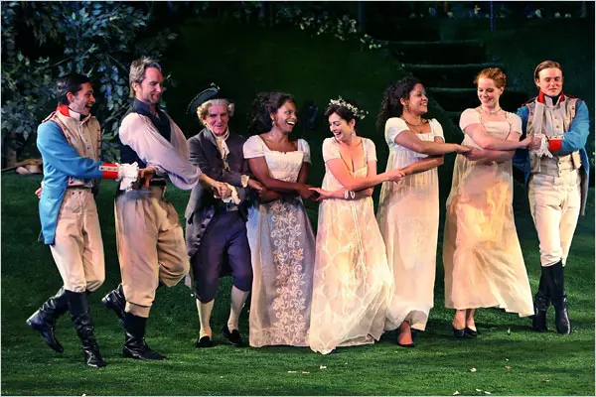
Shakespeare in the Park production of "Twelfth Night," at the Delacorte Theater

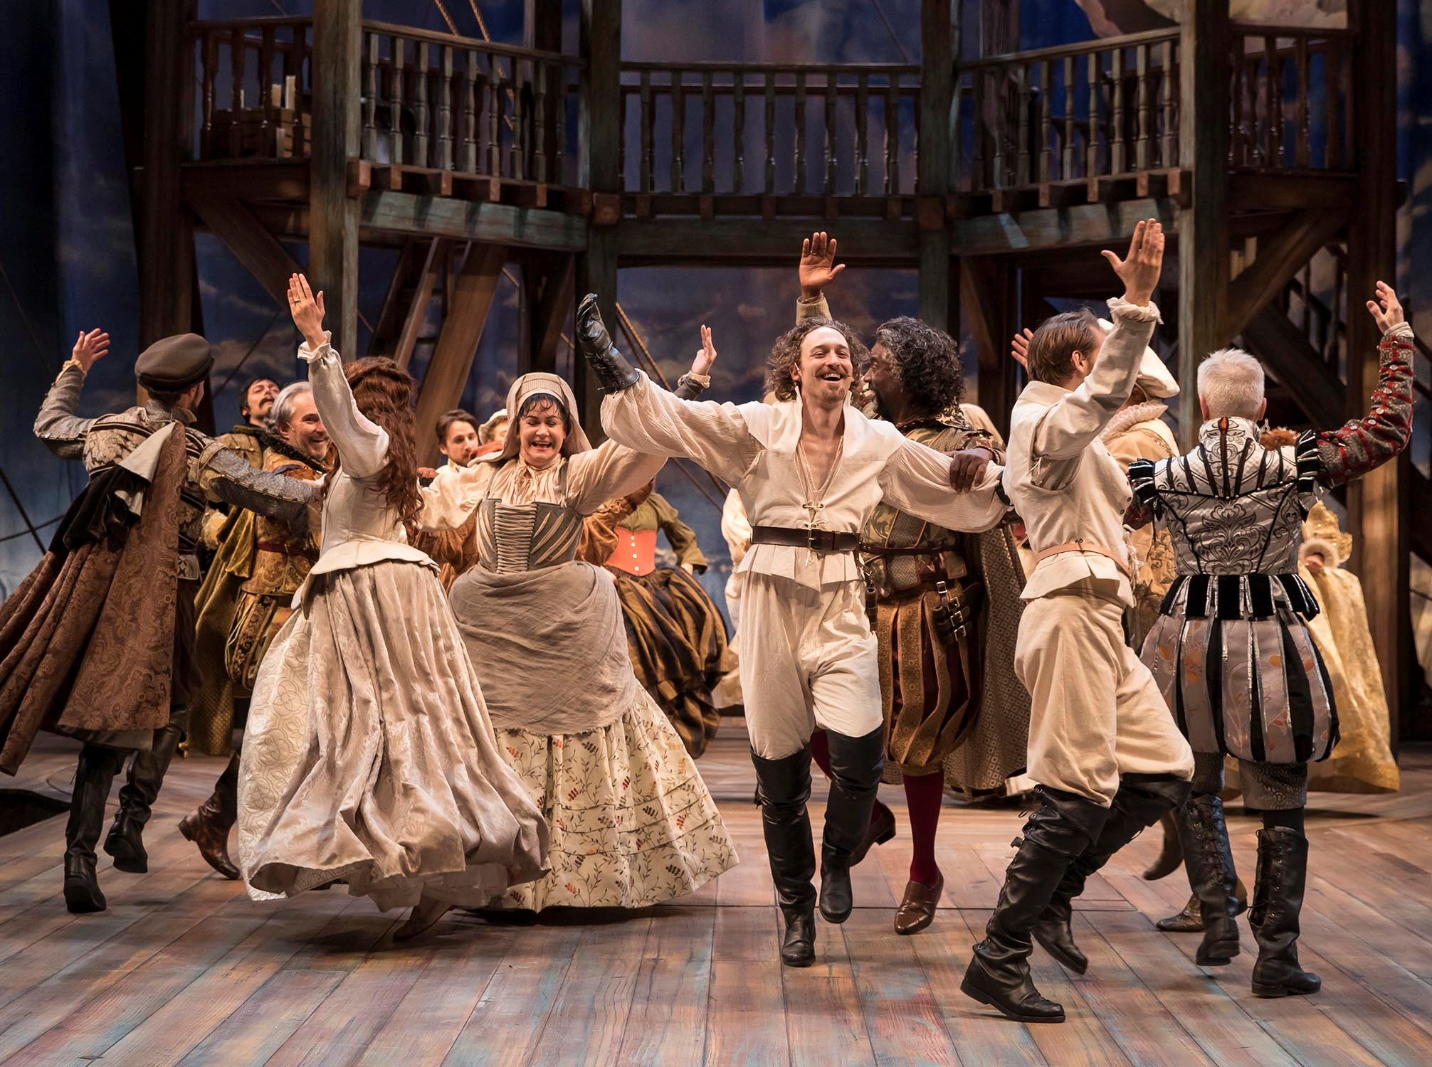
Chicago Shakespeare Theater’s production of Shakespeare in Love

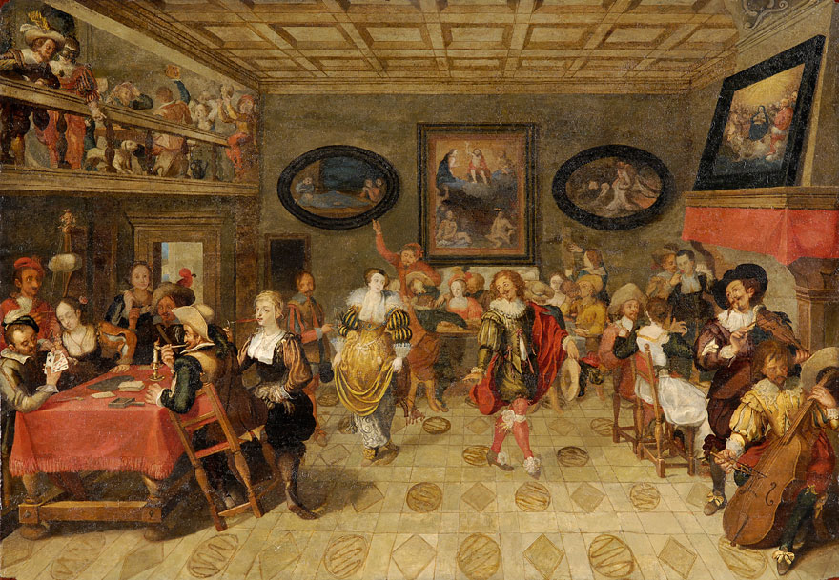

Wedding reception in 17th-century Russia by Konstantin Makovsky

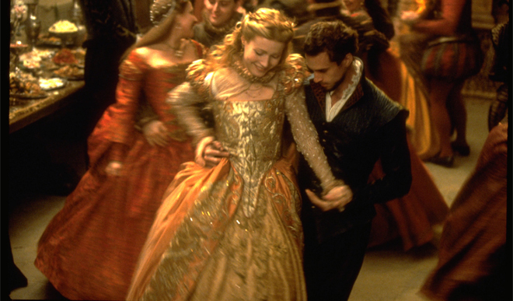
Shakespeare in Love (1998)

Song of the Train by David McCord

Clickety-clack,
Wheels on the track,
This is the way
They begin the attack:
Click-ety-clack,
Click-ety-clack,
Click-ety, clack -ety,
Click-ety
Clack.

Clickety-clack,
Over the crack,
Faster and faster
The song of the track:
Clickety-clack,
Clickety-clack,
Clickety, clackety,
Clackety .
Clack.

Riding in front,
Riding in back,
Everyone hears
The song of the track:
Clickety-clack,
Clickety-clack,
Clickety, clickety ,
Clackety
Clack .

Example Poem

Wedding Madness

Feasting guests
Slurp and slosh
Chitter and chatter
Bang and clang.

Hyper children
Scream and squeal
Wail and howl
‘Let’s go home!’

Music is playing
Toot and hoot
Tingle and jingle
What a tune.

Drinks are flowing
Drip and drop
Splish and splash
‘Top me up!’

Lovers dancing
Giggle and swish
Kiss and smooch
All night long.

On the Ning Nang Nong by Spike Milligan

On the Ning Nang Nong
Where the Cows go Bong!
and the monkeys all say BOO!
There's a Nong Nang Ning
Where the trees go Ping!
And the tea pots jibber jabber joo.
On the Nong Ning Nang
All the mice go Clang
And you just can't catch 'em when they do!
So its Ning Nang Nong
Cows go Bong!
Nong Nang Ning
Trees go ping
Nong Ning Nang
The mice go Clang
What a noisy place to belong
is the Ning Nang Ning Nang Nong!!

