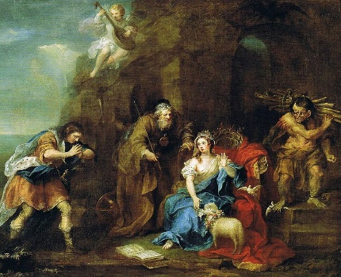What’s a Name Worth?

a = 1024

b = 1302

c = 1278

d = 2341

e = 1769

f = 4560

g = 2237

h = 4489

i = 1804

j = 2347

k = 3109

l = 2201

m = 7692

n = 8766

o = 2505

p = 8405

q = 2113

r = 3738

s = 1325

t = 6209

u = 2546

v = 3841

w = 9710

x = 1382

y = 2540

z = 1315

Add all of the letters in each name together to work out whose name is worth the most!

Miranda - The daughter of Prospero

Caliban - Another of Prospero’s servants

Alonso - King of Naples and father of Ferdinand

Ferdinand - Son and heir of Alonso

Prospero - The play’s protagonist, and father of Miranda. Former duke of Milan.

P = 8405

r = 3738

o = 2505

s = 1325

p = 8405

e = 1769

r = 3738

o = 2505

32,390

Sebastian - Alonso’s brother

Antonio - Prospero’s brother

Ariel - Prospero’s spirit helper

Whose name is worth the most?

Whose is name is worth the least?

Now, have a go at finding out what your name is worth. Then chose a friend’s name and work out what theirs is worth. Whose name is worth more?