Twelfth Night
Act 4
Year 5 and 6 noble household perimeters

Context

Olivia’s jester Feste is sent to find Cesario and instead stumbles across Viola’s brother, Sebastian. Sebastian is confused as Feste pretends to know him and he offers him money to go away.

Sir Andrew and Sir Toby attack Sebastian believing him to be Cesario. As they begin to fight, Olivia arrives and angrily demands the men to stop. Mistaking him for Cesario, she invites Sebastian to her house. Although he is confused, he enjoys her attention and gladly accompanies her.

Locked away in a dark room, Feste visits Malvolio disguised as a priest. He tries to convince Malvolio of his own madness and the servant pleads with him to deliver a letter to Olivia.

Sebastian walks around Olivia’s house confused as to why this beautiful woman wants to marry him. He wonders where his friend Antonio is so that he can discuss the matter with him. Before this can happen, Olivia arrives with a priest and Sebastian agrees to marry Olivia before him.

Maths

The household of the noblewoman Olivia inspires this activity.

LI: To measure and calculate the perimeter of composite rectilinear shapes (Y5)
LI: To recognise that shapes with the same areas can have different perimeters and vice versa. (Y6)

The Household of Olivia

LI: To measure and calculate the perimeter of composite rectilinear shapes. (Y5)

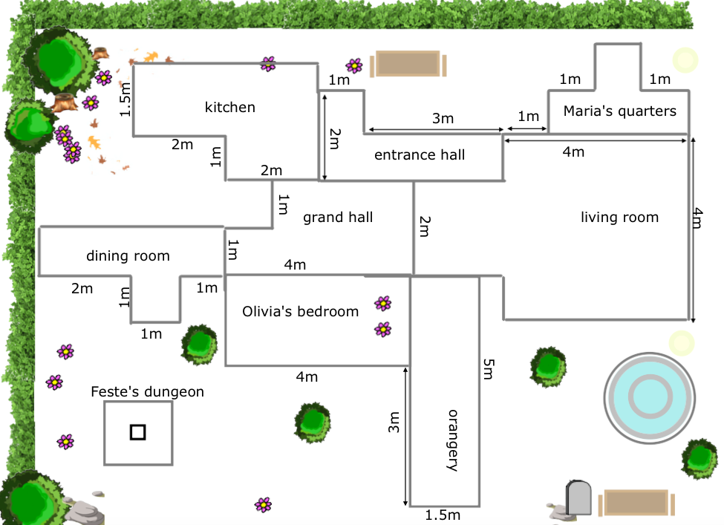

Questions

- What is the perimeter of the dining room?

- Which perimeter is bigger: maria’s quarters or the entrance hall? By how much?

- What is the perimeter of the kitchen?

- What is the perimeter of the orangery?

- The perimeter of the inner square of feste’s dungeon is 160cm. It is ¼ of the perimeter of the outer square. What is the length of one side of the outer square?

WRITE YOUR ANSWER IN M AND CM.

- Olivia decides to build a games room for her new husband. She wants it to have a perimeter of 2o metres. Investigate the different shapes the room could be.

Answers

LI: To measure and calculate the perimeter of composite rectilinear shapes. (Y5)

- DINING HALL = 12m

- entrance hall by 2m

- KITCHEN = 12m

- ORANGERY = 13m

- 160cm OR 1.6M

- suggestions OF 20M PERIMETER ROOMS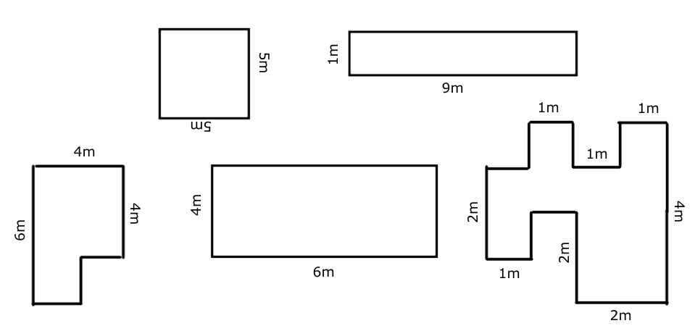

The Household of Olivia

LI: To recognise that shapes with the same areas can have different perimeters and vice versa. (Y6)

QUESTIONS

- find two rooms with the same area.

- Which 5 rooms have the same perimeter?

- Sir toby and sir Andrew want rooms with matching areas. Draw 2 different rooms that have an area of 9m²

- true or false? Rooms with the same perimeter have the same area. Use the rooms of olivia’s estate to support your explanation.

- A room in the home of duke orsino has an area of 24cm² . sir Andrew says the perimeter is 6, 6, 6, 6 m but sir toby says the perimeter is 8,8,3,3 m. Who is correct? Explain why.

- The only window in feste’s dungeon is quadrilateral ? use these clues to find its lengths.
Clues
- The smallest length is 4cm
- The area is less than 30cm²
- The perimeter is 22cm

Answers

LI: To recognise that shapes with the same areas can have different perimeters and vice versa. (Y6)

- Olivia’s bedroom + kitchen (8m²) / entrance hall + dining room (5m²)

- Kitchen + dining room + entrance hall + olivia’s bedroom + grand hall

- Any drawing with area of 9m²

- e.g. olivia’s room and entrance hall have the same perimeter but different area

- 8 x 3 = 24 6 x6 =36

- 4m, 4m, 7m, 7m

