Juliet’s Relationships
In Act 4, Scene 3, after Juliet’s ‘death’, each character’s reaction says a lot about their relationship with Juliet. The people in Juliet’s life reflect on their relationship but how old are they all?

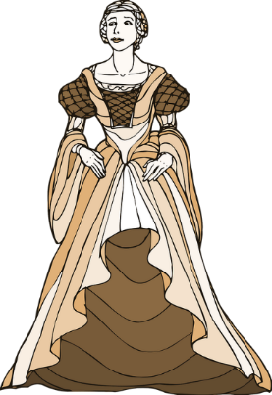
- I am Juliet…
6. I am Juliet’s suitor, Paris.
I have been alive for 228 months.
How old am I in years?

I have been alive for 156 months.
How old am I in years?

7. I am Juliet’s nurse’s servant, Peter.
I have been alive for 780 months.
How old am I in years?

- I am Juliet’s Father, Capulet.
I have been alive for 384 months.
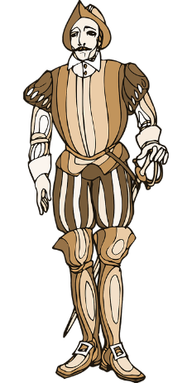
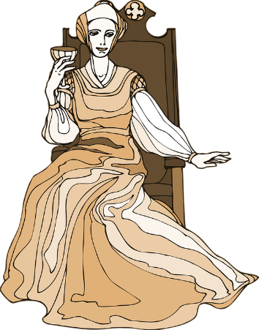
How old am I in years?

- I am Juliet’s mum, Lady Capulet…
8. I am the musician supposed to play at Juliet’s wedding to Paris.
I am 360 months old.
How old am I in years?

I have been alive for 384 months.
How old am I in years?

- I am Juliet’s friar…
I have been alive for 588 months.
How old am I in years?
Can you write your own missing number problem using your age predictions of other characters not in this scene?

- I am Juliet’s Nurse…
I have been alive for 636 months,
How old am I in years?

