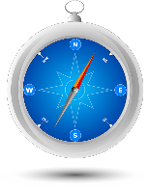
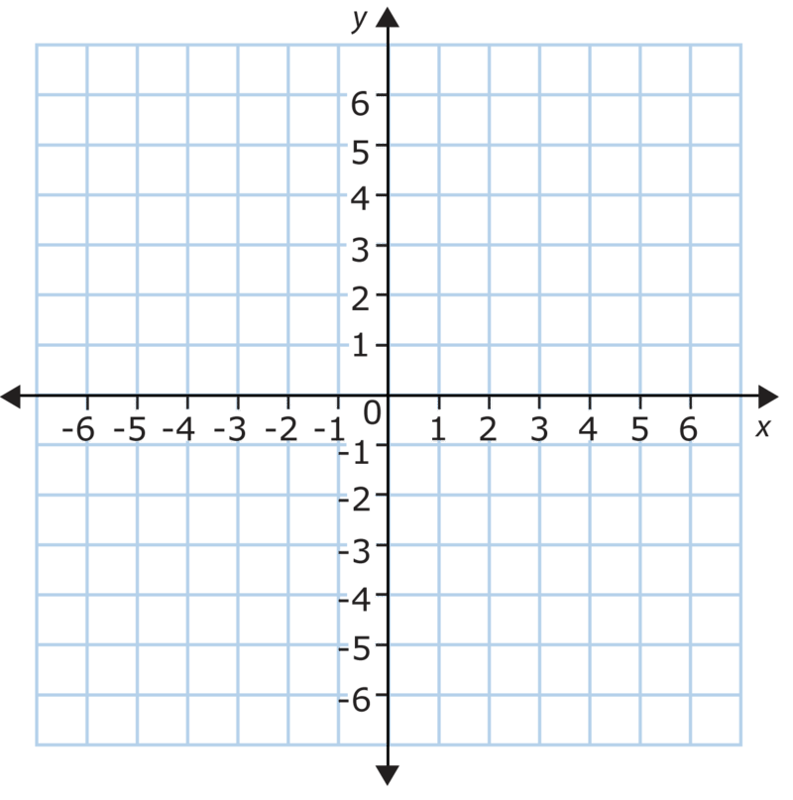
Act 5, Scene 1 begins with Romeo in Mantua, where he escaped to after being banished from Verona. He is reflecting on a dream that he had when Balthasar rushes in to tell him that Juliet is dead. Romeo wants to return to Verona as quickly as possible, help him to figure out how…

- Romeo decides he will go to the apothecary to buy himself some poison so that he can die next to Juliet. He needs to know the coordinate…

- Romeo then goes to pick up roses to lie by Juliet. Which coordinate does he need to visit?

- He then decides to visit a chapel to pray on route to Juliet. Where is the chapel?

- Although Romeo doesn’t feel hungry, he knows he should eat to keep his strength up and so buys a loaf of bread from a market seller. Give the coordinates for the market…

- Some roads are blocked by guards find a route from Mantua to where Juliet is in Verona
Write a route for Romeo to travel from Mantua to Verona, avoiding the guards and in the fewest number of coordinates.

