Lesson 3

LI: To write an effective headline and orientation paragraph.
National Curriculum Links

Writing
Pupils should be taught to draft and write by:
- selecting appropriate grammar and vocabulary, understanding how such choices can change and enhance meaning
- using further organisational and presentational devices to structure text and to guide the reader

Starter:
In partners, children should think of as many words as they can based on the following pictures:
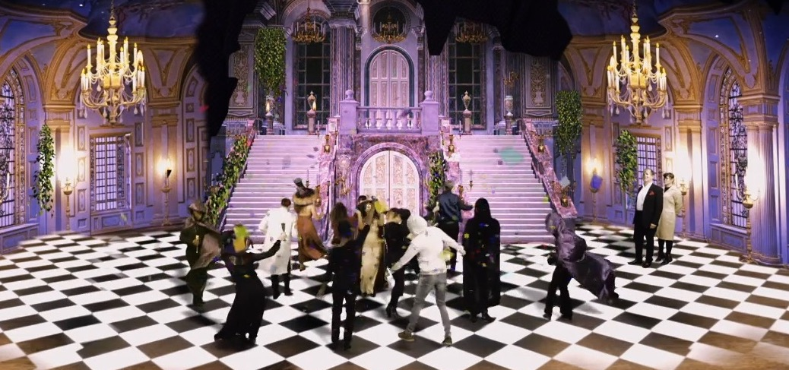

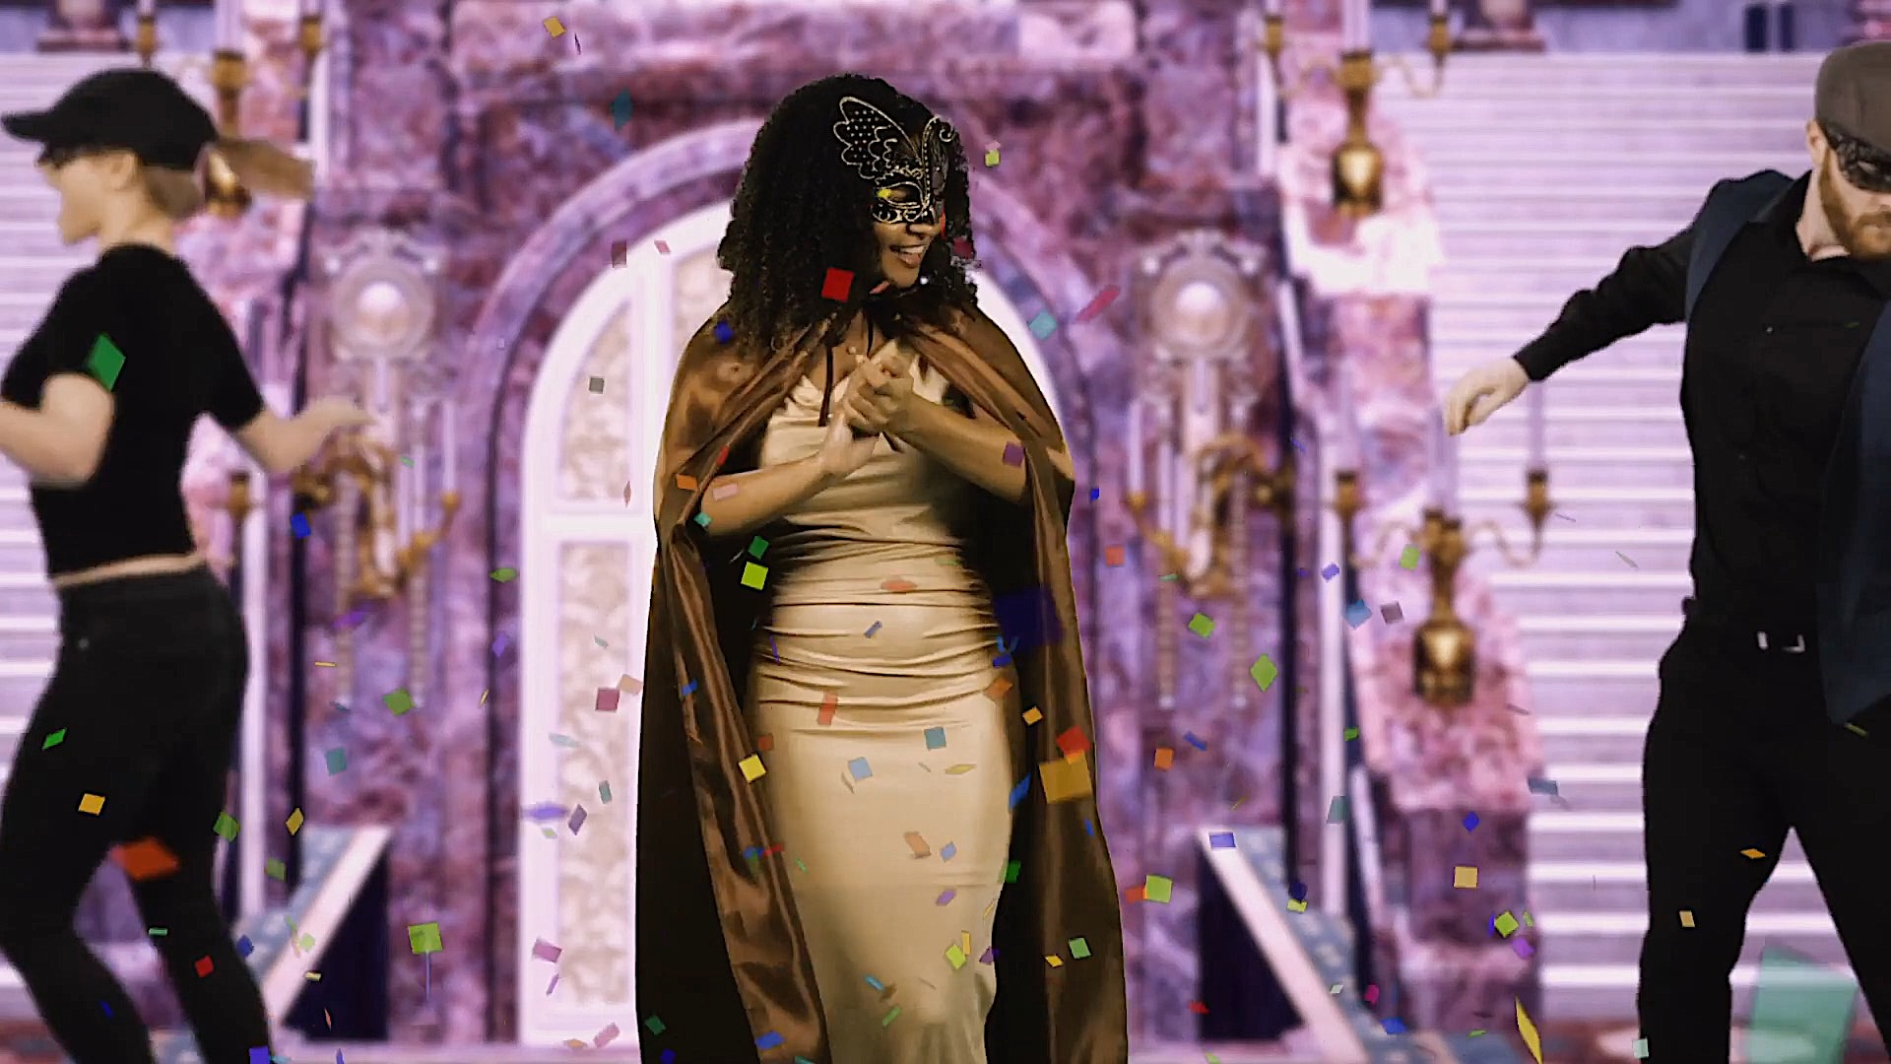

Ask children to share the words they have come up with and record on the whiteboard. Model using a thesaurus to find synonyms to some words (such as party). Children work with a partner to find synonyms for some of the words on the list. Share with each other and add new words to whiteboard.

These words will be used as a word bank to help the children with writing their headline.

Main Teaching:

Part 1: Headline

Show children examples of headlines from newspapers and ask them discuss what makes a good headline:

- Short and snappy
- Eye-catching
- Alliteration
- Rhyme
- Present tense
- Puns

Use the following link for examples of headlines to share with the children:

https://schools.firstnews.co.uk/blog/journalistic-writing/newspaper-headlines-ks2/

Model using the word bank to think of catchy headline about the Capulet ball. Children work in mixed ability pairs to think of their own headline and record in their books.

Part 2: Orientation Paragraph

Then ask the children what the first paragraph of a newspaper is called (the orientation paragraph). Explain that it is a simple paragraph with only one or two sentences which briefly tells the read what happened, when it happened, where it happened and who was involved. Tell the children that it is an important paragraph because it tells the reader what the rest of the article is about and helps them decide if they want to read on or not.

Children should then work with a partner to have an opportunity to practise writing a clear and simple orientation paragraph using the following keys facts:

When: Monday evening
Who: Tybalt and Lucian (a servant from the house of Montague)
What: fighting
Where: in the market square

Children share their orientation paragraphs with the class. Highlight good examples/address any misconceptions.

Having practised writing a paragraph in pairs, the children should now write their own orientation paragraph for their newspaper report on the Capulet ball, using the following success criteria to support them:

- Past tense
- Only one or two sentences
- State the key facts (4 Ws)
- Some details to arouse the reader’s interest

E.g. Yesterday evening, Lord and Lady Capulet welcomed over two hundred guests to their home for a magnificent masked ball.

Ask children to share their orientation paragraphs. Other children to say whether it is a successful orientation paragraph with reference to the success criteria.

