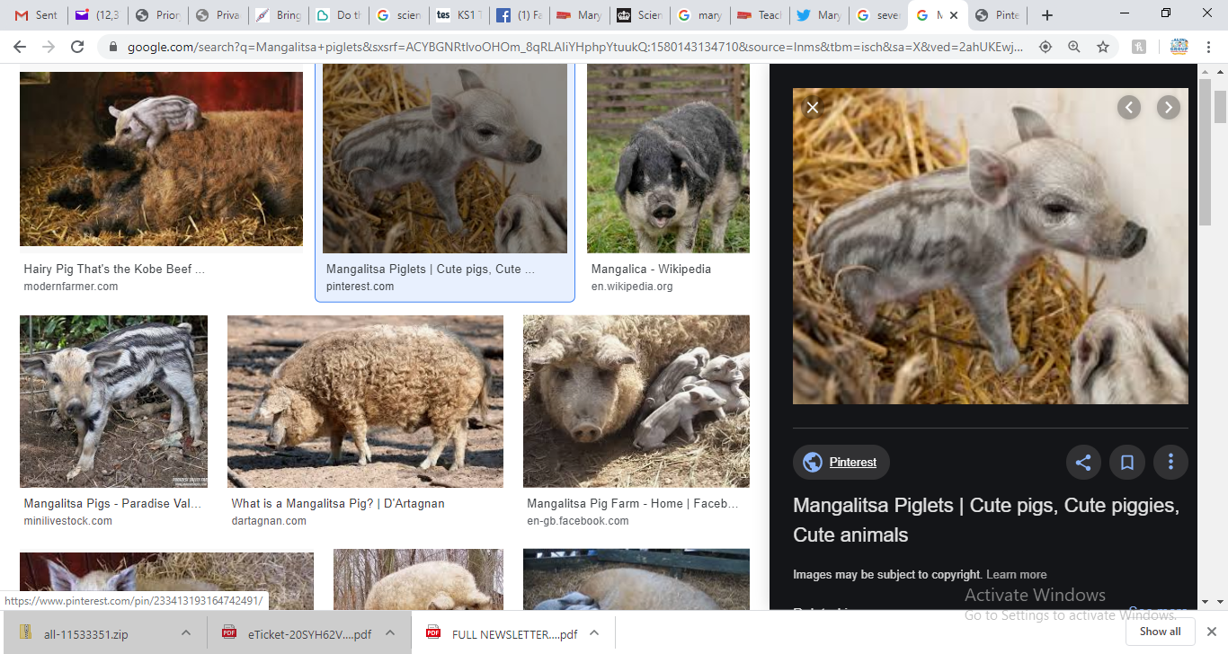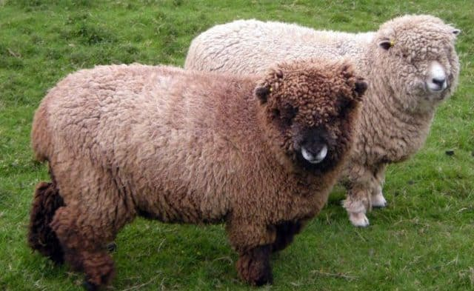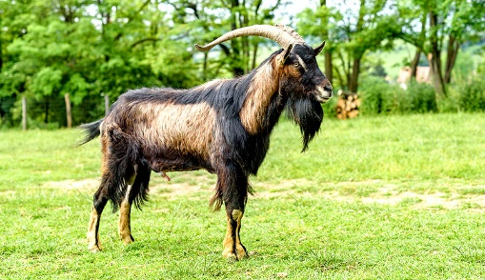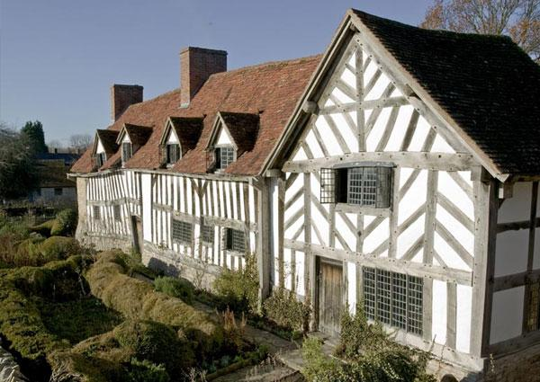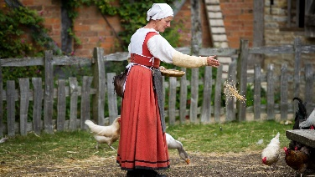

Mary Arden’s farm is a working Tudor farm, located in Wilmcote, just 3.5 miles from Stratford-upon-Avon town centre.

Built by Mary's father, Robert Arden around 1514. Using Tudor farming methods, the farm look after rare heritage breeds that Mary Arden herself would recognise.

**Activity:**

-Children to choose an animal of their choice and create a research project linked to the relevant year group objective. This could be in partners in the classroom or as homework.

**Mary Arden’s (Shakespeare’s Mother) Farm**

Animals at the Farm

Sheep:

Seven Ryland lambs

Ten Norfolk Horn lambs

Nine Portland lambs

Fifteen Cotswold lambs

Arapawa goat

Gloucester cow

Manglalitza piglets

Horses

Donkeys

Birds:

Owls

Harris hawks

Falcons

Year 3

*Animals, including humans*

♣ identify that animals, including humans, need the right types and amount of nutrition, and that they cannot make their own food; they get nutrition from what they eat

♣ identify that humans and some other animals have skeletons and muscles for support, protection and movement.

Year 4

*Animals, including humans*

♣ construct and interpret a variety of food chains, identifying producers, predators and prey.

Year 5

*Living things and their habitats*

♣ describe the differences in the life cycles of a mammal, an amphibian, an insect and a bird

♣ describe the life process of reproduction in some plants and animals.

Year 6

Animals including humans

♣ describe the ways in which nutrients and water are transported within animals, including humans.