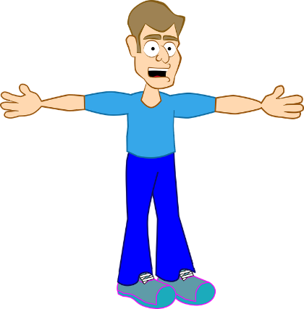Sampson and Abram are bragging and trying to

|  |  |  |
| --- | --- | --- |
| **Sampson** | **Abram** | **Who has more? And how many more do they have?** |
| What Is Place Value? Explained For Primary Parents And Kids!“The Montagues have got more swords than the Capulets!”  What Is Place Value? Explained For Primary Parents And Kids!What Is Place Value? Explained For Primary Parents And Kids!What Is Place Value? Explained For Primary Parents And Kids!What Is Place Value? Explained For Primary Parents And Kids!  What Is Place Value? Explained For Primary Parents And Kids!  What Is Place Value? Explained For Primary Parents And Kids! | What Is Place Value? Explained For Primary Parents And Kids!What Is Place Value? Explained For Primary Parents And Kids!What Is Place Value? Explained For Primary Parents And Kids!What Is Place Value? Explained For Primary Parents And Kids!What Is Place Value? Explained For Primary Parents And Kids!What Is Place Value? Explained For Primary Parents And Kids!What Is Place Value? Explained For Primary Parents And Kids!What Is Place Value? Explained For Primary Parents And Kids!What Is Place Value? Explained For Primary Parents And Kids!What Is Place Value? Explained For Primary Parents And Kids!“No, way. The Capulets have more!” |  |
| “The Montagues have more money than the Capulets will ever have!”  Money, Bag, Brown, Rope, SackMoney, Bag, Brown, Rope, SackMoney, Bag, Brown, Rope, Sack  Money, Bag, Brown, Rope, Sack  122  coins  120  coins  1221  coins  329  coins | Coins, Gold, Money, Treasure, Treasury, Golden, PotCoins, Gold, Money, Treasure, Treasury, Golden, Pot“I doubt that very much!”  179  coins  170  coins  1270  coins |  |
| Box, Cardboard, Cube, Isometric, Storage, Brown BoxMask, Eyefold, Black, Venice, Ball“My Master has countless masks for celebrations.”  Mask, Eyefold, Black, Venice, Ball, Sweet, Masquerade  1930  masks  Box, Cardboard, Cube, Isometric, Storage, Brown BoxMask, Eyefold, Black, Venice, BallMask, Eyefold, Black, Venice, Ball, Sweet, Masquerade  2123  masks  Mask, Eyefold, Black, Venice, Ball  Mask, Eyefold, Black, Venice, Ball, Sweet, Masquerade  Bread, Bun, Brown, Bakery, Food, WheatBread, Bun, Brown, Bakery, Food, WheatBread, Bun, Brown, Bakery, Food, WheatBag, Sack, Jute, Brown, Goods | Mask, Eyefold, Black, Venice, Ball, Sweet, MasqueradeMask, Eyefold, Black, Venice, BallMask, Eyefold, Black, Venice, Ball, Sweet, MasqueradeMask, Eyefold, Black, Venice, BallMask, Eyefold, Black, Venice, Ball, Sweet, MasqueradeBox, Cardboard, Cube, Isometric, Storage, Brown BoxBox, Cardboard, Cube, Isometric, Storage, Brown Box“Oh give it up already! My Master has far more…”  1140  masks  2175  masks |  |
| Candle, Fire, FlameBag, Sack, Jute, Brown, Goods“The Montagues have so many beautiful candles. More than you could even count!”  Candle, Fire, Flame  2103  candles  1326  candles  Candle, Fire, Flame | Bag, Sack, Jute, Brown, GoodsBag, Sack, Jute, Brown, GoodsCandle, Fire, FlameCandle, Fire, Flame“…oh, this bragging is getting tiring now! We definitely have more candles!”  2627  candles  1118  candles |  |
| “For our banquet, we have so many delicious bread buns!”  Crate, Box, Wooden, Container, Package, Brown, Shipping  1556  buns  Crate, Box, Wooden, Container, Package, Brown, ShippingBread, Bun, Brown, Bakery, Food, Wheat  Bread, Bun, Brown, Bakery, Food, Wheat  1289  buns | Bread, Bun, Brown, Bakery, Food, WheatBread, Bun, Brown, Bakery, Food, WheatBread, Bun, Brown, Bakery, Food, WheatBread, Bun, Brown, Bakery, Food, WheatBread, Bun, Brown, Bakery, Food, WheatBread, Bun, Brown, Bakery, Food, WheatCrate, Box, Wooden, Container, Package, Brown, ShippingCrate, Box, Wooden, Container, Package, Brown, ShippingCrate, Box, Wooden, Container, Package, Brown, Shipping“Well at our banquet, guests will be so full of lovely, fresh bread!”  1113  buns  207  buns  1951  buns |  |

get one over on each other. For each idea, who is right?