A Gorgeous Palace
In Act IV, Scene 1, Prospero describes the vision to Ferdinand and Miranda ‘The cloud-capped towers, the gorgeous palaces, The solemn temples…’
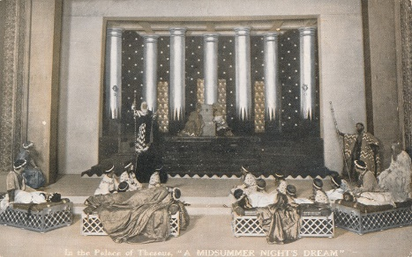
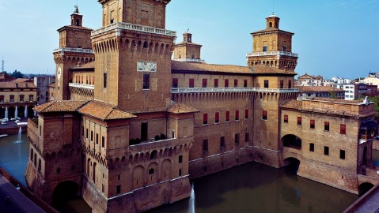
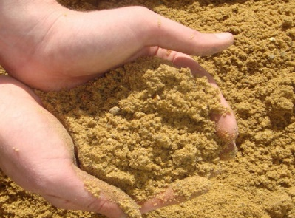
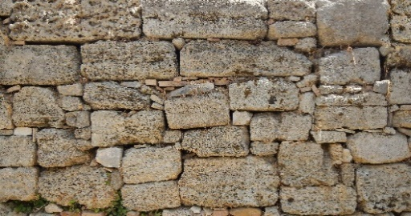
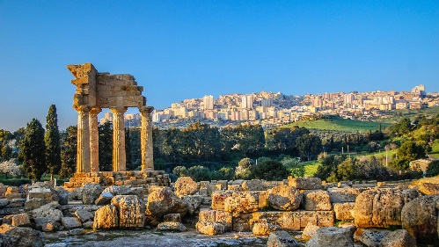
Now Miranda decides she likes the sound of a ‘gorgeous palace’ and researches what materials she would need where. Can you help her?
- 0.08 bag into 10 rooms.
- 62.9 bags into 100 rooms.
- 21.9 bags into 1000 rooms.
- 1.5 bags into 10 rooms.
- 2.8 bags into 1000 rooms.
- 0.2 bags into 10 rooms.
- 1.6 bags into 100 rooms.
- 2 bags into 100 rooms.
- 3 bags into 1000 rooms.
- 4 bags into 100 rooms.
- 5 bags into 100 rooms.
- 4 bags into 1000 rooms.
- 4 bags into 10 rooms.

