A Gorgeous Palace
In Act IV, Scene 1, Prospero describes the vision to Ferdinand and Miranda ‘The cloud-capped towers, the gorgeous palaces, The solemn temples…’
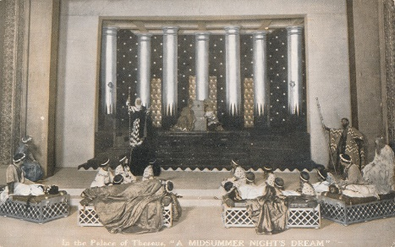
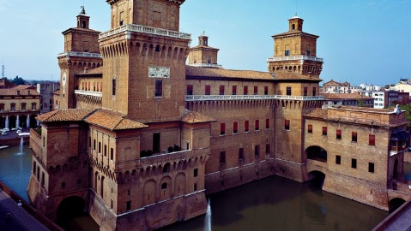
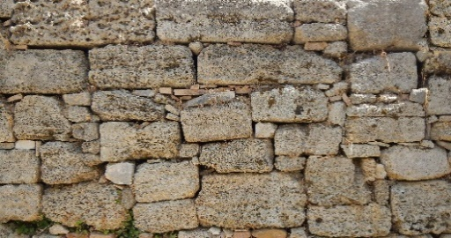
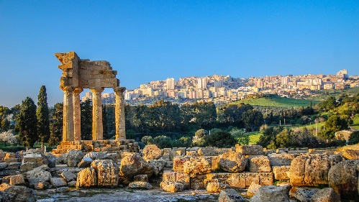
Now Miranda decides she likes the sound of a ‘gorgeous palace’ and researches what materials she would need where. Can you help her?
- 1689 stones into 3 rooms.
- 1625 stones into 5 rooms.
- 2168 stones into 8 rooms.
- 1512 stones into 9 rooms.
- 1393 stones into 7 rooms.
- 936 stones into 6 rooms.
- 820 stones into 4 rooms.
- 992 stones into 8 rooms.
- 333 stones into 9 rooms.
- 870 stones into 6 rooms.
- 435 stones into 5 rooms.
- 721 stones into 7 rooms.
- 276 stones into 4 rooms.

