National Curriculum objectives:
- compare and group together different kinds of rocks on the basis of their appearance and simple physical properties
- describe in simple terms how fossils are formed when things that have lived are trapped within rock
- recognise that soils are made from rocks and organic matter.

Working Scientifically
- asking relevant questions and using different types of scientific enquiries to answer them
setting up simple practical enquiries, comparative and fair tests
- making systematic and careful observations
- gathering, recording, classifying and presenting data in a variety of ways to help in
answering questions
- recording findings using simple scientific language, drawings, labelled diagrams,
keys, bar charts, and tables
- using results to draw simple conclusions, make predictions for new values, suggest
improvements and raise further questions
- identifying differences, similarities or changes related to simple scientific ideas and
processes
- using straightforward scientific evidence to answer questions or to support their
Findings.

Context
Many shipwrecks have occurred when the crew of the ship allowed the ship to collide with rocks, reefs, icebergs, or other ships. Collision has been one of the major causes of shipwreck.
William Shakespeare's play Twelfth Night takes place in Illyria. ''Illyria'' was once used in reference to the Adriatic Sea coast, which included present-day Albania, Bosnia, Croatia, Montenegro, Serbia and Slovenia. The Central Adriatic Sea, is mainly known for its Triassic igneous rocks. However, it also contains Pleistocene conglomerates, limestones and Neptunian dikes, as well as Holocene rock debris, soil, and beach gravels.

Lesson 1- To explore different kinds of rocks and their properties.
- Chn to write/draw what they already know about rocks. Chn to write questions they want to find out about rocks. (Activity 1)
- Exploring session- complete a prediction and complete the table. (Activity 2)
- Complete the challenge and share thoughts and present their findings. (Activity 3)
Lesson 2- To categories rocks according to their characteristics (Sedimentary rocks found in the Adriatic Sea.)
- Discuss different types of rocks. Show the chn how the rocks have been grouped. Discuss the criteria.
- Complete the categorising frame and organise the different types of rocks. (Activity 4)
- Complete the describing frame and describe a rock. (Activity 5)
Lesson 3- To plan and an experiment. (Plan a permeability investigation for different rocks.)
- Discuss the difference between permeable and impermeable rocks.
- Plan the investigation using the planning grid. (Activity 6)
- Complete the table and discuss/write your findings.
Lesson 4- To identify purposes of rocks.
- Recap what we’ve learnt so far about rocks. Chn to now write on the defining frame from Activity 1 what they have learnt in a different colour. Has any of their questions been answered?
- Chn to use the rock classification grid/information sheet to complete the table. Chn to write down the uses of rocks. (Activity 7)
- Chn to write down their opinion on the most useful rock.
Lesson 5- To explore (Illyria)soil formation
https://www.bbc.co.uk/bitesize/topics/zjty4wx/articles/ztvbk2
- Watch the video and discuss soil.
- Investigate soil- complete the table. (Activity 8)
- Complete conclusion

Lesson 6- To identify fossilised remains.
Before the lesson.
Chn to research fossils- specific books given- research a significant person. Mary Anning.

- https://www.bbc.co.uk/bitesize/topics/z9bbkqt/articles/z2ym2p3#:~:text=After%20an%20animal%20dies%2C%20the,compact%20and%20turn%20to%20rock. Watch the video.
- As a class discuss fossils. Sequence how a fossil is formed- complete a sequencing frame. (Activity 9)
- Chn to present their sequencing frame.

Activity 1

Activity 2- Exploring rocks found near Illyria
How are rocks affected by different substances?
________________________________________________________________________________________________________________________________________________________________________________________________________________________________________________________________________________________________________________

Observation | Results
Are rocks hard?
What is the texture of the rock?
What happens when you put the rock in water?
Does it sink or float?
Is there a reaction? Does it fizz when a drop of vinegar touches the rock?
Is it heavy or light?
How do you know?

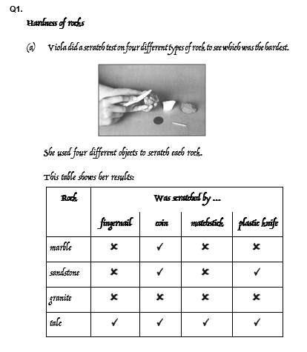
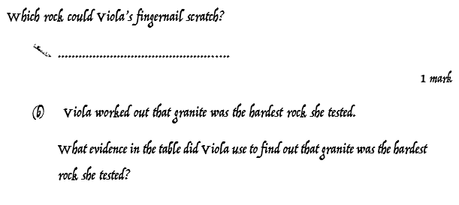
Activity 3
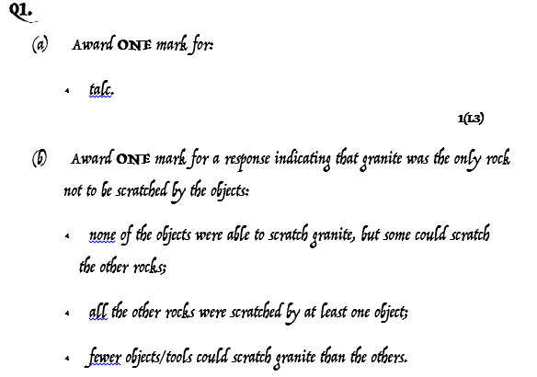

Activity 4

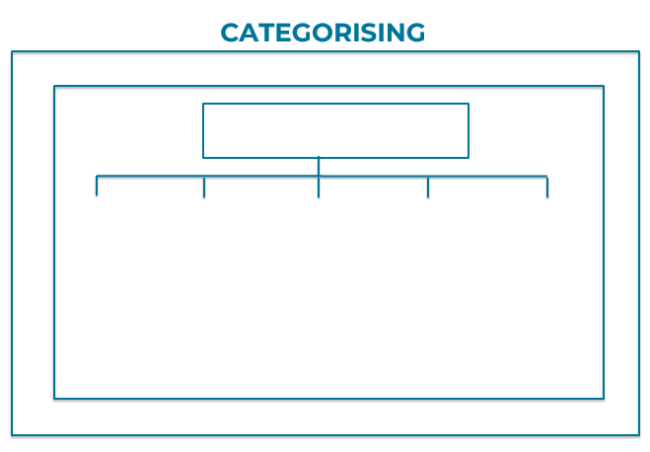

Activity 5
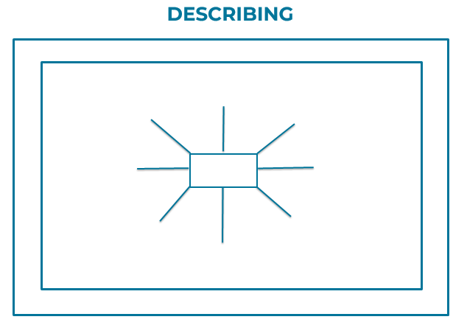

Example of challenge

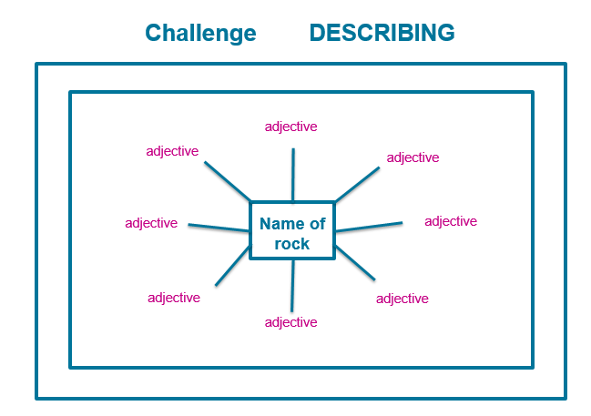
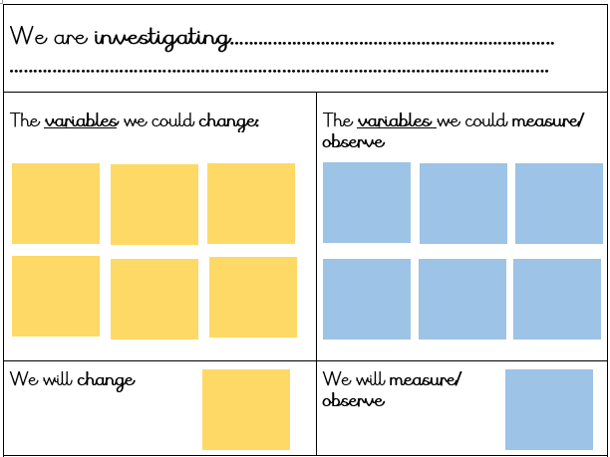
Activity 6

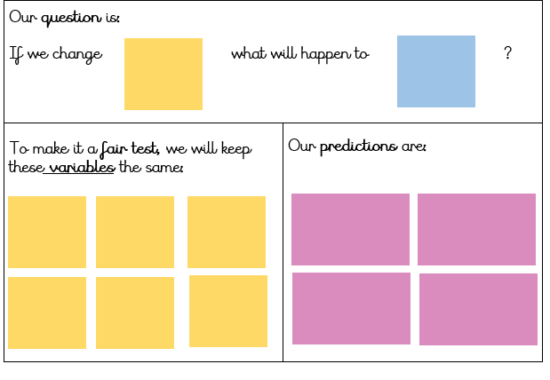

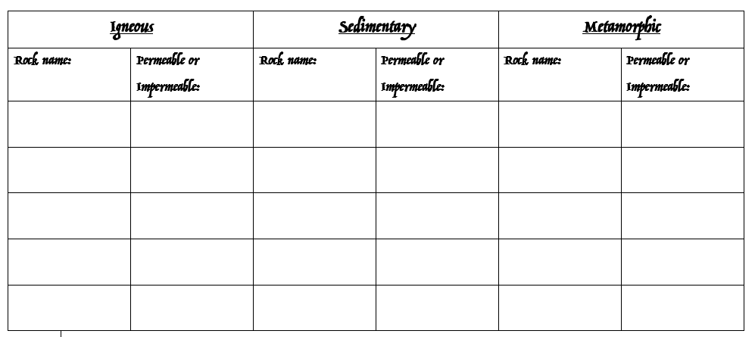
Activity 7

Granite Marble Chalk Clay Pumice Slate Flint Limestone Basalt

Activity 8- experiment to investigate soil.

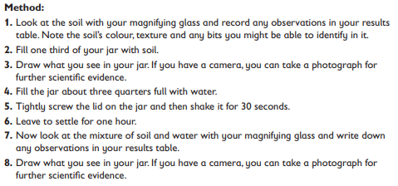
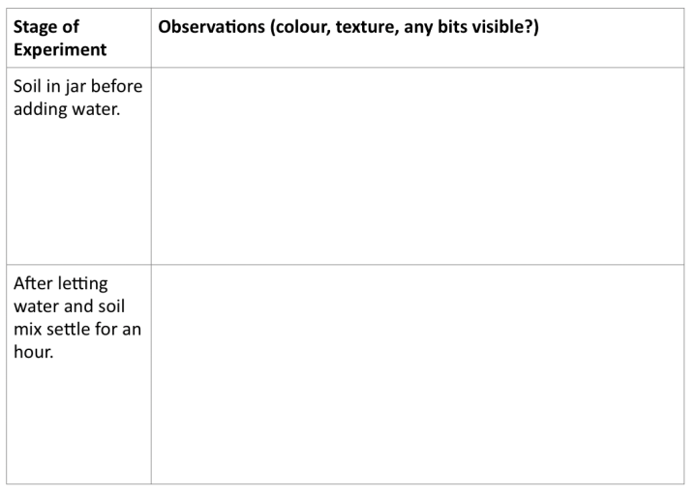

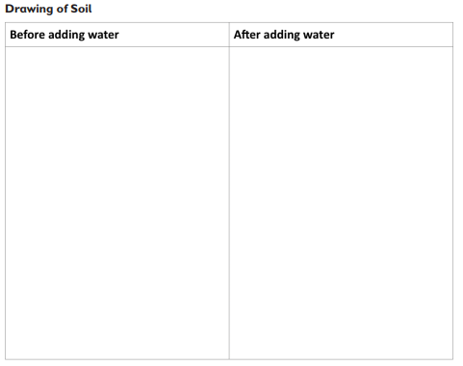

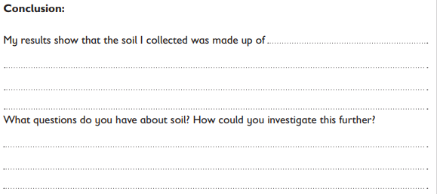

Activity 9- draw the process of how a fossil is formed.
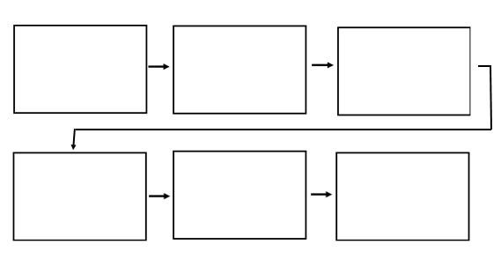
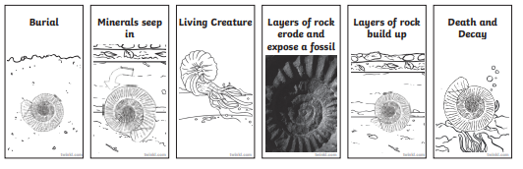

Answers

