Prospero’s House – Area & Perimeter

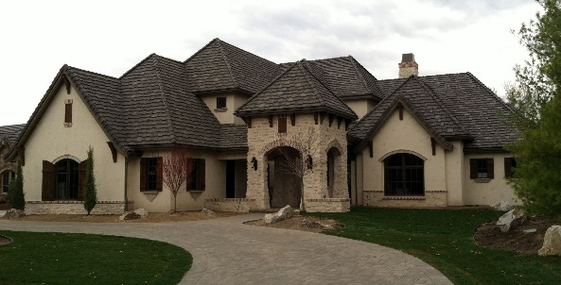

Help measure the different rooms and spaces within my house

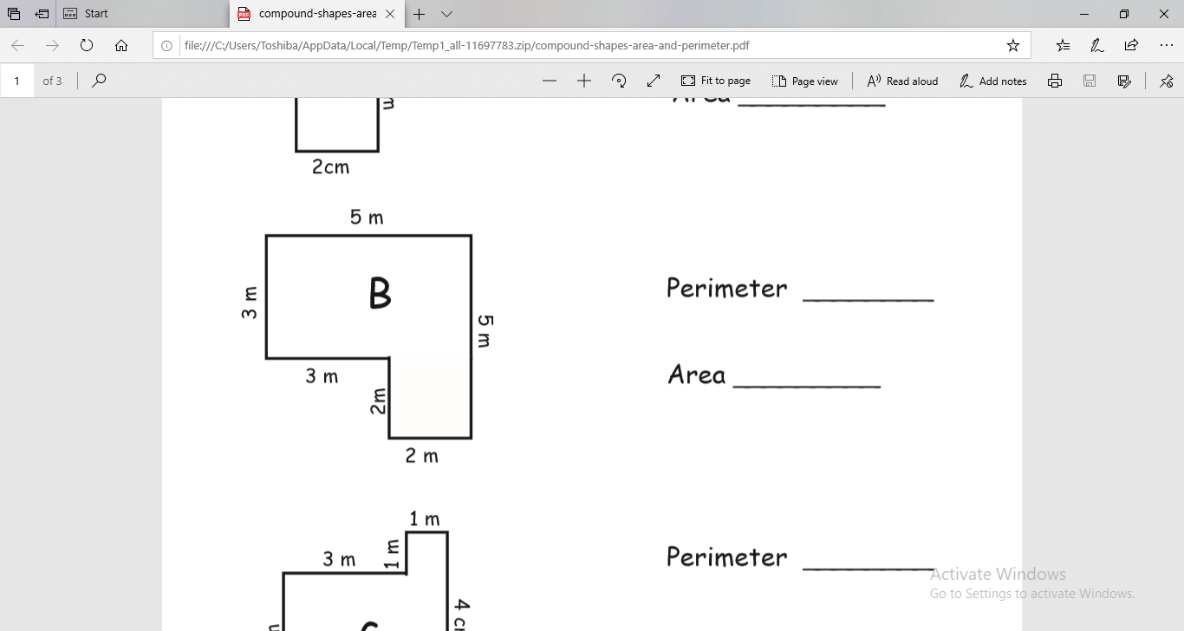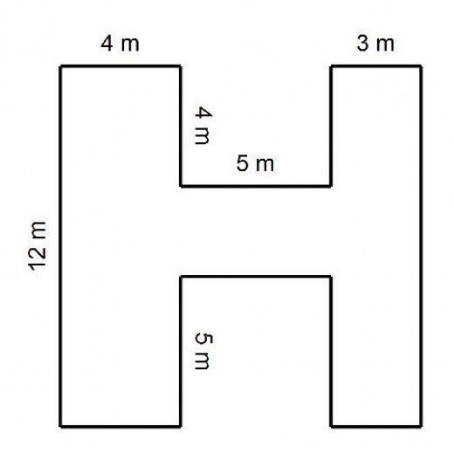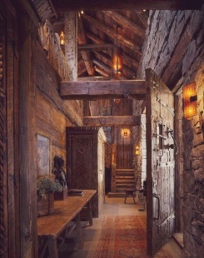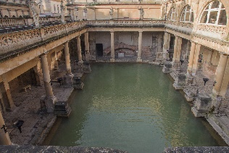[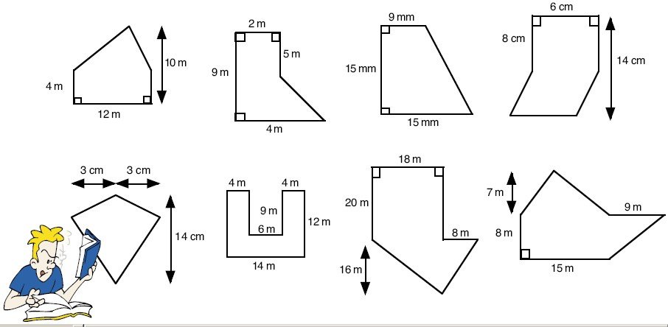](https://www.google.co.uk/url?sa=i&rct=j&q=&esrc=s&source=images&cd=&cad=rja&uact=8&ved=0ahUKEwiNrcn6z8jYAhViJcAKHZIqCTMQjRwIBw&url=http://slideplayer.com/slide/6815005/&psig=AOvVaw0u1lg95teDdX2nrsApzJ1k&ust=1515509276253464)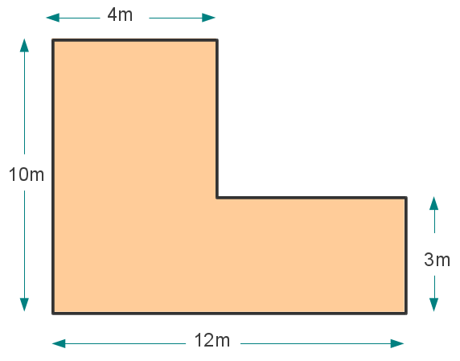[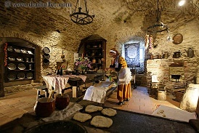](https://www.google.co.uk/url?sa=i&rct=j&q=&esrc=s&source=images&cd=&cad=rja&uact=8&ved=0ahUKEwi54cPDicjYAhXlJ8AKHZDsAnMQjRwIBw&url=https://www.pinterest.com/pin/844493650975513/&psig=AOvVaw3uypFv0CYYNgeqBfxg5dwa&ust=1515490239990160)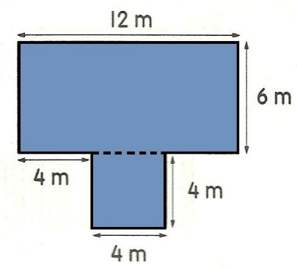[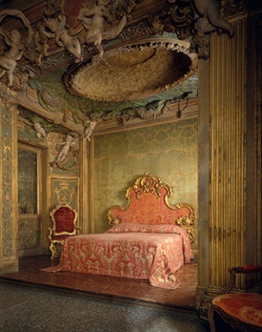](https://www.google.co.uk/url?sa=i&rct=j&q=&esrc=s&source=images&cd=&cad=rja&uact=8&ved=0ahUKEwi27o6PhsjYAhVaOMAKHfzGAcUQjRwIBw&url=https://www.metmuseum.org/toah/ht/09/eustn.html&psig=AOvVaw3ha8JuhB9Ps6ij3Tsb3ter&ust=1515489939824480) **[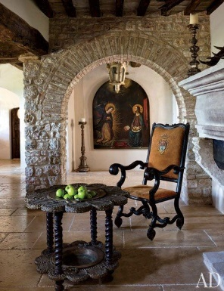](http://www.architecturaldigest.com/decor/2013-11/martyn-lawrence-bullard-evgeny-lebedev-domenico-minchilli-umbria-italy-castle-slideshow_slideshow_After--Dining-Room_12)**

1. hallway
2. swimming pool

Challenge:

Prospero’s special room where he practices magic has 5 sides. 4 of the sides are: 2m, 4m, 2.5m and 5m. The perimeter is 16m. a.) What is the missing length? B.) What is the area of the shape?

1. Kitchen
2. entrance way
3. bedroom