Lesson | Writing | Drama
Lesson 7  Moon Imagery  (flipped activity: writing precedes the drama in this lesson) | L.O. To compose a poem | Freeze Framing
Interesting starter fact:  Three of Uranus’s largest moons are named after characters from A Midsummer Night’s Dream: Titania, Puck and Oberon.  Background:  In the play, there are frequent references to the moon, unsurprising given that a lot of the action takes place during the night | Starter: ‘A Poem in a Matchbox’  This will take some time to prepare. Using the ‘crunched’ (i.e. extracted vocabulary) text, print and cut out words, placing sets in individual matchboxes. In small groups, the children empty the words from the matchbox, and work together to create their own poetic phrases. The words should be ‘placed’ on a large sheet of sugar being, the idea being that there should be as much manipulation of word order as possible. High frequency words e.g. an/to/the/it can either be provided separately or invite the pupils to simply write these words in. But be strict! Set a limit e.g. five HF words per phrase.  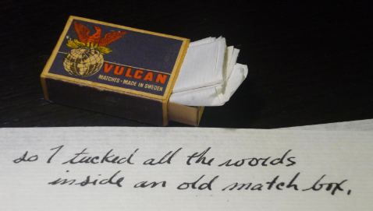  Extend very able pupils to experiment with sound techniques e.g. repetition of words, rhyme, assonance and alliteration. At every opportunity, emphasise the need for the phrases to be read aloud, so that particular techniques, and their effects, can be recognised and discussed.  If appropriate, target how the meaning can alter when different forms of punctuation are used  Teacher’s suggested modelled version:  The Moon  Love wanes, and the moon’s fair hymns  Linger, a thousand fiery flowers: their silver eyes pierce its slow, cold beams.  Make sure the children realise that their poems don’t have to make perfect sense: this is about playing with words, and having fun with Shakespeare’s language!  When happy with the compositions, pupils can then rehearse their own readings | Using resource 7B, explain that the words the pupils have just used are from the following extracts.  Discuss these various references to the moon in the play. Encourage children to think about what image of the moon is created through these extracts. What abstract themes are developed? e.g. age, sadness, beauty, time, change, purity, coldness, prayer, love, marriage.  This will then lead on to the freeze framing activity. In their groups, pupils will devise a frozen tableau which will represent their own image of the moon, as per their poetic phrase.  This can become a whole class performance. Use of percussion instruments (chimes, bell, cymbals) signal the transition between each group’s frozen scene.

LESSON 7A

References to the moon in ‘A Midsummer Night’s Dream’:
(Act 1, Scene 1) Theseus, bewailing that time is passing too slowly until his wedding day:
Now fair Hippolyta our nuptial hour
Draws on apace; four happy days bring in
Another moon: but, O, methinks, how slow
This old moon wanes! she lingers my desire
(Act 1, Scene 1) Hippolyta’s response to Theseus:
Four nights will quickly dream away the time
And then the moon, like to a silver bow
New-bent in heaven, shall behold the night
Of our solemnities

(Act 1, Scene 1) Theseus, describing to Hermia what fate awaits her, should she disobey her father
….to be in a shady cloister,
To live a barren sister all your life,
Chanting faint hymns to the cold fruitless moon.

(Act 2, Scene 1) Oberon, describing how the flower gained its power from Cupid’s arrow:
….and loosed his love-shaft smartly from his bow,
As it should pierce a hundred thousand hearts
But I might see young Cupid’s fiery shaft
Quenched in the chaste beams of the watery moon

(Act 3, Scene 1) Titania, falling in love with Bottom:
The moon, methinks, looks with a watery eye
And when she weeps, weeps every little flower,
Lamenting some enforced chastity

LESSON 7B

The ‘Crunched’ Text (from extracts above)

enforced quenched hundred loosed old cold behold thousand apace pierce life like little time some desire chaste live eye bring chanting lamenting young nuptial all shall will dream from barren heaven moon another cloister sister silver flower fair four hour solemnities wanes methinks looks beams hymns weeps lingers fruitless night hearts draws days Cupid shaft love might night new bent faint bow how slow now away shady quickly smartly happy fiery watery every chastity

