Capulet’s Extension
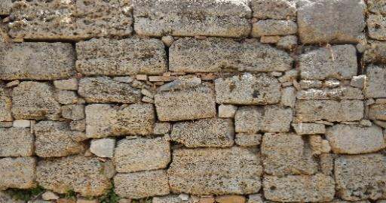
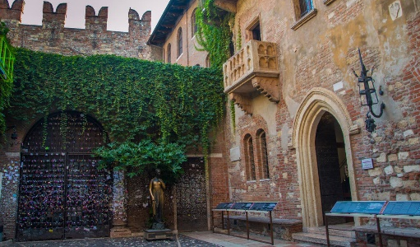
Capulet has decided that he wants a larger place to host more parties so he decides to build an extension. Help the builders divide the bags of sand correctly to the place where each new room will be.
4 bags into 100 rooms
4 bags into 10 rooms
4 bags into 1000 rooms
5 bags into 100 rooms
3 bags into 1000 rooms
2 bags into 100 rooms
1.6 bags into 100 rooms
0.2 bags into 10 rooms
2.8 bags into 1000 rooms
1.5 bags into 10 rooms
21.9 bags into 1000 rooms
62.9 bags into 100 rooms
0.08 bag into 10 rooms

