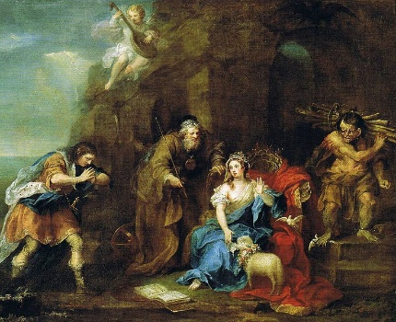What’s a Name Worth?

a = 10124

b = 13302

c = 126678

d = 23341

e = 124769

f = 44560

g = 2237

h = 41489

i = 18904

j = 12347

k = 310900

l = 222401

m = 769832

n = 876126

o = 250675

p = 84015

q = 21130

r = 13738

s = 13250

t = 6209

u = 25246

v = 83841

w = 97510

x = 231382

y = 21540

z = 91315

Add all of the letters in each name together to work out whose name is worth the most!

Miranda - The daughter of Prospero

Caliban - Another of Prospero’s servants

Alonso - King of Naples and father of Ferdinand

Ferdinand - Son and heir of Alonso

Prospero - The play’s protagonist, and father of Miranda. Former duke of Milan.

P = 84015

r = 13738

o = 250675

s = 13250

p = 84015

e = 124769

r = 13738

o = 250675

834,875

Sebastian - Alonso’s brother

Antonio - Prospero’s brother

Ariel - Prospero’s spirit helper

Whose name is worth the most?

Whose is name is worth the least?

Now, have a go at finding out what your name is worth. Then chose a friend’s name and work out what theirs is worth. Whose name is worth more?