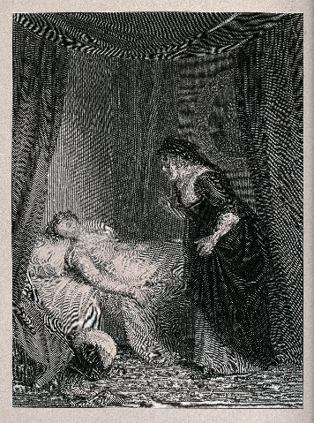
Juliet’s Bedroom
Act 4, Scene 5 takes place in Juliet’s bedroom, where the Nurse finds her
‘dead’… The Primary Shakespeare Company are dressing their stage for this scene.
Help them to work out what they need to prepare the scene…
If the number is written in numerals, convert it to words and if the number is
written, convert it into numerals.

- They need twenty-nine thousand, nine hundred and ninety-five millilitres
of gold paint for the bed.

- They will need ninety-three thousand, seven hundred and fifty-nine seconds to paint the room.

- They need one hundred and fifty-two thousand, two hundred and forty cm in length of wood to build the chest of drawers

- For the curtain ties, three hundred and two thousand, one hundred and eight gold threads and eighty-five thousand and ninety-four cream.
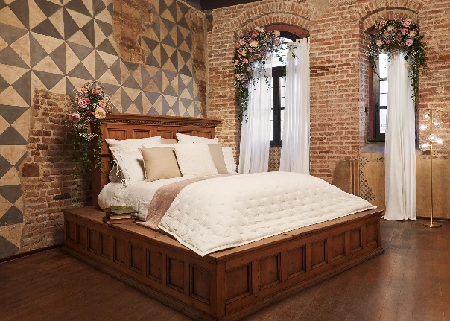

- 202,435 pastel-coloured rose petals

- 101,911 tea light candles

- 123,787 bricks for one stage wall

- Five hundred and three thousand, one hundred and sixty-one feathers for the duvet.

Write 4 of your own sentences that include numbers written as words for a partner to convert.

