
THE WINTER’S TALE
ACT 4

Use your comic to answer the following questions from ACT 4

- Who is Florizel’s dad?

______________________________

- Where has Florizel been spending his time? Tick one box

At school Horseriding

At the shepherd’s house Swimming in the sea

- Why does Camillo think Florizel has been spending so much time there? Use one direct quote from the text to justify your answer
_____________________________________________________

_____________________________________________________

_____________________________________________________

_____________________________________________________

- Who is “on his way to market”?

_____________________________________________________

- What is the name of the “trickster” who robs Perdita’s brother?

_____________________________________________________

- What synonym for “trickster” does the author also use?

_____________________________________________________

- Look at these two pictures.

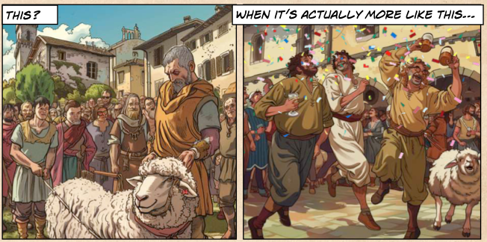

- Write 2 things which are the same in both pictures.

_____________________________________________________

_____________________________________________________

- Write 2 things that are different in both pictures.

_____________________________________________________

_____________________________________________________

- Which scene would you rather be in and why?

_____________________________________________________

_____________________________________________________

_____________________________________________________

_____________________________________________________

- How did Florizel first meet Perdita?

_____________________________________________________

_____________________________________________________

_____________________________________________________

- What has Florizel told everybody his name is?

_____________________________________________________

10.Why do you think Florizel told Perdita the truth?

_____________________________________________________

_____________________________________________________

_____________________________________________________

11.What one word describes how Perdita feels about King Polixenes finding out about her and Florixel being in love.

_____________________________________________________

12. Write a synonym for each of the words below

Scared ________________________

Worried _________________________

Happy _________________________

13. What does Florizel do at the sheep shearing festival?

_____________________________________________________

_____________________________________________________

14. Does Florizel know his father is at the sheep shearing festival? Explain your answer with reference to the text.

_____________________________________________________

_____________________________________________________

_____________________________________________________

_____________________________________________________

_____________________________________________________

_____________________________________________________

15. Look at the pictures below. Write the name of each character under each picture. One character appears twice!

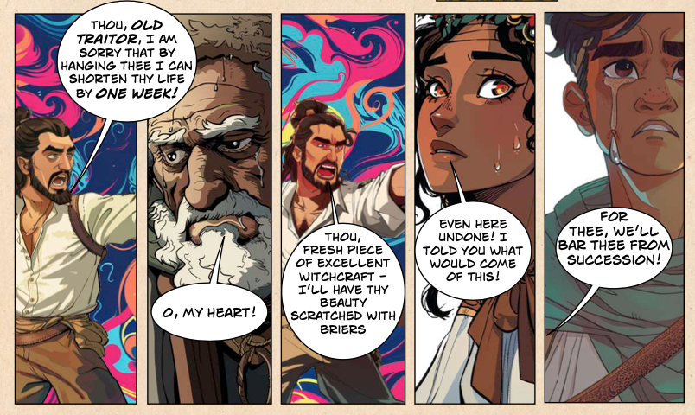

__________. _________. _________. _________. __________.

16. Where does Camillo suggest Perdita and Florizel go?

_________________________
17. What does Camillo ask Autolycus to do?

Take Florizel and Perdita to Sicilia

Swap clothes with Florizel

Go to the market

Talk to the old shepherd and his son

18. Why do you think Autolycus is so happy to agree?

_____________________________________________________

_____________________________________________________

_____________________________________________________

19. Do you think Camillo is right in thinking that if Polixenes goes to the court of Leontes everyone will be forgiven and become friends again?

YES NO

Explain your answer

_____________________________________________________

_____________________________________________________

_____________________________________________________

_____________________________________________________

_____________________________________________________

_____________________________________________________

_____________________________________________________

_____________________________________________________
WINTER’S TALE
ACT 4
ANSWERS

- Who is Florizel’s dad?
Polixenes
- Where has Florizel been spending his time? Tick one box
At the shepherd’s house

- Why does Camillo think Florizel has been spending so much time there? Use one direct quote from the text to justify your answer
Because he’s in love with a girl! Camillo says to Polixenes that the shepeherd “hath a daughter of most rare note” and/or they couly quote the supporting text “Florizel has been ignoring his duties to go and hang out at an old shepherd’s house! The reason? It’s the girl who lives there!)

- Who is “on his way to market”?
Perdita’s brother/Old shepherds’ son

- What is the name of the “trickster” who robs Perdita’s brother?
Autolycus

- What synonym for “trickster” does the author also use?
Conman

- A.Write 2 things which are the same/similar
People/Buildings/Sheep

B.Write 2 things that are DIFFERENT
People are dancing/drinking/laughing/smiling/there’s confetti in the air

C.Which scene would you rather be in and why?
Dependant on children- some may say the first picture as it looks calmer/quieter/more organised! Others may say the second picture because it looks more lively/fun

- How did Florizel first meet Perdita?
He was lost whilst hunting and strayed into one offields owned by the shepherds

- What has Florizel told everybody his name is?
Doricles

10.Why do you think Florizel told Perdita the truth?
Because he loves and trusts her

11.What one word describes how Perdita feels about King Polixenes finding out about her and Florixel being in love.
Terrified

12. Write a synonym for each of the words below
Answers will vary but some examples below
Scared terrified
Worried anxious
Happy joyful

13. What does Florizel do at the sheep shearing festival?
Propose to Perdita/Ask Perdita to marry him!

14. Does Florizel know his father is at the sheep shearing festival? Explain your answer with reference to the text.
No- because Polixenes and Camillo went in disguise. Also, after Florizel proposes Polixenes asks him whether his father knows that he’s just asked someone to marry him- Florizel says, “he neither does, nor shall”. They they have an argument before Polixenes reveals his true self!

15. Look at the pictures below. Write the name of each character under each picture. One character appears twice!

Polixenes Leontes Polixenes Perdita. Florizel

16. Where does Camillo suggest Perdita and Florizel go?
Sicilia

17. What does Camillo ask Autolycus to do?
Swap clothes with Florizel

18. Why do you think Autolycus is so happy to agree?
Because he makes more money for himself!

19. Do you think Camillo is right in thinking that if Polixenes goes to the court of Leontes everyone will be forgiven and become friends again?
Answers will depend but as long as they are justified – for example they might say a long time has past so Leontes will have changed/the picture of Leontes shows how unhappy he is so this would indicate he’s sorry for what has happened/ the fact that Florizel and Perdita are actually the son and daughter of the old friends might bring everyone together. Opposing views might be Polixenes now feels betrayed by his son so may never be able to forgive him/Leontes won’t recognise Perdita because so much time has passed…

