Act 3, Scene 1 starts with Benvolio and Mercutio debating who is more hot-tempered. Then Mecutio is killed by Tybalt. The cast of a Romeo and Juliet play are acting out this scene. They need to work out how the fight props look on stage.
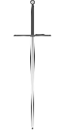
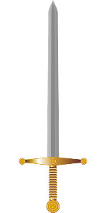
- Circle parallel lines in red identify and perpendicular lines in blue. If a pair of swords is neither parallel or perpendicular, do not circle them.
- Next to the parallel lines, write a H if they are horizontal and a V if they are vertical.
Draw…
parallel swords | perpendicular swords | Swords that are neither parallel or perpendicular
