Ariel’s Magic Spell
Ariel was rescued by Prospero from the tree in which he was imprisoned by Sycorax, the witch who previously inhabited the island.
Now, Ariel wants to punish the witch and turn her into a debauched fish but he needs some help with his spell... The recipe says it needs 12 legs (L) and 4 wings (W). You cannot use a creature more than once.
Which creatures could Ariel put into his spell? How many different ways can you make the recipe?
Example:
Solution 1.
crab + kangaroo + butterfly
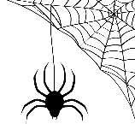
(10L) + (2L) + (4W)

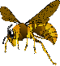
Solution 2.
spider + wasp
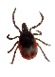
(8L) + (6L + 4W)
Solution 3.

creature | No. of legs | No. of wings
butterfly | 0 | 4
wasp | 6 | 4
earwig | 6 | 2
spider | 8 | 0
ladybird | 6 | 4
flea | 6 | 0
larval tick | 8 | 0
crab | 10 | 0
pigeon | 2 | 2
bat | 2 | 2
kangaroo | 2 | 0

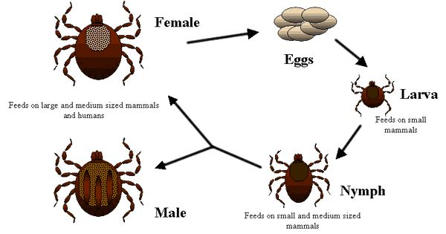
Interesting fact! Did you know that Larval Ticks hatch with six legs, acquiring the other two after a blood meal!

Create a similar spell problem for a friend.

