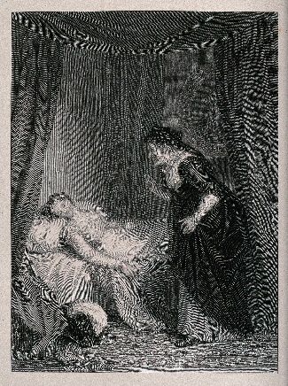
Juliet’s Bedroom
Act 4, Scene 5 takes place in Juliet’s bedroom, where the Nurse finds her
‘dead’… The Primary Shakespeare Company are dressing their stage for this scene.
Help them to work out what they need to prepare the scene…
If the number is written in numerals, convert it to words and if the number is
written, convert it into numerals.

- They need four hundred and twenty-nine thousand nine hundred and ninety-five millilitres
of gold paint for the bed.

- They will need one hundred ninety-three thousand seven hundred and fifty-nine seconds to paint the room.

- They need one million one hundred and fifty-two thousand two hundred and forty mm in length of wood to build the chest of drawers

- For the curtain ties, two million three hundred and two thousand, one hundred and eight gold threads and eighty-five thousand and ninety-four cream.
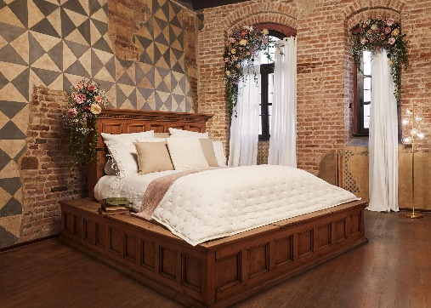
- 202,435g pastel-coloured rose petals

- 410,1911 tea light candles

- 2,123,787g of cement to build the balcony.

- Two million, five hundred thousand, one hundred and sixty-one feathers for the duvet and cushions.

Write 4 of your own sentences that include numbers written as words for a partner to convert.

