Juliet’s Relationships
In Act 4, Scene 3, after Juliet’s ‘death’, each character’s reaction says a lot about their relationship with Juliet. The people in Juliet’s life reflect on their relationship but how old are they all? There is a mean average of 30.436875 days in a month. For this activity, we will round the number of average days in a month to 30.

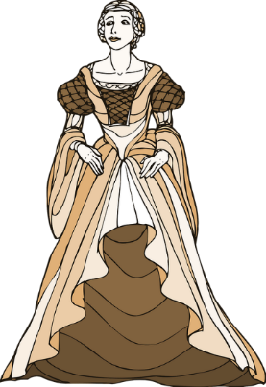
- I am Juliet…
6. I am Juliet’s suitor, Paris.
I have been alive for 6840 days.
How old am I in years?

I have been alive for 4680 days.
How old am I in years?
4680 / 30 = 156
156 / 12 = 13
7. I am Juliet’s nurse’s servant, Peter.
I have been alive for 23400 days.
How old am I in years?

- I am Juliet’s Father, Capulet.
I have been alive for 13320 days.
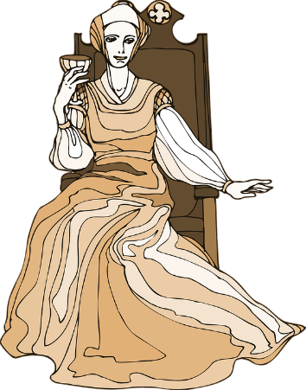
How old am I in years?

- I am Juliet’s mum, Lady Capulet…
8. I am the musician supposed to play at Juliet’s wedding to Paris.
I am 10800 days old.
How old am I in years?

I have been alive for 11520 days.
How old am I in years?

- I am Juliet’s friar…
I have been alive for 17640 days.
How old am I in years?
Can you write your own missing number problem using your age predictions of other characters not in this scene?

- I am Juliet’s Nurse…
I have been alive for 19080 days,
How old am I in years?

