Multiplying Storm Ingredients
Prospero creates the tempest, causing his enemies' ship to wreck with the help of Ariel.
Now Ariel’s fascinated with creating storms and wishes to create an even bigger one. Help him to conjure up spells to try out different storms… Work out how much of each ingredient is needed for the storm potion:

5 lots of 7 cow tongues…
11 lots of 4 eyeballs…
5 lots of 9 frog legs…
12 lots of 8 nettles…
3 piles of 4 rubies…

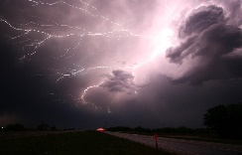

6 lots of 7 cow tongues…
6 lots of 6 millilitres of goat bile…
11 lots of 8 bat wings…
8 lots of 8 pig snouts…

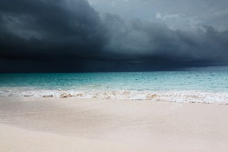

8 lots of 4 owl claws…
12 lots of 4 goblin teeth…
12 lots of 6 pieces of werewolf fur…
6 lots of 3 monkey tails…

W

Write 3 multiplication problems about ingredients for your own storm potion. Make them different to the ones above. Ask a peer to solve the problems.

