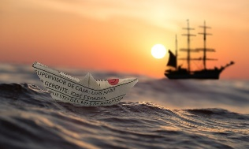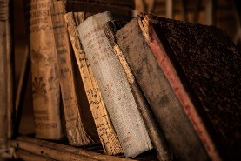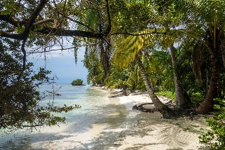

Activities:

Research and look into plants and animals in Mediterranean

Research and learn about different remote islands in different climates.

Think about evolution on islands, i.e. Darwin’s finches

Y6 Objectives:

* describe how living things are classified into broad groups according to common
* observable characteristics and based on similarities and differences, including microorganisms, plants and animals
* give reasons for classifying plants and animals based on specific characteristics.

**Evolution & Inheritance**

* identify how animals and plants are adapted to suit their environment in different ways and that adaptation may lead to evolution.

[www.kew.org/read-and-watch/plants-in-shakespeare](http://www.kew.org/read-and-watch/plants-in-shakespeare)

[www.stem.org.uk/resources/elibrary/resource/35391/evolution-darwins-finches](http://www.stem.org.uk/resources/elibrary/resource/35391/evolution-darwins-finches)

[www.bbc.co.uk/bitesize/topics/zgffr82](http://www.bbc.co.uk/bitesize/topics/zgffr82)

[www.outstandingscience.co.uk/index.php?action=view_page&page=view_unit&unit=4d](http://www.outstandingscience.co.uk/index.php?action=view_page&page=view_unit&unit=4d)

Activity:

Collect junk from home and add in string, elastic, cellophane etc. Give groups sounds from the play, i.e. birds, ship, thunder and lightning. Which group can make noises that sound most like the above?

Learn about frequency waves.

Think about the sounds of the water around the island. Plan an experiment, i.e. have 5 containers each with a different amount of water in, tap each different container with a drumstick – do they sound different? Why?

Activity:

Use objectives from working scientifically to plan an experiment linked to paper, i.e. make recycled paper.

Links to Text:

Like the tempest, Prospero’s books are a symbol of his power. “Remember / First to possess his books,” Caliban says to Stephano and Trinculo, “for without them / He’s but a sot” (III.ii.86–88). The books are also, however, a symbol of Prospero’s dangerous desire to withdraw entirely from the world.

[www.bbc.co.uk/teach/class-clips-video/primary-science-how-paper_is_made/zryb92p](http://www.bbc.co.uk/teach/class-clips-video/primary-science-how-paper_is_made/zryb92p)

[www.youtube.com/watch?v=NlH3C19s4ww](http://www.youtube.com/watch?v=NlH3C19s4ww)

[www.gov.je/SiteCollectionDocuments/Environment%20and%20greener%20living/ID%20PaperMaking%20291209%20ER.pdf](http://www.gov.je/SiteCollectionDocuments/Environment%20and%20greener%20living/ID%20PaperMaking%20291209%20ER.pdf)

Link to text:

Shakespeare's The Tempest is full of noises and sounds of all kinds. Sometimes there are horrible noises, hauling winds, clinking chains and sometimes it’s the sweet music of a harp. Shakespeare has used these sounds perfectly to maintain the intensity of his drama and to create several distinct moods.

KS2

Science Ideas

The Tempest

Y4 Objectives:

* identify how sounds are made, associating some of them with something vibrating
* recognise that vibrations from sounds travel through a medium to the ear
* find patterns between the pitch of a sound and features of the object that produced it
* find patterns between the volume of a sound and the strength of the vibrations that produced it
* recognise that sounds get fainter as the distance from the sound source increases.

**sound**

Link to Text:

In The Tempest (1611), Gonzalo, a honest counsellor to King Alonso of Naples, expresses how green the island is. Yet his short line, “How green!” (2.1.54)

Ceres: ‘Earth’s increase, foison plenty, Barns and garners never empty, Vines and clustering bunches growing, Plants with goodly burden bowing—’

**Prospero’s Books**

**island life**

Y3 Objectives:

identify and describe the functions of different parts of flowering plants: roots,

stem/trunk, leaves and flowers

* explore the requirements of plants for life and growth (air, light, water, nutrients from
* soil, and room to grow) and how they vary from plant to plant
* investigate the way in which water is transported within plants
* explore the part that flowers play in the life cycle of flowering plants, including
* pollination, seed formation and seed dispersal.

Y5 Objectives:

* identify how sounds are made, associating some of them with something vibrating
* recognise that vibrations from sounds travel through a medium to the ear
* find patterns between the pitch of a sound and features of the object that produced it
* find patterns between the volume of a sound and the strength of the vibrations that produced it
* recognise that sounds get fainter as the distance from the sound source increases.

Y5 Objectives:

* describe the differences in the life cycles of a mammal, an amphibian, an insect and
* a bird
* describe the life process of reproduction in some plants and animals.

Y4 Objectives:

* recognise that living things can be grouped in a variety of ways
* explore and use classification keys to help group, identify and name a variety of living things in their local and wider environment
* recognise that environments can change and that this can sometimes pose dangers to living things.