A cast are preparing to put on a performance of Romeo and Juliet but first, they need to get the numbers in order…

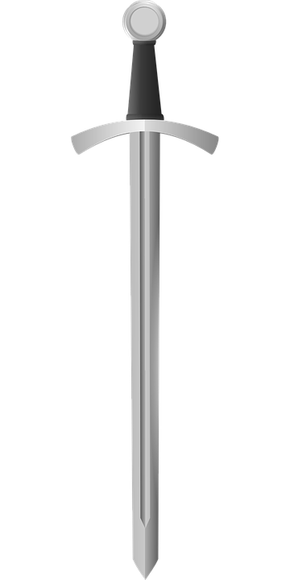
Act 1, Scene 1 - Montague V Capulet brawl
In the Act 1 fight in July, swords were swung a total of 1298436 times.
In a previous fight in June, swords were swung a total of 1393231 times.
In a previous fight in May, swords were swung a total of 1289415 times.
In a previous fight in April, swords were swung a total of 1271442 times.
In a previous fight in March, swords were swung a total of 1171397 times.
Order which month had the least sword swings to the month that had the most.
……………………… ……………………… ……………………… ……………………… ………………………

Act 1, Scene 2 – The Invitation
Peter is asked to deliver invitations to the Capulet feast for Paris to try and win Juliet’s heart.
He takes them to 4 different districts in Verona: Veronetta, Valdonega, Borgo Roma
And San Zeno. Peter repeatedly drops the invitations and so has to create more!
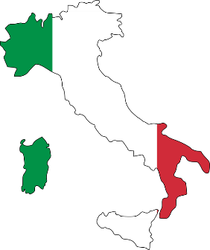
To Veronetta, Peter delivers 1102189 invitations.
To Valdonega, Peter delivers 1134191 invitations.
To Borgo Roma, Peter delivers 2111881 invitations.
To San Zeno, Peter delivers 2100198 invitations.

Order the districts. Start with the district that had most invitations delivered.

……………………… ……………………… ……………………… ………………………

Act 1, Scene 3, - The Feast –
- ………………………………………

- ………………………………………

- ………………………………………

- ………………………………………

- ………………………………………

- ………………………………………

- ……………………………………...

- ………………………………………

- ………………………………………

- ………………………………………
The cooks to pre-order the food items for the next year. Put the
food items for the next years’ feasts in order, from: 1. Dishes that
they need the most of - 10. Dishes that they need the least of…
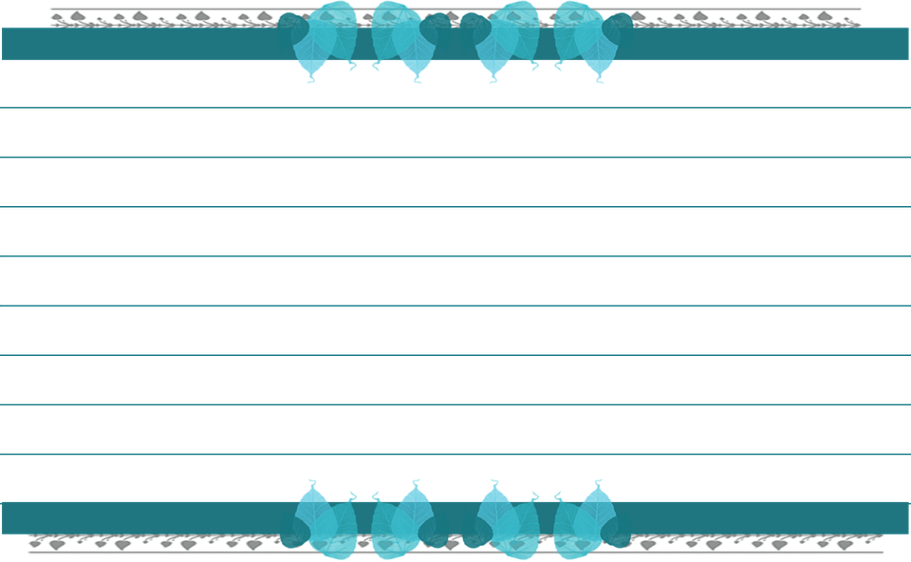
Bowls of gooseberry fool 2321719

Bowls of mixed cooked greens 2319027

Bowls of oxtail soup 2315014

Boiled mutton 2316812

Portions of raspberry pudding 1321682

Baked pies 3417792

Oysters 2318761

Slices of almond cake 1213897

Fresh bread rolls 2118123

Roasted venison 1217543

