Topic lessons |  | Pathway : Thematic |  |  | TERM: 5
 |  | Week 1 & 2 | Week 3 | Week 4 |  | Week 5 | Week 6
 | LO  ACTIVITIES  RESOURCES | I can explore a play.  Focus: exploring characters and setting.  Tell students the summer play will be: A Winters tale.  What do you think this play will be out? Student to make predictions about what the play will be about.  As a class read either:  Winter tale symbol supported text or the simplified version.  Carousel of activities:  Tuff tray: In the tuff tray have a winter scene created. Teachers can use ice and water for a sensory approach. Cotton wool can be used to create snow, paper snowflakes, plastic toys of Kings, Queens, baby, princess, prince if available.  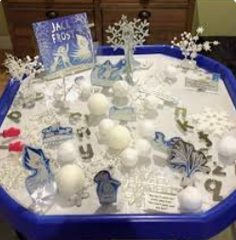  Conversation activity: Students discuss with adult if they liked the story or not. Use sentence stems and communication to support with conversation.  Sentence stems:  I did like the story because_______  I did not like the story because________  Students to take turns in talking, showing respect and listening to peers.  Activity 3: Students to create stick puppets of Kings, Queens, Prince, Princess and baby. Students can then either engage in onlooker, associative or cooperative play with peers. If able can students recreate a scene from the play with stick puppets with adult support where necessary. | I can explore a setting.  Focus: What is winter? What does winter look like to you?  Starter: What can you remember about a Winter’s tale?  Teacher can either read story to class or watch animation again, whichever is best for the class.  Ask question: What is Winter? What does Winter look like?  Create class spider diagram about Winter.  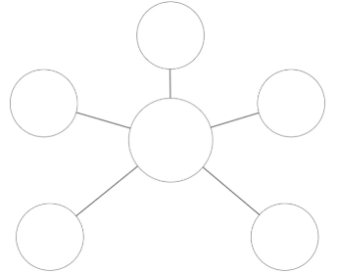  Activity 1: Students explore ice and water in tuff tray. What does the ice feel like? What happens to the ice? Do you like the feeling of the ice?  Activity 2: Make fake snow  Snow Ingredients  baking soda  shaving cream  Dish or container (to mix it all up in)  DIY Snow Directions  Pour the baking soda into a plastic container with a lid.  Add some shaving cream, and knead it into the baking soda.  Add more shaving cream, mix, and repeat, until the mixture is the consistency of snow.  The DIY fake snow become light and powdery, and will leave very little residue on your hands when fully mixed. | I can explore characters.  Focus: exploring characters personalities and appearances.  Starter: What can you remember about a Winter’s tale?  Watch the Winters tale animation as a class.  https://www.primaryshakespearecompany.org/testemonials  Ask students what characters are in the story?  Create class list of characters.  Questions for discussion:  Who is your favourite character? Why?  Are they all good characters?  Which character would you like to be?  Students use communication boards to support with answers.  Activity 1: Students can make stick puppets if didn’t have time in previous lesson or students can use stick puppets to play. Students have 10 minutes free play time to explore stick puppets and play with peers in groups.  Activity 2: Students split into group of 3-4. Each group explores a different character with adult support. Create a list od adjectives to describe that characters personality and appearance.  Activity 3: In the same groups can students use stick puppets to recreate a scene from the play. At end of lesson students share scenes created with rest of class. |  | I can explore character emotions  Focus: Feelings and emotions  Starter: Ask students what can you remember about the play?  Who are the key characters?  What is the setting like?  As a class read either:  Winter tale symbol supported text or the simplified version.  Throughout the story stop at key points and discuss emotions. How do you think the character would feel? Students to use feelings communication board to support.  Key points:  King Leontes and Queen Hermione having a baby.  King Leontes and King Polixenes fighting/arguing.  Queen Hermione being sent to the dungeon.  Princess Perdita and Prince Florizel fall in love.  King Leontes and Princess Perdita are re-united.  All the family are back together.  Key emotions to explore: Sad, happy, love, anger, excitement.  Activity play Winter tale music:  Can students move around happily, angrily, excitedly, sadly.  Can students create a pose either independently or in groups to show a different emotion. | I can explore props and costumes  Focus: Character appearances.  Starter: Ask students what can you remember about the play?  Who are the key characters?  What is the setting like?  Look at different pictures of characters. Class discusses what they are wearing.  Activity 1: Students design a costume for a King, Queen, prince or princess. Students to have blank outlines of people. Students then use felt tips, glitter, colourful paper to design a costume for a character.  Activity 2: Students look at a range of materials. What could each material be used for e.g. we could use this to make a dress, we could use this for a crown etc. Focus on costumes and props characters might need.  Activity 3: Make a crown. Students explore making paper crowns. Students can use different coloured paper, stick on gems, tissue paper.
Term
LO

ACTIVITIES

RESOURCES

