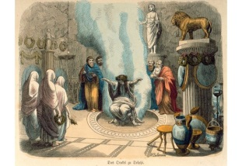
The Oracle of Delphi

The Pythia was the name of the High Priestess of the Temple of Apollo at Delphi who also served as the oracle, commonly known as the Oracle of Delphi.
Here are some predictions that the Oracle made. If the numbers is written in numerals, convert it to words and if the number is written, convert it into numerals.
Example: There will be enough crops to feed 1997 people.
Answer: one thousand, nine hundred and ninety seven
- Greece will reach temperatures of one hundred and thirteen degrees Fahrenheit.

- The River Elbe will carry two thousand, two hundred and thirty eight boats this year.

- When Mount Etna erupts, it will kill five thousand, six hundred and nine trees.

- In Spring, in Bohemia, 7435 calves will be born.

- Sicily will be invaded by 10,911 people.

- The Grande River will break it’s bank 6087 times.

- On Mount Olympus it will snow eleven thousand, one hundred and sixty one times.

- Eighteen thousand, one hundred sperm whales will come to the Greek Coast.

- Twentytwo thousand and twenty three olive trees will grow in Greece.

- There will be three hundred thousand and four hundred shooting stars over the Sicilian skies.

Write 4 of your own sentences that include numbers written as words.

