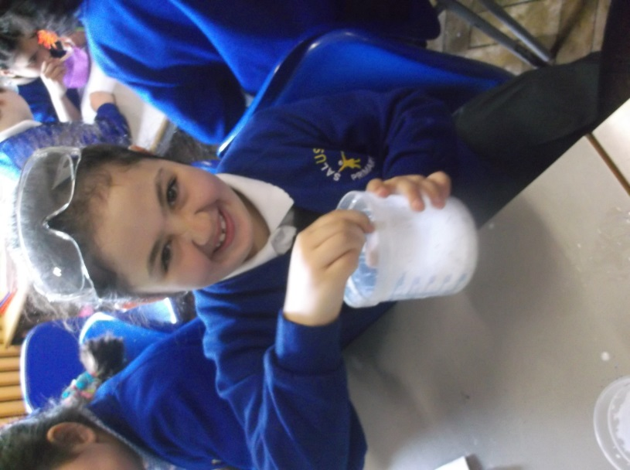

*IPC/Science:*

*Here’s Moonstone as the devious King Claudius, concocting slimy poison for poor old King Hamlet.*

*6 May 2015*

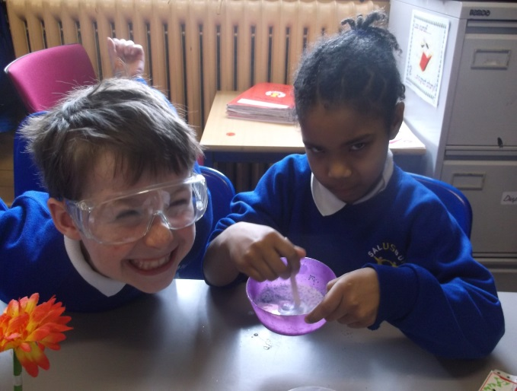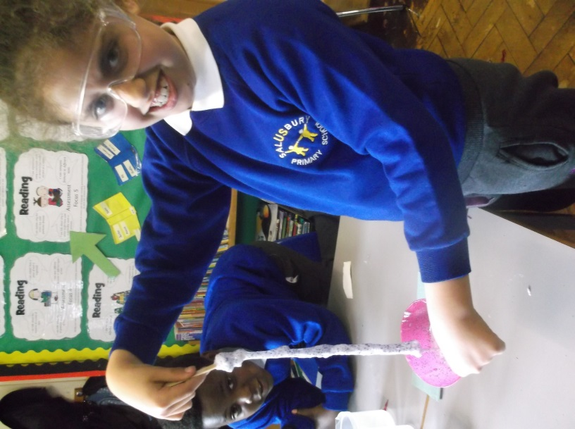

*In this space, children used and explained some of the technical vocabulary related to this new material. For example, ‘viscoelastic’.*

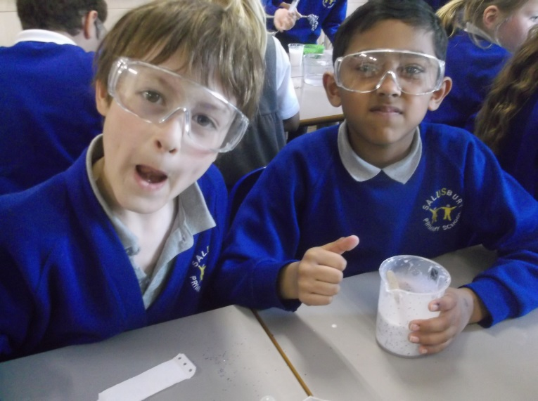 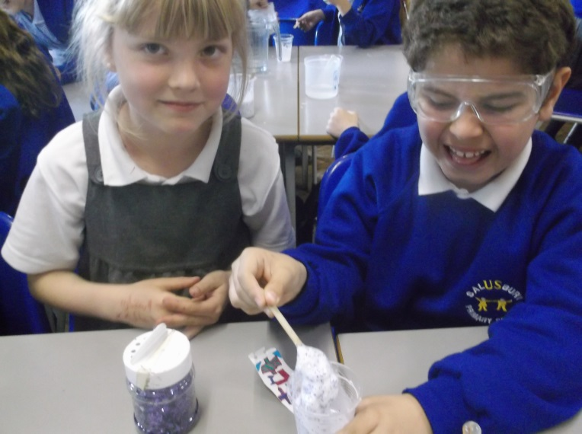

*In this space, the children described the materials and procedures they’ve take to create this slimy polymer.*

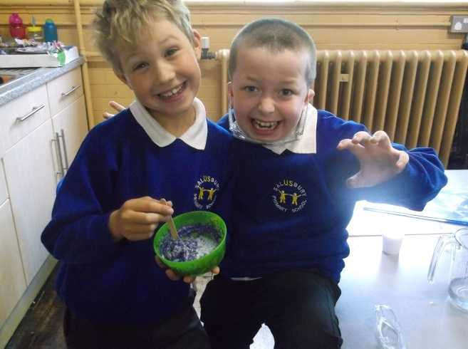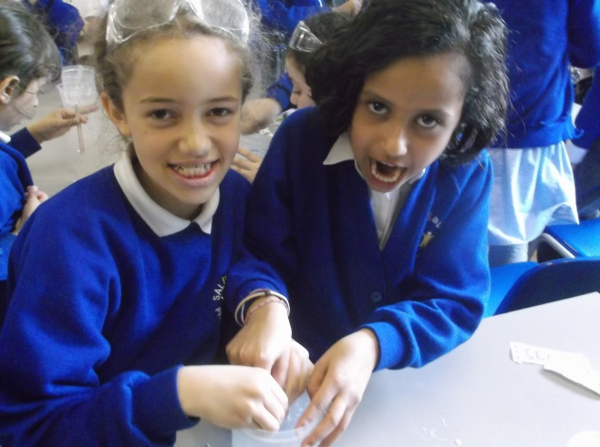

*In this space, children named some other polymers.*

Here’s an example of a finished write-up:

