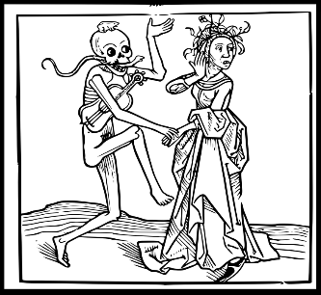
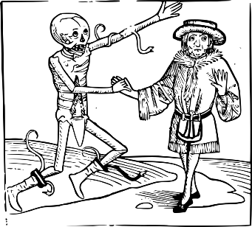
‘Here in this city visiting the sick, And finding him, the searchers of the town,
Suspecting that we both were in a house. Where the infectious pestilence did reign,
Sealed up the doors and would not let us forth.
Friar John talks of an infectious disease and being quarantined in a house that he had been
visiting.

Round the death rate of infectious diseases that affected Italy around and after when Romeo and Juliet was set.

Disease | Year | Approximate Deaths in Italy | Round to the nearest 10… | Round to the nearest 100… | Round to the nearest 1000… | Round to the nearest 10,000 | Round to the nearest 100,000
Bubonic plague | 1346–1353 | 6,345,213
Influenza pandemic | 1510 | 110,345
Influenza pandemic | 1557–59 | 231,487
Italian plague | 1629–1631 | 1,982,578
Naples Plague | 1656 | 156,722
Sicily plague epidemic | 1743 | 48,781

