To make amends for Juliet's death, Lord Montague promises to erect a golden statue of her for all of Verona to admire. Not to be outdone, Capulet promises to do the same for Romeo.

If the measurement is in cm, convert it to mm and if the measurement is in mm, convert it to cm.

Romeo statue

Juliet statue

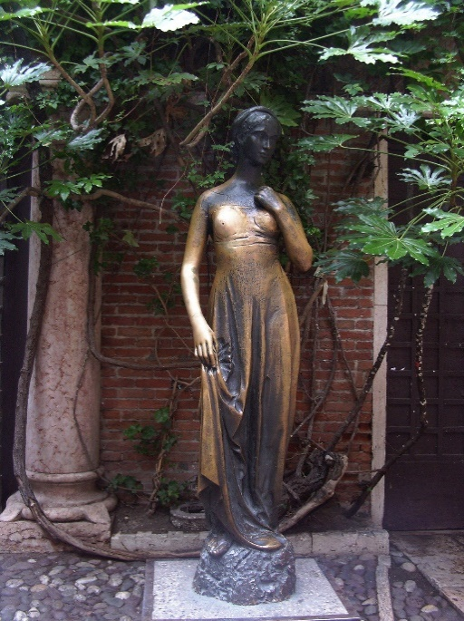

Height 1438 mm

…………………………

height 156.6 cm

…………………………

head circumference

307 mm ………………………………………

shoulder width

426 mm ………………………………………

ring finger

5.3 cm ………………………………………

waist

39.7 cm ………………………………………

shoe

34.5 cm ………………………………………

shoe

261 mm ………………………………………

waist

342 mm ………………………………………

ring finger

5.8 cm ………………………………………

shoulder width

41.9 cm ………………………………………

head circumference

32.6 cm ………………………………………

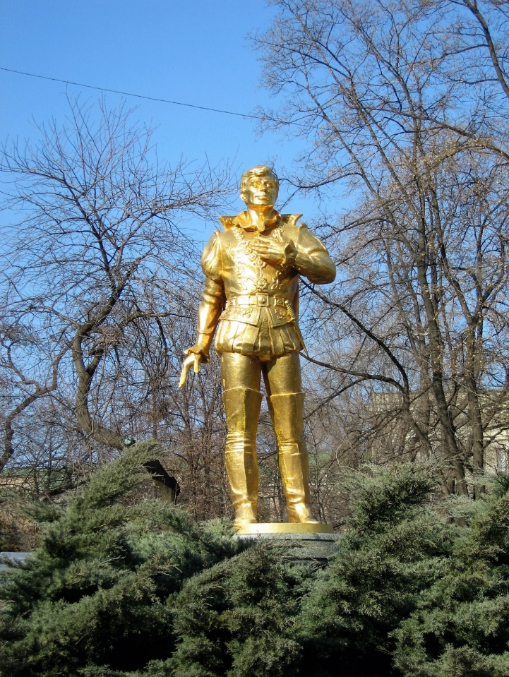

Order Romeo’s measurements from shortest to longest:

………………………………………………………

………………………………………………………

………………………………………………………

………………………………………………………

………………………………………………………

Order Juliet’s measurements from shortest to longest:

………………………………………………………

………………………………………………………

………………………………………………………

………………………………………………………

………………………………………………………

1. Juliet’s sculptor had a 182.5cm length of bronze. Subtracting her height, what length of bronze will be left?
2. How long would the statue of Romeo and the statue of Juliet be if you put them head to toe?
3. Romeo stands on a plinth that is 42.9cm tall. How tall is the statue and plinth together?
4. If the statues stand shoulder to shoulder, how wide would they be?