Multiply the Ingredients for the Wedding Feast

In Act 4, Juliet tells her parents she will marry Paris. Lady Capulet is so excited and demands the servants plan a fabulous feast. They don’t have much time to prepare and need your help to work out the quantities of ingredients that they will need.

For the bread:

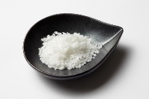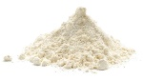

11 x 8g of salt =

8 x 2g of salt =

9 x 9g of flour =

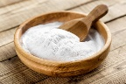

6 x 7ml of warm water =

5 x 6g of baking soda =

7 x 8ml of milk =



For the Soup:

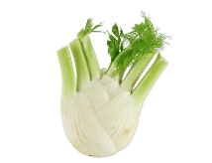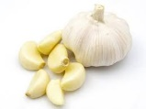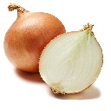

3 x 7g of fennel =

2 x 8g of oregano =

10 x 8g of garlic =

12 x 4g of onion =

9 x 6g of beans =

11 x 4g of fava beans =

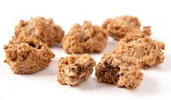

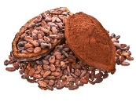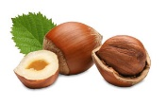For the Bruttiboni(type of cake):

9 x 5g of cocoa =

7 x 7g of vanilla=

8 x 8g of sugar =

6 x 4g of almonds =

7 x 4g hazelnuts =

9 x 8 eggs =