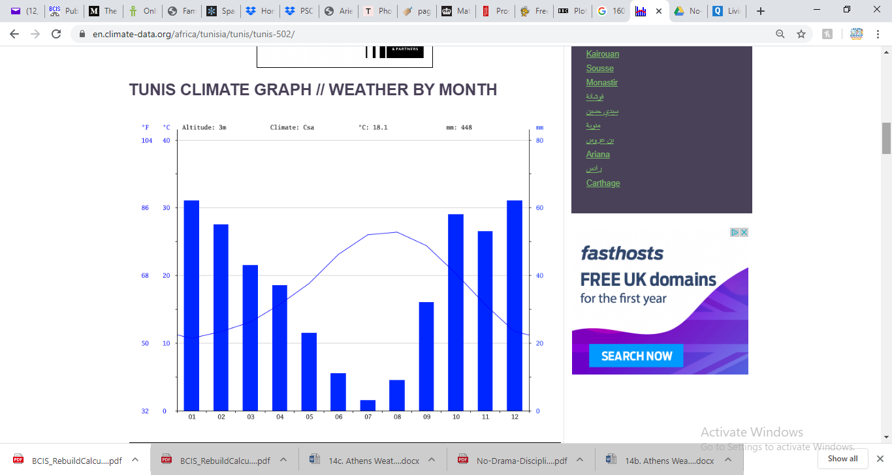 Rainfall in Tunis and Milan

Answer the questions for both cities…

1. How many mm of rain was there on the hottest month?
2. How many mm of rain was there on the coolest month?
3. Approximately, how much rainfall (in mm) was there in January and February?
4. Approximately, how much rainfall (in mm) was there in July and August?
5. Which months do you think are most popular for tourists to visit? Why?
6. In which month was there the biggest difference between rainfall and temperature? What does this mean for plants?
7. What are the main similarities and differences between the companies?
8. Which county would you rather live in? Why?
9. Ask two of your own questions…

