
THE WINTER’S TALE
ACT 1

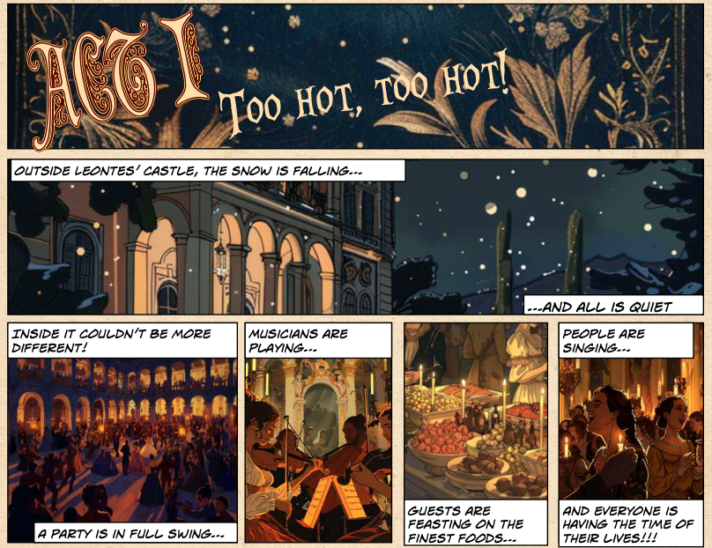

- Where does the story start? Tick one box

Hever Castle Leonte’s Castle

Buckingham Palace A swimming pool

- What is in “full swing”?

________________________________________

- Write down three things that are happening at the party.

________________________________________

________________________________________

________________________________________

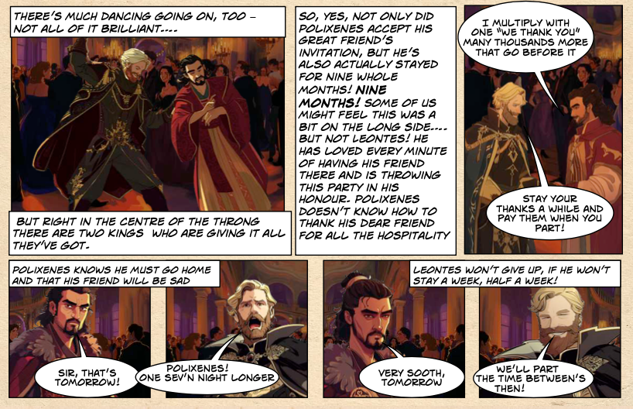

- How long has Polixenes’ been staying with Leontes?
Tick one box

9 days 9 months

9 years 9 weeks

- Where does Polixenes say he needs to go?

_________________________________________________________

- Why? Use a direct quote from the comic

_______________________________________________________

_______________________________________________________

- What-or who- is Leonte’s ‘secret weapon’?

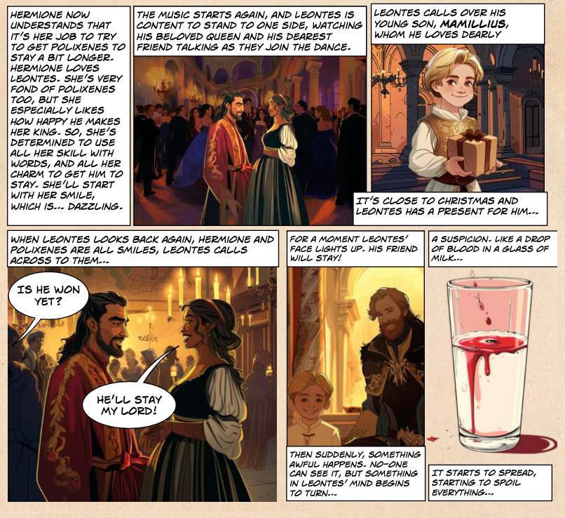

- What word is used to describe Hermione’s smile.
Use the word from the text.

_________________________________

- Is Hermione successful in persuading Polixenes to stay?

___________________

10.What simile Is used to describe the change in Leontes’ feelings?

_______________________________________________________

_______________________________________________________

11.What emotion is Leontes feeling? Tick one

Jealous Angry

Sad Calm
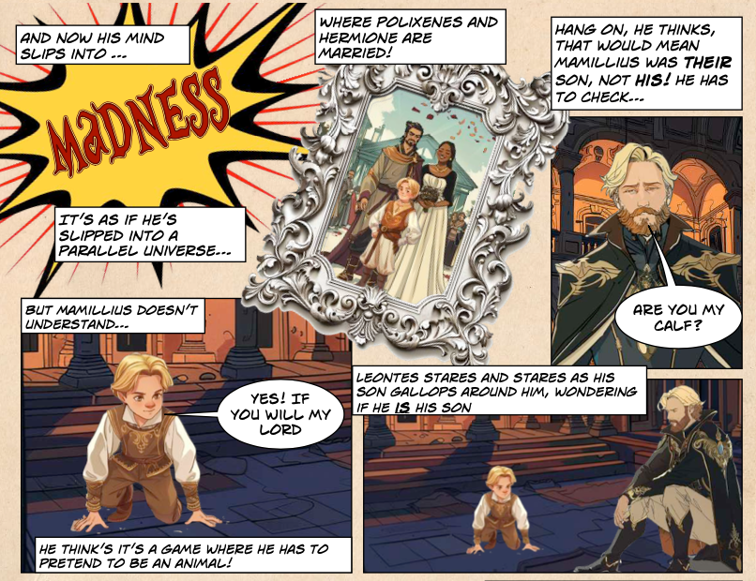

12. What “parallel universe” has Leonte’s mind slipped into?

_________________________________________________________

_________________________________________________________

13. Leontes asks Mamillius if he “is a calf”?
What does Mamillius think?

Tick one box
His dad has gone mad His dad is playing a game

His dad is sad His dad is happy

14. Is Leontes enjoying himself?

YES NO

Explain your answer

_________________________________________________________

_________________________________________________________
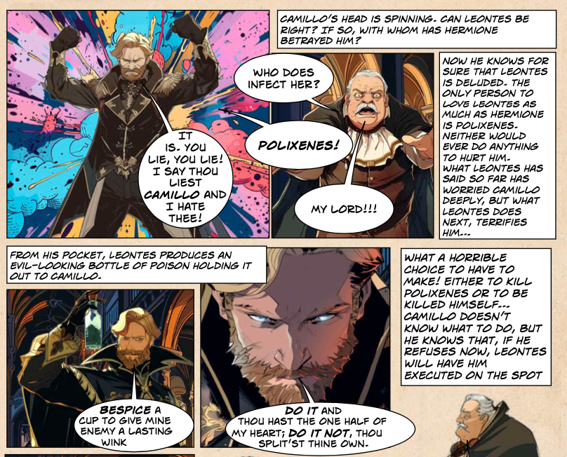

15. Why does Leontes say he hates Camillo?

_________________________________________________________

_________________________________________________________

16. What does Leontes give to Camillo? Tick one box

A book A pencil

A bottle of poison A present

17. What “horrible choice” does Camillo have to make?

a.________________________________________________________

OR

b.________________________________________________________
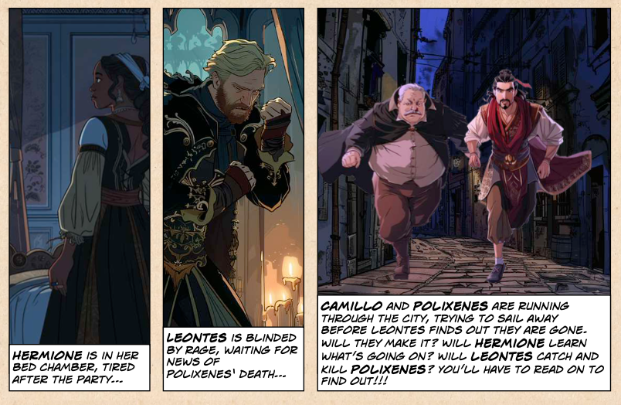

18. Where or what are the following characters at the end of Act 1?

- Camillo and Polixenes are

_____________________________________________________

- Hermione is

_____________________________________________________

- Leontes is

_____________________________________________________

19. Number these events of Act 1 in order.

Hermione persuades Leontes to stay

Polixenes tells Leontes he needs to return home

Camillo helps Polixenes to escape back to Bohemia

Leontes flies into a jealous rage and accuses Hermione of being in love with Polixenes

THE WINTER’S TALE
ACT 1
ANSWERS

- Where does the story start? Tick one box
Leonte’s Castle

- What is in “full swing”?
A party

- Write down three things that are happening at the party.
Musicians are playing
Guests are feasting/eating
People are singing

- How long has Polixenes’ been staying with Leontes?
9 month

- Where does Polixenes say he needs to go?
Home to Bohemia

- Why? Use a direct quote from the comic
“ My affairs do even drag me homeward”

- What-or who- is Leonte’s ‘secret weapon’?
Hermione

- What word is used to describe Hermione’s smile.
Use the word from the text.

“dazzling”

- Is Hermione successful in persuading Polixenes to stay?
YES

10.What simile Is used to describe the change in Leontes’ feelings?
“Like a drop of blood in a glass of milk”

11.What emotion is Leontes feeling? Tick one

Jealous

12. What “parallel universe” has Leonte’s mind slipped into?
One where Hermione and Polixenes are married!

13. Leontes asks Mamillius if he “is a calf”?
What does Mamillius think?

Tick one box
His dad is playing a game

14. Is Leontes enjoying himself?

NO

Explain your answer
He is consumed by jealousy and paranoia- he thinks that Hermione and Polixenes are in love/he thinks that Polixenes is Mamillius’ father

15. Why does Leontes say he hates Camillo?
Because he won’t believe Leontes/ doesn’t think that Hermione is in love with Polixenes

16. What does Leontes give to Camillo? Tick one box
A bottle of poison

17. What “horrible choice” does Camillo have to make?
A. To kill Polixenes of
OR
B. Be killed himself

18. Where or what are the following characters at the end of Act 1?

- Camillo and Polixenes are running through the city/trying to escape
- Hermione is in her bedroom/bed chamber
- Leontes is waiting for news of Polixenes’ death

19. Number these events of Act 1 in order.

Hermione persuades Leontes to stay 2

Polixenes tells Leontes he needs to return home 1

Camillo helps Polixenes to escape back to Bohemia 4

Leontes flies into a jealous rage and accuses Hermione of being in love with Polixenes 3

