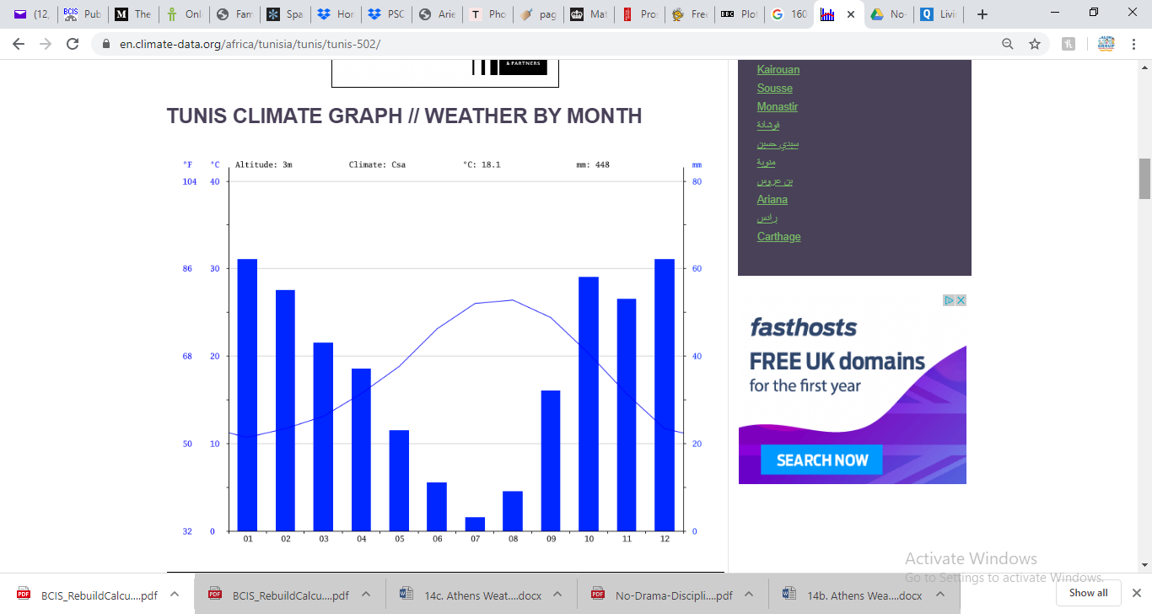 Rainfall in Tunis and Milan

Answer the questions for both cities…

1. How many mm of rain was there on the hottest month?
2. How many mm of rain was there on the coolest month?
3. Which months do you think are most popular for tourists to visit? Why?
4. In which month was there the biggest difference between rainfall and temperature? What does this mean for plants?
5. What is the mean rainfall for each season? (Winter, Spring, Summer, Autumn)
6. What is the mean temperature for each season?
7. What is the mean rainfall in the year?
8. What is the mean temperature in the year?
9. What are the main similarities and differences between the countries?
10. Which county would you rather live in? Why?
11. Ask two of your own questions…

