Multiply the Ingredients for the Wedding Feast

In Act 4, Juliet tells her parents she will marry Paris. Lady Capulet is so excited and demands the servants plan a fabulous feast. They don’t have much time to prepare and need your help to work out the quantities of ingredients that they will need.

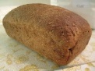For the bread:

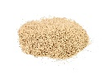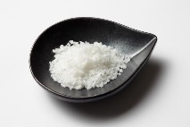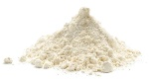

327 x 8g of salt =

311 x 2g of salt =

415 x 9g of flour =

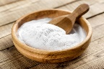

146 x 47ml of warm water =

381 x 16g of baking soda =

421 x 18ml of milk =

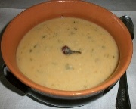

For the soup:

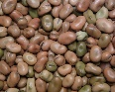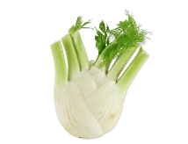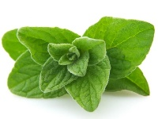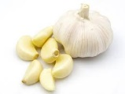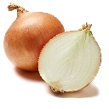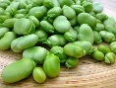

901 x 17g of fennel =

831 x 28g of oregano =

612 x 18g of garlic =

591 x 42g of onion =

651 x 61g of beans =

508 x 54g of fava beans =

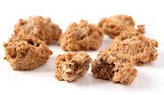

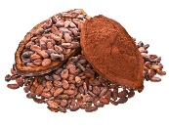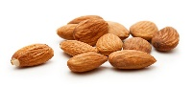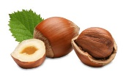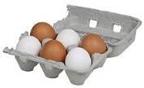For the bruttiboni (cake):

2421 x 55g of cocoa =

2160 x 94g of vanilla=

3187 x 38g of sugar =

1923 x 64g of almonds =

2012 x 73g hazelnuts =

1171 x 28 eggs =