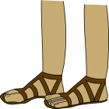
Roman Shoe Problems
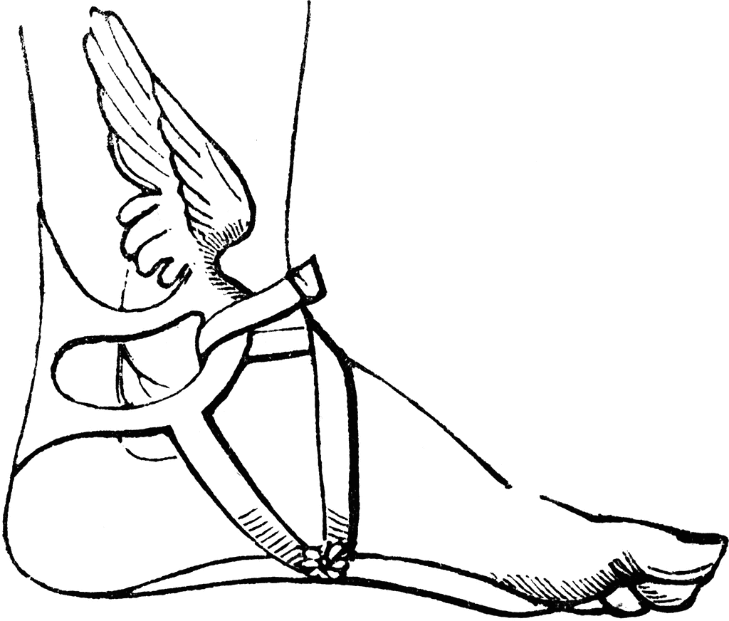
- The cobbler is trying to work out how many pairs of shoes he’s fixed Autumn. In September, he fixed 345 pairs, in October, 239 pairs and in November, he fixed 304 pairs. How many pairs did he fix altogether?

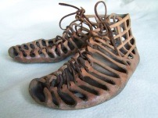
- In his shop, the cobbler has 987 pairs of shoes. He sold 134 and 409 were stolen during a raid. How many pairs does he have left? How many single shoes does he have left?

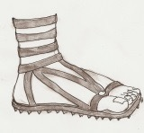
- In Spring, the cobbler makes 129 pairs of grey shoes, 189 brown shoes and 540 black shoes, How many shoes does he make altogether?

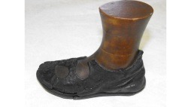
- The cobbler made 345 pairs shoes in July and 239 pairs of shoes in August but he wasn’t happy with the quality of 98 pairs so he threw them in the bin. How many did he have left?

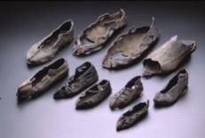
- The cobbler is tired. Today, he’s mended half of the 410 pairs of shoes he has to do. He manages another 80 before bedtime. How many shoes did he mend?


- The cobbler needs 186m of brown leather, 302m of grey leather and 921m of black leather. He gives 128m of the leather to the cobbler in the next village. How much does he have left?

- The cobbler makes 145 drachmas in Winter, 234 drachmas in Spring, 304 drachmas in Summer and 220 drachmas in Autumn. He has to pay for his materials, which cost 408 drachmas for the year. How much has he made?

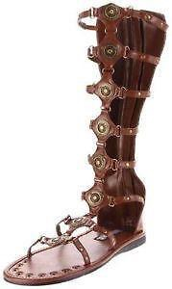
- Caesar orders 146 army boots but the cobbler only manages to make 78. Caesar orders another 68. This time the cobbler makes 10 more than the order. How many boots does Caesar end up with?

