
THE WINTER’S TALE
ACT 5

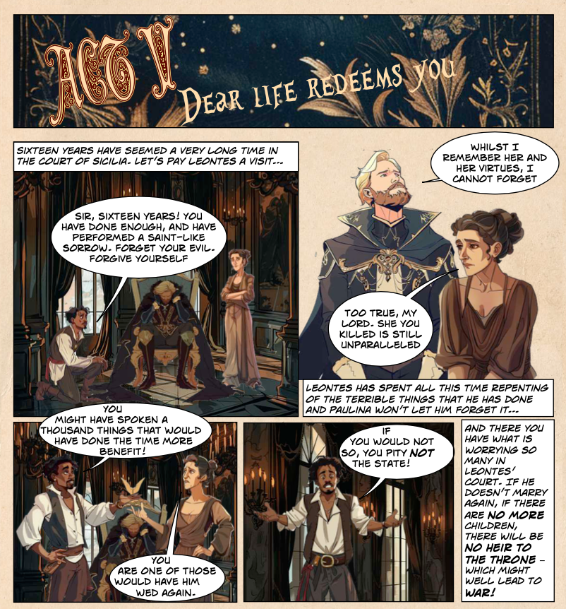

- What has Leontes spent the last 16 years doing? Tick one box

Being angry

Regretting all the terrible things he’s done

Thinking about Polixenes

Playing golf

- Who won’t let him forget about all the terrible things he did?

Hermione Paulina

Antigonus Florizel

- What are people worried about?

_______________________________________________________

_______________________________________________________

_______________________________________________________
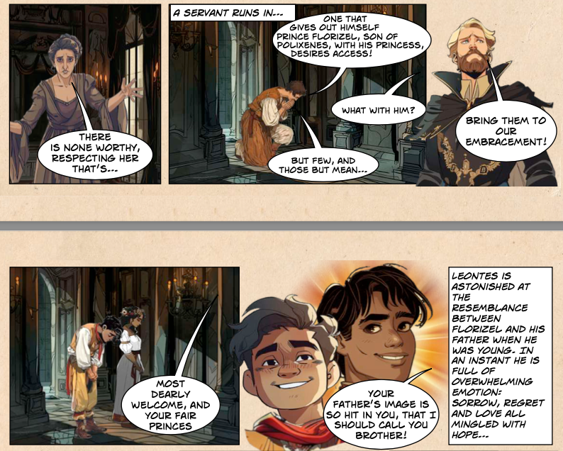

- Who enters the court?

____________________________________________

- What emotions does Leontes’ feel when Florizel enters?
Write down three words, directly from the text
i.__________________________

ii__________________________

iii__________________________
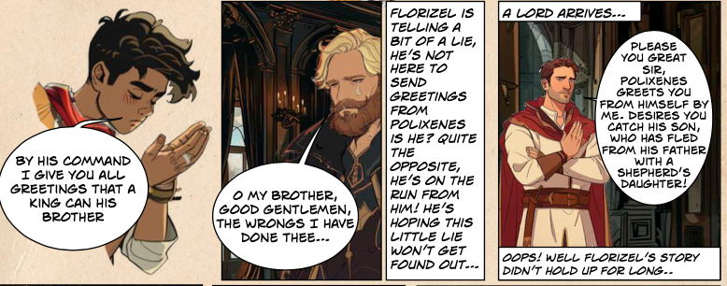

- What lie does Florizel tell Leontes?

He’s come to send greetings from Polixenes

He’s come to start a war

He’s come with lots of money for Leontes

- Why do you think Florizel tells this lie?

_______________________________________________________

_______________________________________________________

_______________________________________________________

- What happens when “A LORD ARRIVES”?
Tick TWO boxes

He tells Leontes that Polixenes is here to catch his son

He tells Leontes Polixenes is here to start a war

Leontes realises he is still cross with Polixenes

Leontes realises Florizel has been lying

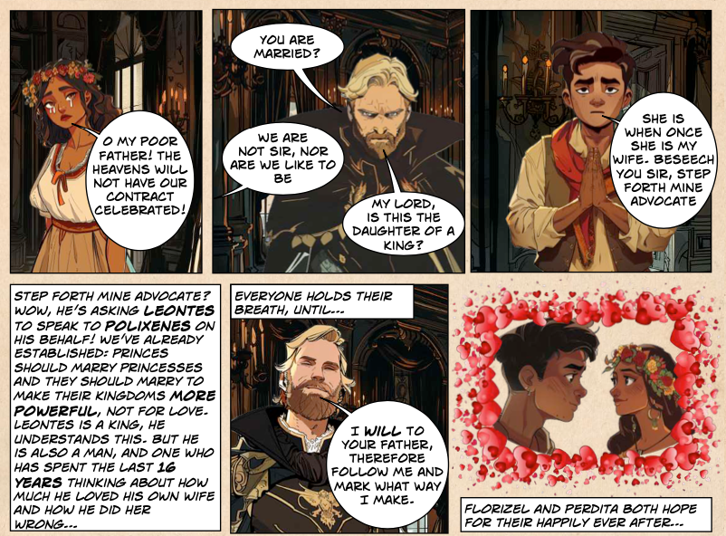

- Why is it believed that princes should marry princesses?
Use a direct quote from the text

_______________________________________________________

_______________________________________________________

_______________________________________________________

- Why does Leontes agree to help Florizel and Perdita? Tick one box

Because Perdita is his daugher

Because he’s a kind man

Because he’s spent the past 16 years thinking about how much he loved his own wife

Because he likes the clothes Florizel is wearing

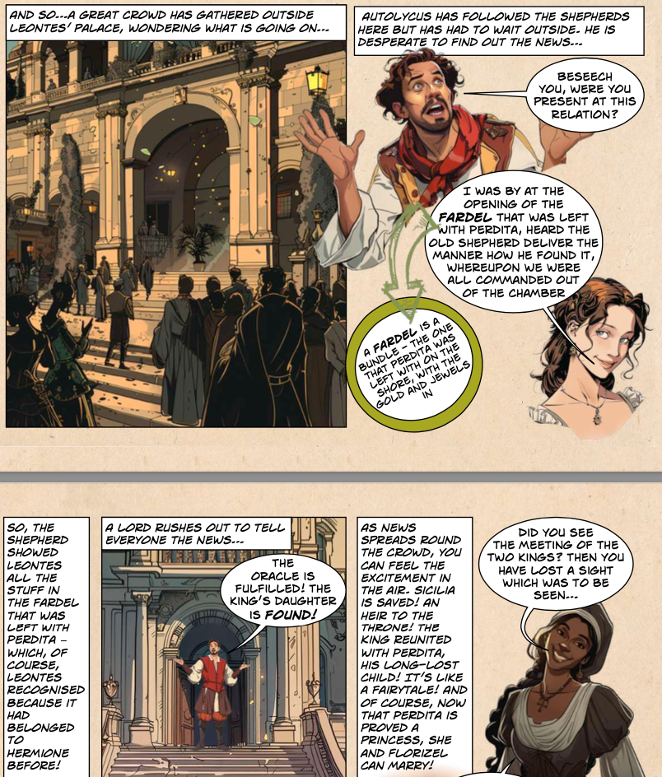
- What is a ‘fardel’? Tick one box

A servant A musical instrument

A bundle A suitcase

- Why was it so important that the shepherds showed the ‘fardel’ to Leontes?

_______________________________________________________

_______________________________________________________

_______________________________________________________

- Write down three reasons why the crowd outside the palace were so excited?
i.___________________________________________________

ii___________________________________________________

iii__________________________________________________
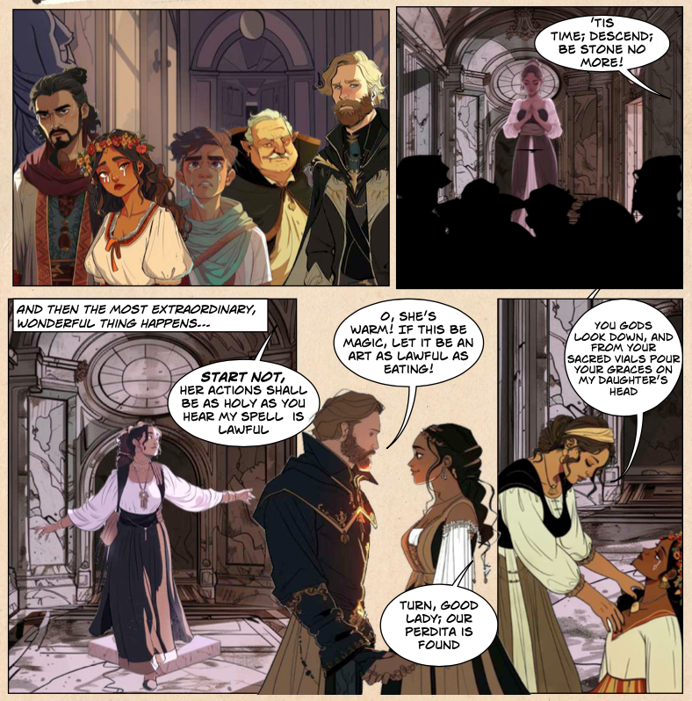

- Write down the phrase that Paulina says to ‘wake’ the statue

_______________________________________________________

_______________________________________________________

- Put these events from Act 5 in order

The shepherds show Leontes the things that were left with Perdita.

Florizel and Perdita arrive at Leonte’s palace.

Leonte’s recognises Florizel.

The ‘statue’ of Hermione comes alive

Leontes and Polixenes become friends again.

. Everyone lives happily ever after.
THE WINTER’S TALE
ACT 5
ANSWERS
- What has Leontes spent the last 16 years doing? Tick one box
Regretting all the terrible things he’s done

- Who won’t let him forget about all the terrible things he did?
Paulina

- What are people worried about?
That there won’t be an heir to the throne and then war may break out

- Who enters the court?
Florizel and Perdita
- What emotions does Leontes’ feel when Florizel enters?
Write down three words, directly from the text
Sorrow/regret/love or hope

- What lie does Florizel tell Leontes?
He’s come to send greetings from Polixenes

- Why do you think Florizel tells this lie?
Because he wants Leontes to help him and Perdita marry

- What happens when “A LORD ARRIVES”?
Tick TWO boxes
He tells Leontes that Polixenes is here to catch his son
Leontes realises Florizel has been lying

- Why is it believed that princes should marry princesses?
Use a direct quote from the text
“princes should marry princesses to make their kingdoms more powerful, not for love”

- Why does Leontes agree to help Florizel and Perdita? Tick one box
Because he’s spent the past 16 years thinking about how much he loved his own wife

- What is a ‘fardel’? Tick one box
A bundle

- Why was it so important that the shepherds showed the ‘fardel’ to Leontes?
Because he then recognised the belongings as they had belonged to Hermione and realised who Perdita really was

- Write down three reasons why the crowd outside the palace were so excited?
Sicilia was saved
An heir to the throne had been found
The King was reunited with his long lost child
- Write down the phrase that Paulina says to ‘wake’ the statue
Tis Time; Descend; Be stone no more!

- Put these events from Act 5 in order
Florizel and Perdita arrive at Leonte’s palace.
Leonte’s recognises Florizel.
The shepherds show Leontes the things that were left with Perdita.
Leontes and Polixenes become friends again.
The ‘statue’ of Hermione comes alive.
Everyone lives happily ever after.

