ACT 3: Newspaper Report

Summary of Act 3:

Olivia’s Confession
OIivia meets ‘Cesario’ and confesses her love for ‘him’.

Sir Andrew
Sir Andrew realises that Olivia is not interested in him so he decides to leave. He is then convinced by Sir Toby and Fabian to challenge ‘Cesario’ to a duel.

In Yellow Stockings and Smiling
OIivia sends for Malvolio and is shocked to see him wearing yellow stockings and smiling at her (everything that is asked of him in the letter). Maria and Sir Toby use this as an excuse to say that Malvolio has lost his mind and they lock him up in a dark room.

Fight!
Sir Toby tells ‘Cesario’ that Sir Andrew is waiting to fight him. Sir Toby and Fabian go between the two of them telling each of them lies about the other. ‘Cesario’ and Sir Andrew fight each other. Antonio tries to stop them thinking that ‘Cesario’ is Sebastian. Antonio is arrested.

Under Arrest
Antonio arrives just as ‘Cesarioand Sir Andrew begin to fight. Antonio tries to stop them, thinking that he is defending Sebastian. At that moment, officers arrive to arrest Antonio for his past crimes against Orsino. Antonio asks ‘Cesario’ for help but 'Cesario' says that he doesn’t know him.

Week 1 - Lesson 1: Features of a Newspaper Report
Learning Intention | To understand the features of a newspaper report
Key Vocabulary | headline, orientation sentence, main body, photograph, caption
Activities/  Lesson | Starter  - Show children pictures of a selection of different newspapers and ask them to discuss with a partner anything they would expect to see in a newspaper (e.g. an eye-catching headline, paragraphs, direct speech).  - Children share their ideas as the teacher makes a list on a flipchart paper (children should be able to refer to this list later in the lesson.) This will help the children link what they already know about newspapers with their new learning, and will support the children who are less sure of the features of newspaper reports.  Main Teaching  (This part of the lesson should take place in a space for the children to work in groups on the floor).  -Put the children into mixed ability groups of 5. Each group should be given one of the newspaper reports (see resources) and some Post-it notes.  - Ask the children to read through their newspaper report. They should then pick out any features that they think all newspaper reports would have (e.g. headline, orientation sentence, paragraphs).  - Tell them to write each feature on a different Post-it note and stick their post-it notes on the flip-chart paper around the example. Encourage groups who are struggling to use the list created at the start of the lesson.  - Once the groups have been given enough time to find as many features as they can, ask the class to share their findings. Do they want to add any more features to the list made at the beginning of the lesson?  - After this class discussion, each group should swap pieces of paper with a group who have a different newspaper report. They should repeat the activity with their new example and do the following:  - Add in any features they think the other group has missed  - Put ONE tick next to any features they agree with  - If they do not agree with a feature, they should leave it blank but do not remove it.  - Now the children have looked at two different models in detail with their group, they will be working individually.  - Ask the children to walk sensibly around the room and look at the Post-it notes that have been written around the newspaper reports. If they agree with a feature, they should put ONE tick next to it. If they see a feature they do not agree with, they should leave it blank.  - At the end of this activity, collect all the Post-it notes that have been ticked lots of times and stick them onto a board at the front of the classroom.  - Write STRUCTURE on one side of the board and LANGUAGE on the other side of the board. Ask the children to help you sort the post-it notes onto the correct side of the board.  - Review the features the class has come up with and ask them if they think any are missing. Draw out the missing features with reference to the examples the children have read.  - Use the discussions from the lesson, draw out the success criteria for a newspaper report, divided into language and structural features. Display on your working wall display for the children to refer to for the rest of the week.  Below is a list of key features of newspaper reports to support your teaching of this text type:  Structural features:  Headline  Picture/photograph with caption  Orientation paragraph (who, what, where, when)  Further paragraphs giving more detail  Language features:  Passive language  A catchy headline (alliteration, word play, short and snappy)  Direct speech  Time fronted adverbials (Not long after... Later on... At about 11pm...)  Mainly past tense (apart from the headline which is present tense)  Punctuation:  Parenthesis to add extra detail
Notes for Teachers | - See ‘Resources’ box below for the preparation for this lesson.  - Class teachers should read and tailor the writing examples provided to suit the needs of the class.
Resources | - Prior to this lesson, you will need to stick an A3 sized example newspaper report (see resources) onto large pieces of flipchart paper. Enough for 6 groups of 5 children.  - https://www.bbc.co.uk/bitesize/topics/z2yycdm/articles/z739whv

Week 1- Lesson 2: Drama
Learning Intention | To understand the key events of the fight
Key Vocabulary | Chronological order, events, hot-seating, eyewitness, statement, quotations
Activities/  Lesson | Warm Up  - Explain to the children that in Act 3, there is a fight scene between Sir Andrew and Cesario and that this week we are going to write a newspaper report about the fight.  - Tell the children the names of the main characters who are part of the fight scene. For each character, show the children an action and tell them a line explaining their role in the fight. (see writing in bold).  - Sir Toby (Olivia’s Uncle): Whispered and gossiped to start the fight  - Sir Andrew: Fought Cesario for Olivia’s heart  - Cesario: Did not want to fight but had no choice!  - Antonio: Thought Cesario was Sebastian and tried to save him  - Police Officers: Recognised Antonio and arrested him  - The children should repeat each action and their role back to you until they have memorised each one.Once they have learnt them, they need to do the action and say the quotation each time you say the name of the character. You could also switch this around. You do the action and say the role, and they have to say the name of the character.  - Encourage the children to use expression in their voices and large actions. (N.B. you will need to think of a simple action for each character). Praise children who are doing this well and ask them to demonstrate to the class.  Main Activity  Part 1: Main Events  - Split the children into groups of 5 and give each group a set of the main events of the fight scene (see resources).  - Ask them to take an event each, read it aloud to their group and order the events in chronological order.  - Once the children have established the order, review the order with the class to check that every group has ordered the events correctly.  - Tell them that each of them will play one of the five characters in the scene (Sir Toby, Sir Andrew, Cesario, Antonio and a police officer) and they have 10 minutes to ask out the scene in the correct order. Encourage the children to use expression, body language and voice to convey feeling.  - Pick a couple of groups to perform for the class.  Part 2: Hot-Seating  - Now that the children have acted out and understand what happened in the fight scene, explain that they will now be acting as journalists doing some research for a newspaper report they are writing about the fight that took place.  - Pick someone to act as an eyewitness. This person should sit on a chair at the front of the class, while the rest of the class (the journalists) sit on the floor facing them.  -The journalists will be asking the guest questions about the party and will need to write down the responses they hear.  - The teacher should first model asking questions to the eyewitness (e.g. What were you doing before the fight started? Who was at the scene?) and then the ‘journalists’ should start to think of their own questions.  - After a few questions, pick a different child to act as a different eyewitness.  - Make sure that children are recording the responses of the eyewitnesses in their books as these will be used as quotations in their newspaper report later in the week. Ask the child acting as the eyewitness to pause after speaking so the children have time to record what is being said.
Notes for Teachers | - You will need to think of a simple action for each character for the warm up activity prior to the lesson
Resources | - Cut up and shuffle the main events of the fight scene (see resources) so that each group has a set

Week 1 - Lesson 3: Headline and Orientation
Learning Intention | To write an effective headline and orientation paragraph
Key Vocabulary | headline, orientation, alliteration. rhyme, present tense, puns
Activities/  Lesson | Starter  - In partners, children should think of as many words as they can based on the following pictures of the fight scene (see resources).  - Ask children to share the words they have come up with and record on the whiteboard. Model using a thesaurus to find synonyms to some words (such as ‘fight’). Children work with a partner to find synonyms for some of the words on the list. Share with each other and add new words to the whiteboard. These words will be used as a word bank to help the children with writing their headline.  Main Teaching  Part 1: Headline  Show children examples of headlines from newspapers and ask them discuss what makes a good headline:  Short and snappy  Eye-catching  Alliteration  Rhyme  Present tense  Puns  - Model using the word bank to think of catchy headlines for the fight. Children work in mixed ability pairs to think of their own headline and record in their books.  Part 2: Orientation Paragraph  - Ask the children what the first paragraph of a newspaper is called (the orientation paragraph). Explain that it is a simple paragraph with only one or two sentences which briefly tells the reader what happened, when it happened, where it happened and who was involved. - Tell the children that it is an important paragraph because it tells the reader what the rest of the report is about and helps them decide if they want to read on or not.  - Children should then work with a partner to have an opportunity to practise writing a clear and simple orientation paragraph using the following keys facts:  When: Wednesday afternoon  Who: Sir Andrew, Cesario  What: duel/fight  Where: at Lady Olivia’s house  - Children share their orientation paragraphs with the class. Highlight good examples/address any misconceptions.  - Having practised writing a paragraph in pairs, the children should now write their own orientation paragraph for their newspaper report on the fight, using the following success criteria to support them:  - Past tense  - Only one or two sentences  - State the key facts (4 Ws)  - Some details to arouse the reader’s interest  - Ask children to share their orientation paragraphs. Other children to say whether it is a successful orientation paragraph with reference to the success criteria.
Notes for Teachers | - The success criteria should be accessible to the children when they are writing the orientation paragraph.
Resources | - Prepare a bank of effective headlines

Week 1 - Lesson 4: Main Body
Learning Intention | To use appropriate language to write the main body of a newspaper report
Key Vocabulary | passive voice, formal tone, fronted adverbials,
Activities/  Lesson | Starter  - Display the newspaper report examples (see resources) and ask the children to work in pairs to pick out sentence starters that they could ‘magpie’ to use in their own newspaper report (e.g. It has been reported that... Sources suggest...)  - Children to share the sentence starters they have identified and the teacher records them on the whiteboard.  Main Teaching  Part 1: The Passive Voice  - Remind children on any work they have done in grammar lessons on the passive voice (i.e. when the subject of the sentence has the action ‘done’ to it). You might like to play the following clip as a reminder:  https://www.bbc.co.uk/bitesize/topics/z4hrt39/articles/zkttng8  - Discuss how newspaper reports often use the passive voice to make the writing sound formal and impersonal.  - Show children a selection of sentence starters and ask them to sort them into those that use the active voice and those that use the passive voice:  It has been reported that...  Many people think...  Sources suggest...  It has been confirmed that...  It is thought that...  - Ask children to say which sentence starters they think are passive and which ones they think are active, explaining their reasons. Then ask them which ones they could use in their report and give their reasons.  - Promote discussion using the following questions:  Is ‘I think that...’ formal enough? Do we include personal opinions in a newspaper report?  What could be used instead?  Does the passive voice have to be used in every sentence?  Part 2: Fronted Adverbials of Time  - Now ask the children to think back to the drama activity when they acted out the fight scene in lesson 2. What were the main events of that evening? (see resources)  - Remind children that, in the next paragraphs, they need to report what happened during the fight scene, using time fronted adverbials to help them structure their paragraph. Show the children the following list and ask them to suggest others:  Later on...  At approximately 3pm...  Not long after…  Before long…  In no time at all…  - Make sure that both the formal sentence starters (including the passive ones) from the beginning of the lesson and the time fronted adverbials are displayed somewhere in the classroom to help the children write the next section of the newspaper.  - Now model/share writing the first few sentences of the next paragraph, giving more detail about the events of the night. Ask children to help you once you have modelled the first sentence.  - Ask the children what they need to include in their writing to make it successful (past tense, passive and formal language, time fronted adverbials, further details about the party, carefully chosen adjectives to interest the reader) and then ask the children to write the next few paragraphs of their own report.  - Editing: At the end of the lesson, the children should read their paragraph to a partner to help them edit their work. They should look out for missing words and punctuation as well as making sure their writing makes sense.
Notes for Teachers | - Make sure that both the formal sentence starters (including the passive ones) from the beginning of the lesson and the time fronted adverbials are displayed somewhere in the classroom to help the children write
Resources | - It would be useful to create word mat with common vocabulary and sentence starters for the children to refer to when writing.  - Newspaper examples (see resources)

Week 1 - Lesson 5: Witness Statement and Publishing
Learning Intention | To use speech marks correctly to report direct speech.
Key Vocabulary | eyewitness statement, quotation, speech marks, parenthesis, commas,
Activities/  Lesson | Main Teaching  - Ask children to look back at the notes they made at the end of the drama lesson earlier in the week. Explain that they should pick two quotations that they are going to include in their next paragraph.  - Ask a few children to record their two quotations on their individual whiteboard and then ask some children to share the examples they have chosen.  Examples:  - Everyone was shocked to see the two of them fighting!  - We heard a lot of shouting so the other servants and I ran out into the courtyard. None of us could believe our eyes.  - I’ve heard from different people that Sir Andrew challenged Cesario to duel out of jealousy and his love for Lady Olivia.  - Then ask the children to think of an appropriate name for each of their eyewitnesses and their relationship to the main characters in the play.. They should also record this on their whiteboard.  e.g.  Maria – Lady Olivia’s maid  Sir Toby - Lady Olivia’s uncle  - The children are now ready to write their paragraph with eyewitness accounts, using the information on their whiteboards to help them.  - Model using commas to give extra detail about each guest (parenthesis) and using speech marks around what was said by each eyewitness.  Example:  Maria, a maid to Lady Olivia, witnessed the whole incident . “I couldn’t believe my eyes! It has been years since a fight had broken out in peaceful Illyria.’’ While some were shocked by Sir Andrew and Cesario’s behaviour, others saw it coming. Sir Toby, a good friend to Sir Andrew and Lady Olivia’s uncle, was not surprised at all. “Sir Andrew has always had strong feelings for my niece but it is plain for everyone to see that her heart has been captured by the young Cesario. Love can make people do stupid things!”  - Having modelled a few sentences of this paragraph, draw out the success criteria (commas for parenthesis, speech marks and then ask children to write their own eyewitness paragraph.  - Once the children have written and checked this paragraph, ask some to share their newspaper reports so far.  - Finally, ask the class how they think the report needs to end.  - Direct the children to end their report on what is happening next. What do the police have to say? What are the police planning to do now?  - Children use modelled examples to help them finish their own newspaper.  Publishing  - Once they have edited and checked their whole article, they should publish their reports in an afternoon session, adding appropriate pictures and captions.  - Use the newspaper report template (see resources) and print in A3 for the children to publish on.
Notes for Teachers | - Make sure that children have their work from the hot-seating activity from lesson 2 for this lesson.
Resources | - Print the newspaper report template (see resources) in A3 for publishing.

Resources

Example Newspaper Report 1 (to be edited by class teachers)
(Image - Royal Shakespeare Theatre 1974)

Neighbours Notice Nobleman Fighting
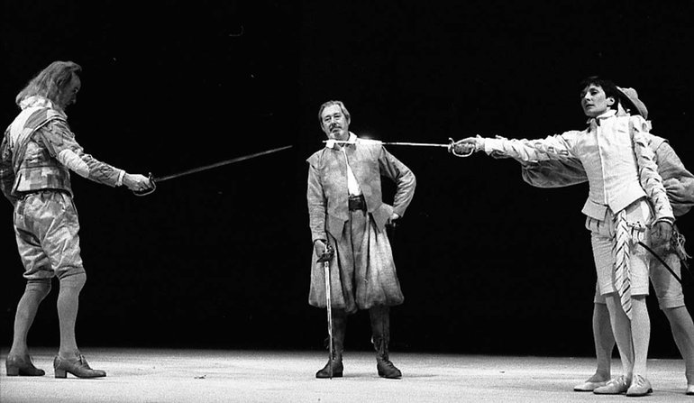
Sir Andrew and Cesario fighting in Lady Olivia’s courtyard

Yesterday afternoon, a brawl broke out at Lady Olivia’s residence between Sir Andrew and Duke Orsino’s page boy, Cesario. The reason for the fighting is unknown however onlookers suspect that the perpetrators were duelling over the noble Lady Olivia.

At 3 o’clock on Wednesday afternoon, a dispute erupted as Sir Andrew challenged Cesario to a duel. According to eyewitnesses, Sir Toby Belch was spotted talking to both men before the fight started. Sources say that Sir Toby was aggravating the situation which eventually led to swords being drawn.

Later on in the day, servants of the household reported that Sir Andrew was the first to draw his sword starting the battle. Neighbours, who were watching from their windows, reported that Cesario only drew his sword after Sir Andrew did in order to defend himself. The men duelled for only a few minutes when a man, thought to be in his twenties, interrupted Sir Andrew and Cesario mid-fight. Almost immediately after the unknown man broke up the fight, police officers arrested the man. Grace Cicero, one of Lady Olivia’s maids, overheard the police officers who arrested the unknown man. “We heard the officers call the man by the name of Antonio and said that he was under arrest for old crimes that he’d committed in Illyria. From what I gather, this man must be a fugitive of some sort!”

The police say that they are still investigating the incident that took place at Lady Olivia’s home and have asked for eyewitnesses to step forward to help the police solve this case.

Example Newspaper Report 2 (to be edited by class teachers)
(Image - George Clint: The Duel between Sir Toby and Sebastian

Foolish Fight Disrupts Peaceful Illyria
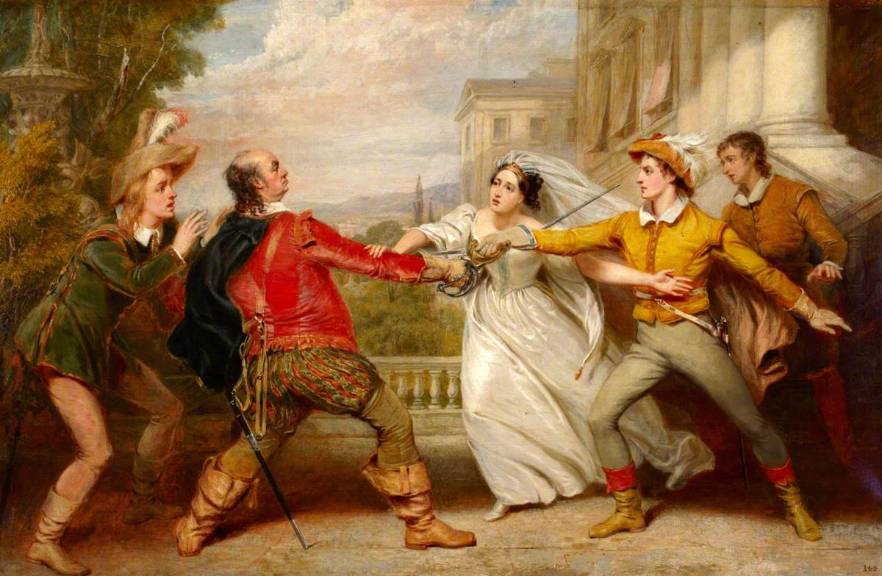
The police are still investigating the cause of the fight which took place on Wednesday afternoon

On Wednesday afternoon, Sir Andrew and Duke Orsino’s page boy, Cesario, were witnessed duelling in Lady Olivia’s courtyard. Police are still investigating and do not yet know why the unruly incident took place.

Reports suggest that Sir Andrew challenged Cesario to a duel out of jealousy. Lady Olivia’s servants reported that, like the Duke, Sir Andrew also has his heart set on marrying Lady Olivia. However, it has been suggested by many that Lady Olivia is madly in love with Cesario and has refused all other marriage proposals. The police are yet to confirm these claims and have asked the public to refrain from gossip while they investigate the case. The duel ended abruptly as an unknown man rushed onto the scene of the fight. He was followed by a large group of police who arrested the man claiming that he is under arrest for several crimes. Neighbours, servants and bystanders were bemused by the commotion.

Sir Toby, Lady Olivia’s uncle and a good friend of Sir Andrew, was at the scene and watched the terrible events unfold. “I am shocked and appalled that Sir Andrew would stoop so low to duel with a page boy! I tried to reason with him and keep him calm but we all know that love can affect people in unexpected ways. It is despicable behaviour.”

The violence that took place on Wednesday is still being investigated by the police. In a bid to keep the streets of Illyria safe, they have issued an official warning that such fighting and disorder will not be tolerated and anyone involved in duelling will be arrested and charged.

Main Events - Fight Scene

Sir Toby takes turns to talk to Sir Andrew and ‘Cesario’- encouraging both of them to fight each other.

Sir Andrew draws his sword to challenge ‘Cesario’ to a duel.

‘Cesario’ does not want to fight but reluctantly draws his sword in defense.

The two men begin to fight but then Antonio enters the scene. He mistakes ‘Cesario’ as Sebastian so wants to save him. Antonio offers to fight Sir Andrew instead.

Several police officers burst onto the scene. They have recognized Antonio -a wanted man in Illyria—and arrested him.

Fight Scene Pictures

George Clint: The Duel between Sir Toby and Sebastian

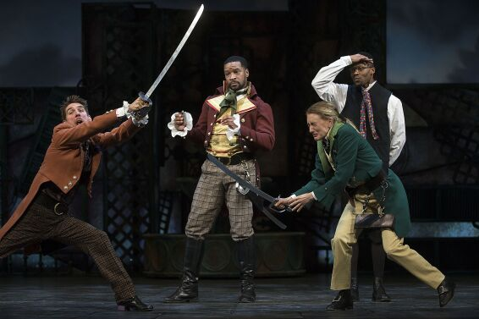
Conner Marx as Sir Andrew Aguecheek, left, Kenajuan Bentley as Sir Toby Belch in Pioneer Theatre Company’s production of William Shakespeare’s “Twelfth Night,”

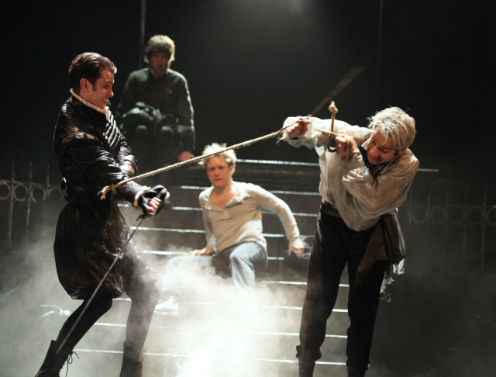
Romeo and Juliet, The Royal Shakespeare Company, Courtyard Theatre, Stratford-upon-Avon

Newspaper Template (print A3)

