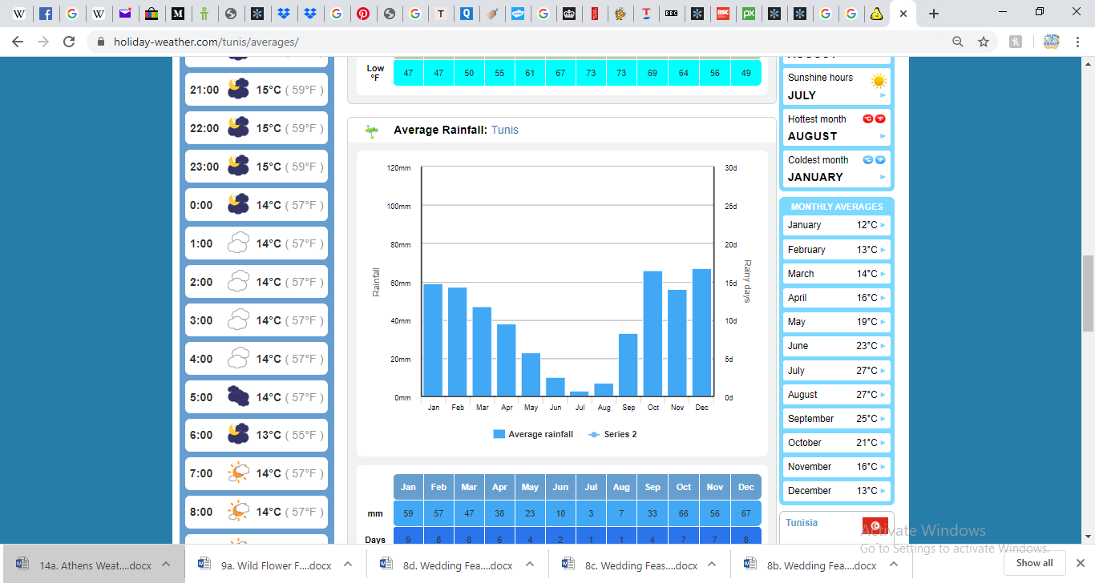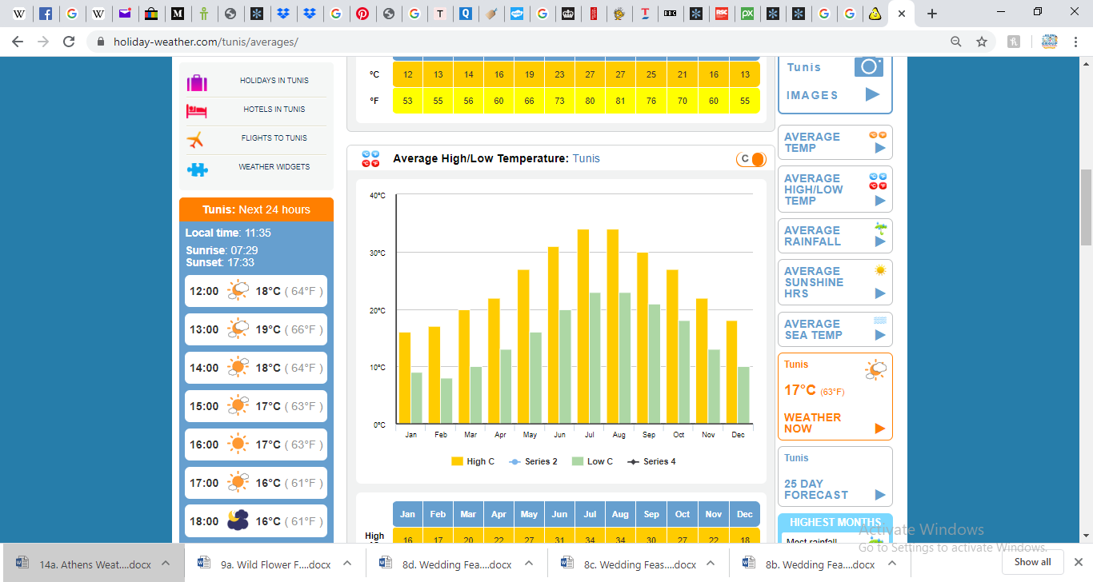Tunis Weather

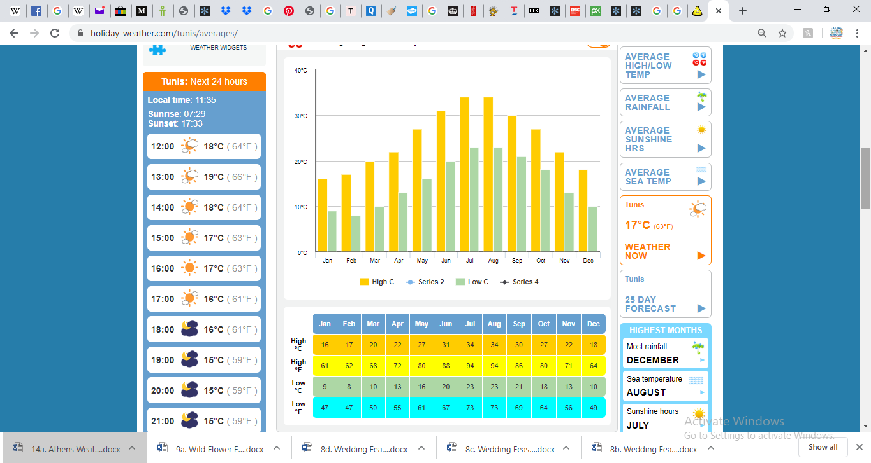

(Answer in ℃ where appropriate)

1. Which was the hottest month?
2. Which was the coolest month?
3. Which month was there 8℃ difference between the high temp and the low temp?
4. Which month had the most number of rainy days? If rain fell equally on each day, how much rain fell per day?
5. How much rainfall was there in June, July and August? Was this the driest season?
6. What’s the mean temperature in the summer months? Was this the hottest season?
7. Does the hottest month have the least rainfall?
8. Doe the coolest month have the most rainfall?
9. Which months do you think most tourists visit Tunis? Why?
10. Which month has the biggest difference in temperature?
11. Ask 2 of your own questions about the table.