
THE WINTER’S TALE
ACT 2

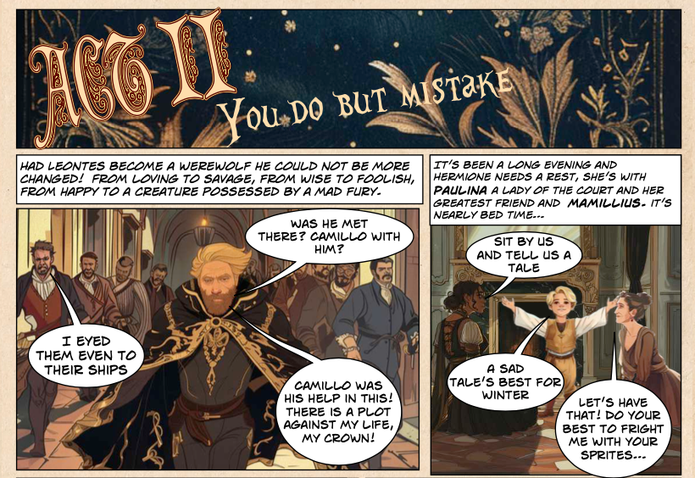

- At the beginning of Act 2 the author describes how Leontes has changed.

Complete each phrase below, using exact words/phrases from the text

From loving to ______________

From wise to ________________

From happy to ______________________________________

- Who is Paulina? Tick 2 boxes

A lady of the court Mamillius’ childminder

Hermione’s greatest friend Leontes’ greatest friend
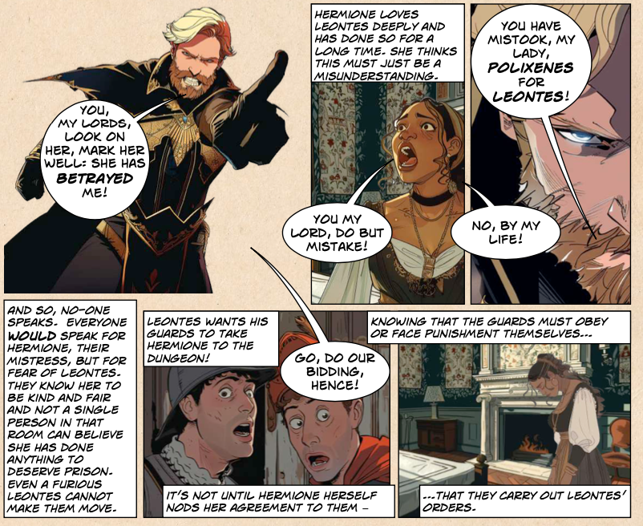

- “YOU, MY LORDS, LOOK ON HER, MARK HER WELL: SHE HAS BETRAYED ME!”

- Who is Leontes talking about here?

_________________________________

- How does Leontes think Hermione has betrayed him?

_______________________________________________________

_______________________________________________________

- What does Leontes’ demand the guards do? Tick 1 box

Take Polixenes away Take Paulina away

Take Hermione to the dungeons Go away themselves

- Who thinks Leonte’s suspicions are right? Write a one word answer

_______________________________________________________
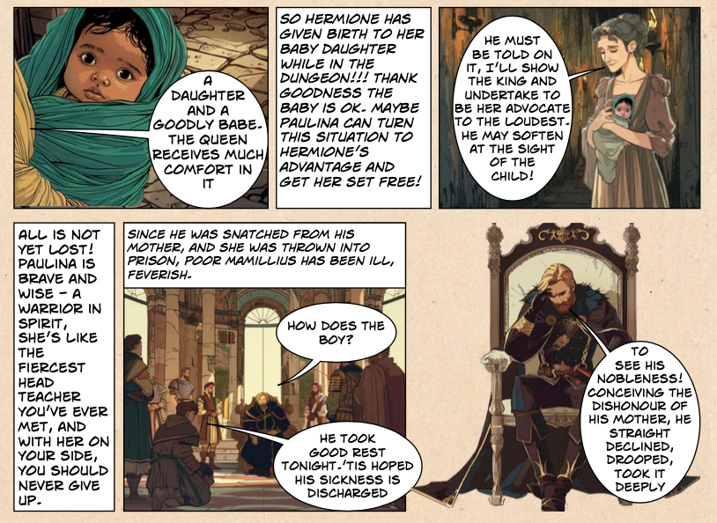

- What happens to Hermione in the dungeon?

____________________________________________________

- Write down two words that are used to describe Paulina in the text

- ________________________________________________

- ________________________________________________

- What has happened to Mamillius since he was “snatched from his mother”? Write down two words from the text

- ________________________________________________

- ________________________________________________

- Why does Leontes think Mamillius has been ill? Tick one box

A reaction to his mum’s dishonest behaviour

Because he stayed up late at the party
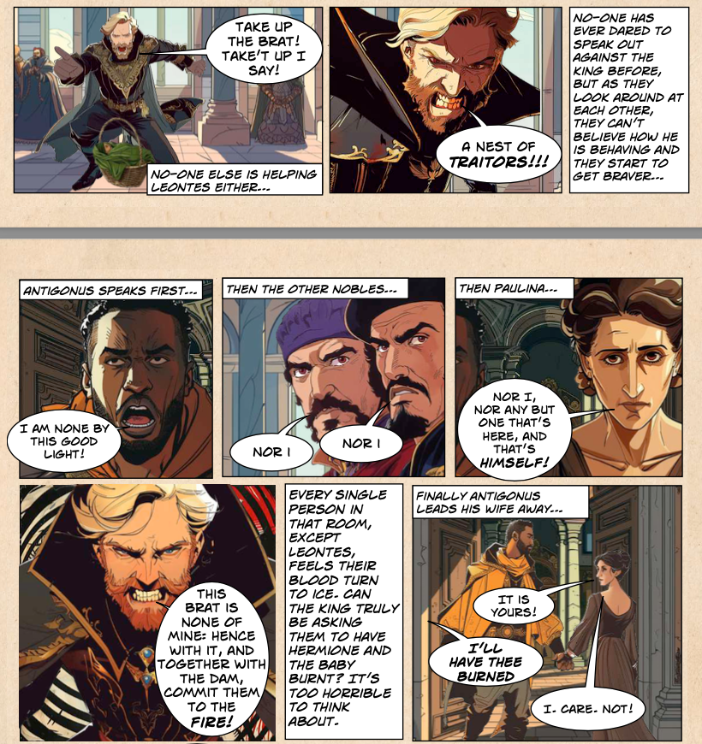

10a. Who is the first to be brave and speak out against Leontes?

____________________________________________________

10b. What do they say? Use a direct quote from the text.

____________________________________________________

____________________________________________________

11.“Every single person in that room, except Leontes, feels their blood turn to ice”
What does this description mean?

____________________________________________________

____________________________________________________

____________________________________________________
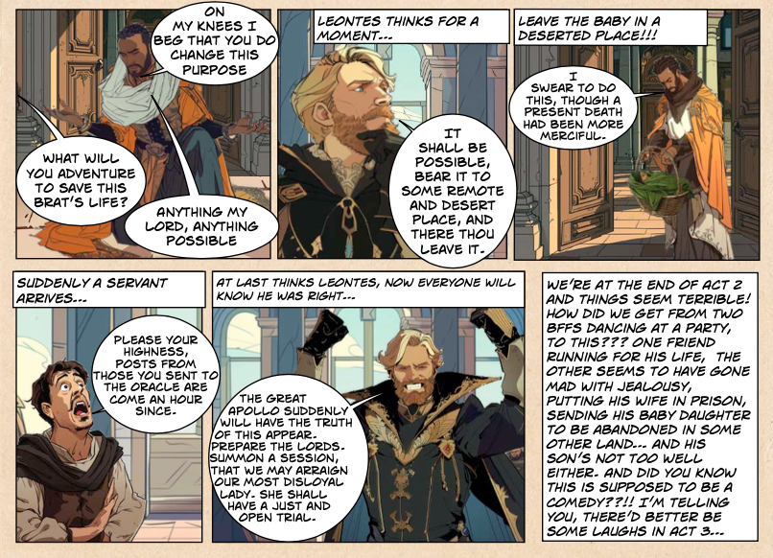

12. What does Leontes’ ask Antigonus to do with the baby?
Tick one box

Take the baby back to Hermione Take the baby to Paulina

Take the baby to a deserted place Take the baby to the party

13. Write three words to describe how Leonte’s is feeling by the end of Act 2

____________________________________________________

____________________________________________________

____________________________________________________

14. Write three words to describe how Hermione is feeling by the end of Act 2

____________________________________________________

____________________________________________________

____________________________________________________
THE WINTER’S TALE
ACT 2
ANSWERS

- From loving to savage
From wise to foolish
From happy to a creature possessed by rage

- Who is Paulina? Tick 2 boxes
A lady of the court
Hermione’s greatest friend

- “YOU, MY LORDS, LOOK ON HER, MARK HER WELL: SHE HAS BETRAYED ME!”
- Who is Leontes talking about here?
Hermione

- How does Leontes think Hermione has betrayed him?
She is in love with Polixenes/cheating on him/having an affair

- What does Leontes’ demand the guards do? Tick 1 box
Take Hermione to the dungeons

- Who thinks Leonte’s suspicions are right? Write a one word answer
NO-ONE
-

- What happens to Hermione in the dungeon?
She give birth to a baby girl
Write down two words that are used to describe Paulina in the text
Brave
Wise

- What has happened to Mamillius since he was “snatched from his mother”? Write down two words from the text
Ill
feverish

- Why does Leontes think Mamillius has been ill? Tick one box
A reaction to his mum’s dishonest behaviour

10a. Who is the first to be brave and speak out against Leontes?
Antigonus

10b. What do they say? Use a direct quote from the text.
I am none by this good light

11.“Every single person in that room, except Leontes, feels their blood turn to ice”
What does this description mean?
Everyone is scared

12. What does Leontes’ ask Antigonus to do with the baby?
Tick one box
Take the baby to a deserted place

13. Write three words to describe how Leonte’s is feeling by the end of Act 2
Answers can-and will- vary but must reflect jealousy, anger, hurt, furious, envious, etc!

14. Write three words to describe how Hermione is feeling by the end of Act 2
Answers can-and will- vary but must reflect worry, hurt, scared, lonely, confused, etc!

