Act 3, Scene 1 starts with Benvolio and Mercutio debating who is more hot-tempered. Then Mecutio is killed by Tybalt. The cast of a Romeo and Juliet play are acting out this scene. They need to work out how the fight props look on stage. With a pencil and ruler, help them by identifying the lines of symmetry in these 2D shapes…

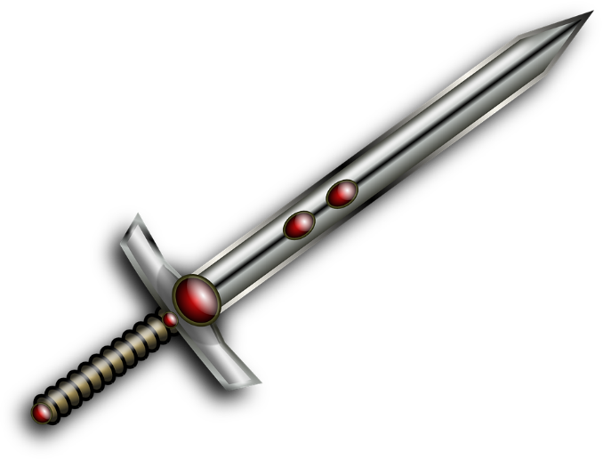



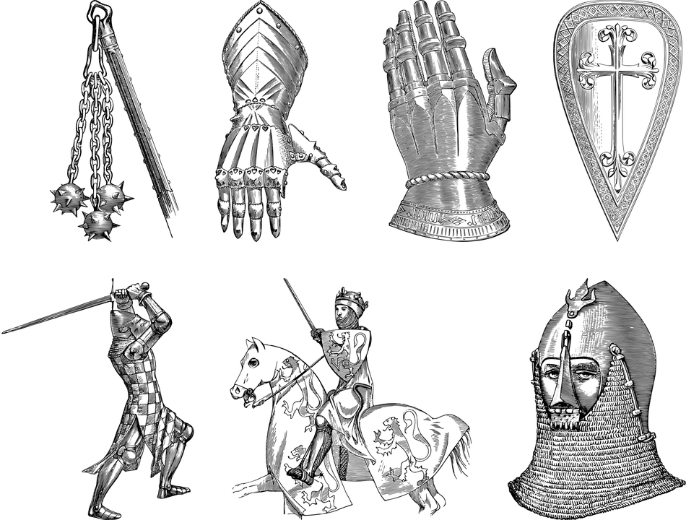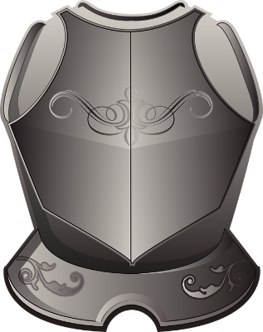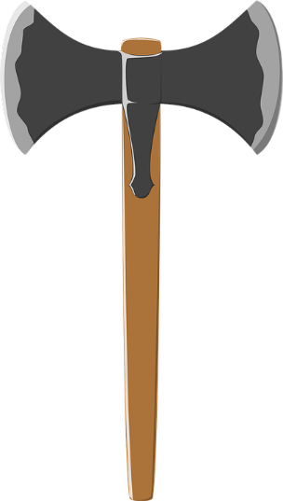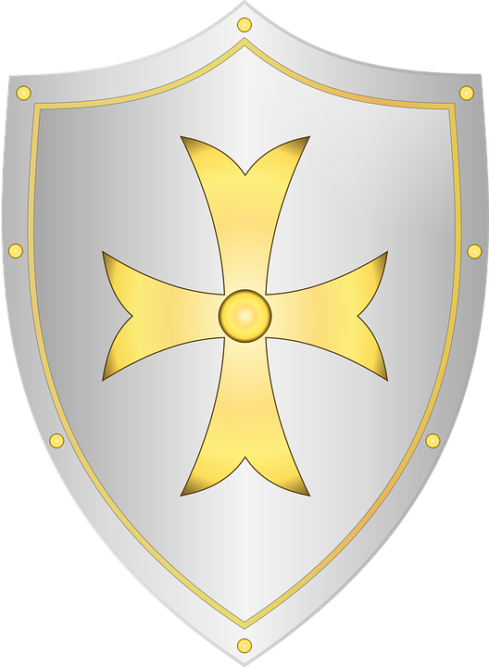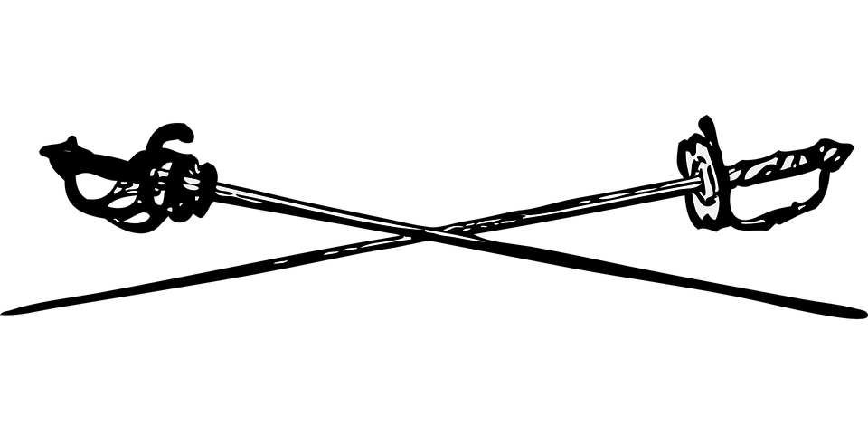

Mercutio’s shield has bent in a duel. Design him another – he’s requested one with two lines of symmetry…