Order the Shipwrecks – Information Sheet
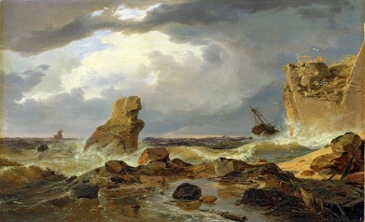
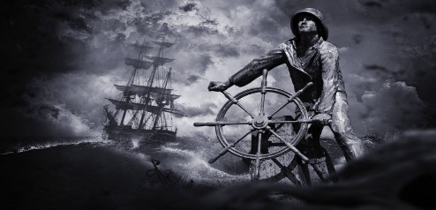
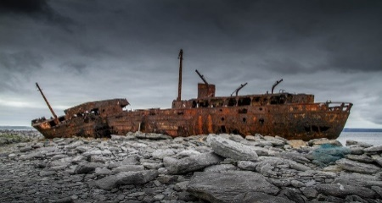

MS WORLD DISCOVERER
The MS World Discoverer was a Danish cruise ship created in 1974. While carrying passengers on a cruise in 2000 it struck a rock at the Solomon Islands, resulting in the ship subsiding. All passengers were escorted safely to another passenger ferry.
NUESTRA SENORA DE LAS MERCEDES
The greatest recovery of treasure was found on the remains of the Spanish warship Nuestra Senora de las Mercedes which sank off Portugal in 1804. In 2007, it was announced that uncovered gold worth an estimated £314 million was found.
MV DONA PAZ
The sinking of the MV Dona Paz from the Philippines in 1987 is remembered in history as the deadliest of all peacetime maritime disasters. A fire and explosion ensued, killing a predicted 4,386 passengers and there were only 24 survivors.
THE QUEEN ANNE'S REVENGE
Queen Anne's Revenge was an 18th century warship mostly known for being the ship of legendary pirate Blackbeard (Edward Teach). First serving in the British Navy, the ship was later captured by the French and then by pirates from 1717 onwards. In 1996 the remains of Queen Anne's Revenge were discovered near North Carolina. So far more than a quarter of a million artefacts have been recovered.
VASA
Vasa is a Swedish warship, believed to have been built in 1628. The ship sank twenty minutes into its maiden voyage on 10 August 1628 after being hit by strong winds and flooding. Sinking less than a mile into its journey, it was regarded as a great embarrassment for the King of Sweden. It was not until 1961 that the shipwreck was successfully recovered, including 30,456 of artefacts.
THE MARY ROSE
The Mary Rose was a Tudor warship commissioned and run during the reign of Henry VIII. Launched in 1511, it served in many battles against France, Brittany and Scotland, and in 1545 it sank during a battle against the French. It was not rediscovered until 1971, and was salvaged in 1982. In addition to the ship's structure itself, over 26,080 artefacts have been recovered.
USS ARIZONA
The USS Arizona was an American battleship built for the US Navy launched in 1915. On 7 December, 1941 USS Arizona was bombed by the Japanese, exploding and sinking. 1,177 crew members and officers were killed. The shipwreck was declared a National Historic Landmark in 1989.
RMS LUSITANIA
RMS Lusitania was a British ocean liner launched in 1906, and made a total of 202 trans-Atlantic crossings before it was torpedoed and sunk by a German U-boat in 1915. Of the 1,962 passengers and crew aboard, 1,191 lost their lives. Causing outrage and shock across the world, some believe it was a major factor in encouraging the US to enter World War II as an ally.
RMS REPUBLIC
The star of Billion Dollar Wreck, the RMS Republic was built in 1903 and operated as a steam-powered ocean liner. It wasn't until 23 January 1909 at 5:30 a.m. that disaster struck, colliding with the Lloyd Italiano liner SS Florida just off Nantucket, Massachusetts and sinking the next day at about 8.40 p.m. A total of six lives were lost. It is estimates that there was $255,700 of gold on the ship- if excavated today it could be worth hundreds of millions of dollars - perhaps even a billion.
RMS TITANIC
The supposedly "unsinkable" ocean liner set sail on its maiden voyage on 10 April 1912 only to hit an iceberg just before midnight on 14 April and sank in less than three hours. Claiming 1,514 lives, it is often remembered as one of the most famous and tragic shipwrecks in history. It wasn't until 1985 that a Franco-American expedition was able to reach the shipwreck, and discovered that it had been split in half - with each half lying within about a third of a mile apart from one another.

Round the Shipwreck Facts (white boxes only)
 | To the nearest 10 | To the nearest 100 | To the nearest 1000 | To the nearest 10,000 | To the nearest 100,000
The predicted number of people killed on the MV Dona Paz
Number of artefacts found on Vasa
Number of artefacts found on The Mary Rose
Number of crew members and officers killed on the ASS Arizona
People on board the RMS Lusitania
People killed on the RMS Lusitania
Lives lost on the RMS Titanic
$ Gold on the RMS Republic

 |  | length  (m) | To the nearest whole number | To the nearest 1 decimal place
RMS Republic | length | 173.7
 | beam | 20.71
 | draft | 10.39
Titanic | length | 269.12
 | beam | 28.28
 | draft | 10.59
MS World Discoverer | length | 87.51
 | beam | 15.12
 | draft | 4.4
VASA | length | 69.7
 | beam | 11.71
 | draft | 4.89

