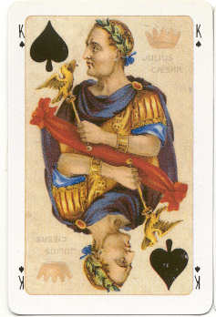
What’s a name worth?
From beyond the grave, Shakespeare’s invented a new game for you to play in class. Each letter
is worth a certain number. Get into pairs and work out how much each name is worth. There are
some examples below to help you.

a=233 b=255 c=101 d=119 e=132 f=136 g=140 h=159 i=320 j=525 k=430 l=652 m=561 n=573 o=584
p=793 q=105 r=111 s=124 t=432 u=549 v=851 w=362 x=177 y=288 z=591
PSC (793 + 124 + 101 = ?)

101
124
+ 793
1018
Examples:

- Caesar
- Brutus
- Cassius
- Antony

- Portia
- Calpurnia
- Casca
- Octavius

- Murellus
- Lepidus
- Cicero
- Flavius

Whose name is worth the most?
Whose name is worth the least?
What is the difference in value between Casca and Portia’s names?
Now, work out what your name is worth…

