Multiplying Storm Ingredients

Prospero creates the tempest, causing his enemies' ship to wreck with the help of Ariel.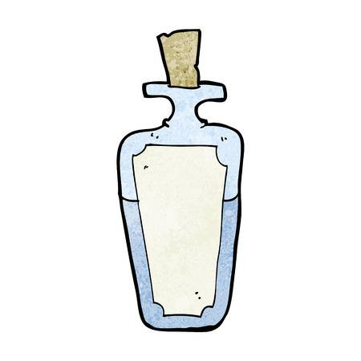

Now Ariel’s fascinated with creating storms and wishes to create an even bigger one. Help him to conjure up spells to try out different storms… Work out how much of each ingredient is needed for the storm potion:



9995 lots of 7098 cow tongues…

1276 lots of 1562 nettles…

1178 lots of 4009 eyeballs…

2837 lots of 1290 frog legs…

3 piles of 4 rubies…

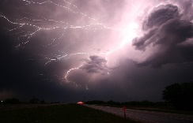



6627 lots of 6018 millilitres of goat bile…

6546 lots of 7100 bull tongues…

1100 lots of 1188 bat wings…

8008 lots of 8127 pig snouts…

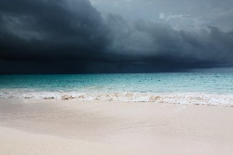



8567 lots of 4019 owl claws…

1298 lots of 4123 goblin teeth…

1982 lots of 1236 pieces of werewolf fur…

6892 lots of 3997 monkey tails…

W

Write 3 multiplication problems about ingredients for your own storm potion. Make them different to the ones above. Ask a peer to solve the problems.