Lesson 3

LI: To write an effective headline and orientation paragraph.
National Curriculum Links

Writing
Pupils should be taught to plan their writing by:
- discussing writing similar to that which they are planning to write in order to understand and learn from its structure, vocabulary and grammar
- discussing and recording ideas

Draft and write by:
- composing and rehearsing sentences orally (including dialogue), progressively building a varied and rich vocabulary and an increasing range of sentence structures

Starter:
In partners, children should think of as many words as they can based on the following pictures

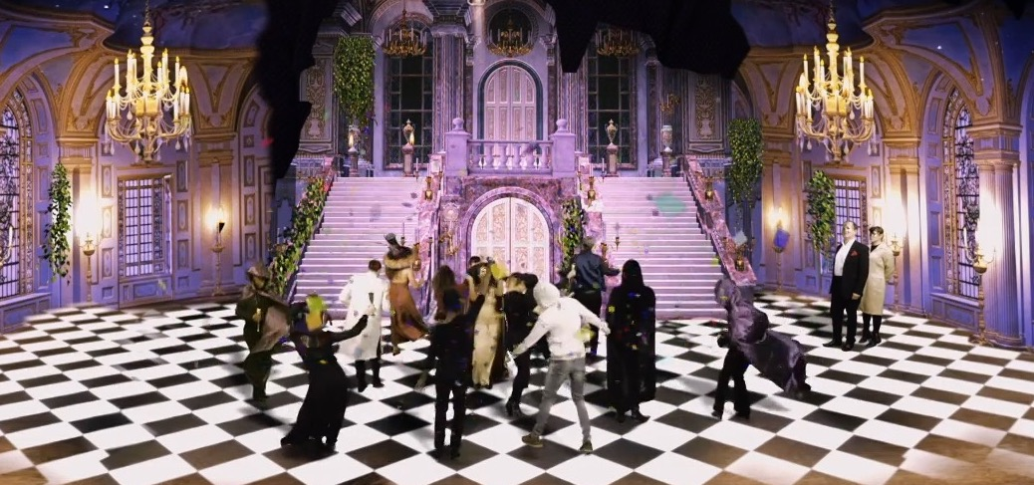

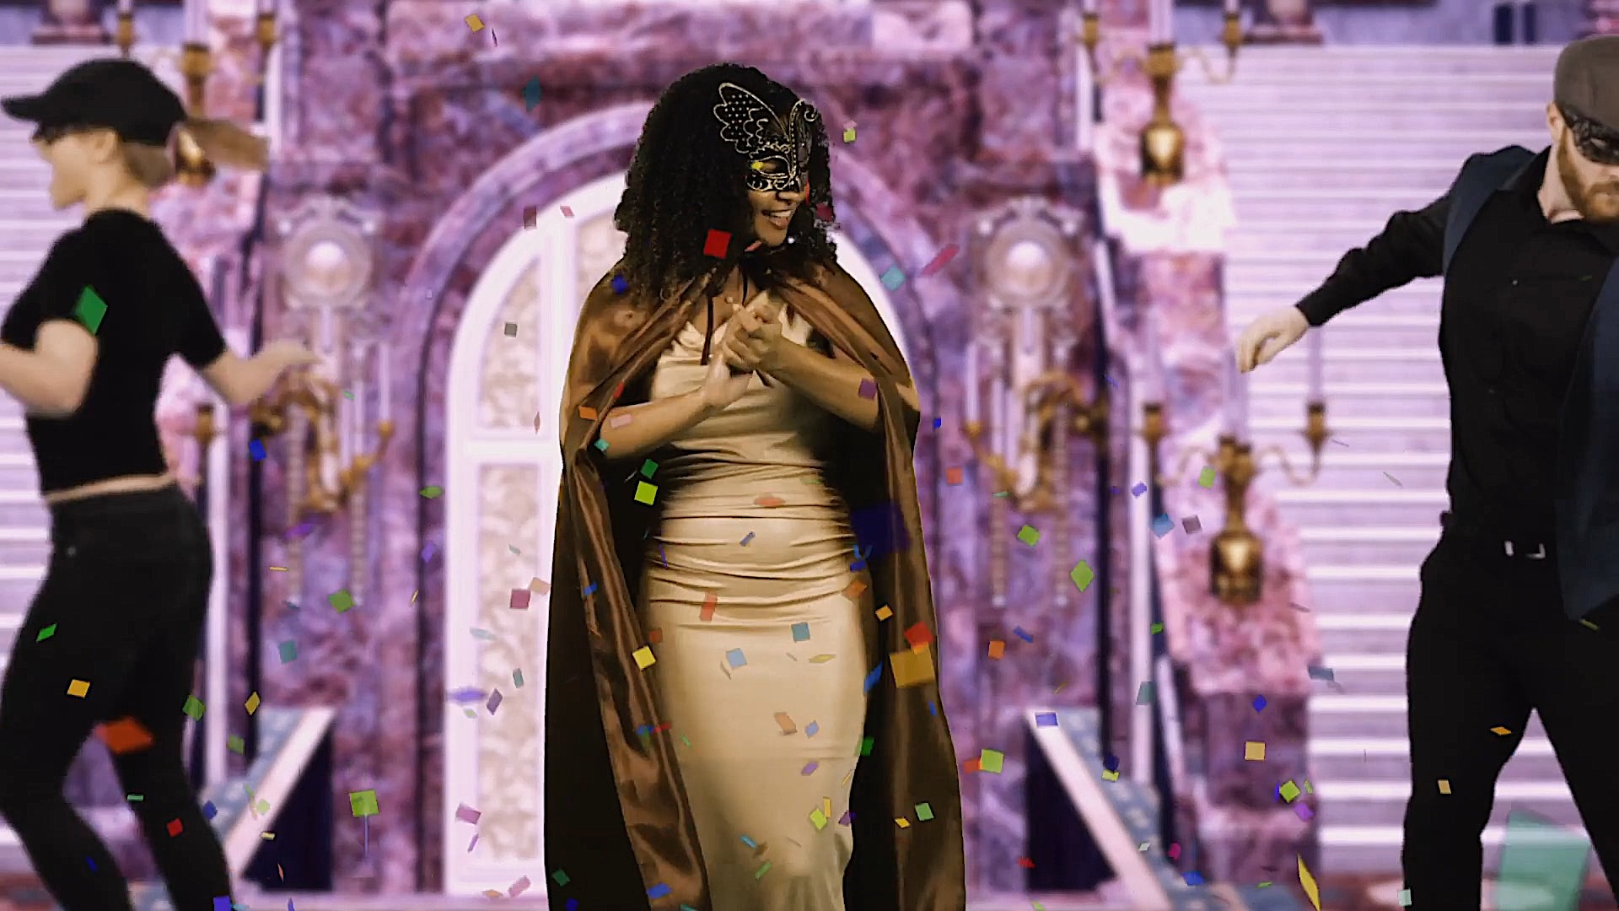

Ask children to share the words they have come up with and record on the whiteboard. Model using a thesaurus to find synonyms to some words (such as party). Children work with a partner to find synonyms for some of the words on the list. Share with each other and add new words to the whiteboard.

These words will be used as a word bank to help the children with writing their headline.

Main Teaching:

Part 1: Headline

Show children examples of headlines from newspapers and ask them discuss what makes a good headline:

https://schools.firstnews.co.uk/blog/journalistic-writing/newspaper-headlines-ks2/

Remind them that headlines should be:

- Short and snappy
- Eye-catching
- In the present tense

Model using the word bank to think of a catchy headline about the Capulet ball. Children work in mixed ability pairs to think of their own headline and record in their books.

Challenge: Can they use alliteration to make their headline more memorable?

Part 2: Orientation Paragraph

Then ask the children what the first paragraph of a newspaper is called (the orientation paragraph). Explain that it is a simple paragraph with only one or two sentences which briefly tells the read what happened, when it happened, where it happened and who was involved. Tell the children that it is an important paragraph because it tells the reader what the rest of the article is about and helps them decide if they want to read on or not.

Children should then work with a partner to have an opportunity to practise writing a clear and simple orientation paragraph using the following keys facts:

When: Monday evening
Who: Tybalt and Mercutio
What: fighting
Where: in the market square

The children share their orientation paragraphs with the class. Highlight good examples/address any misconceptions.

Having practised writing a paragraph in pairs, the children should now write their own orientation paragraphs for their newspaper report on the Capulet ball, using the following success criteria to support them:

- Past tense
- State the key facts (4 Ws)
- Only one or two sentences

E.g. Yesterday evening, Lord and Lady Capulet welcomed over two hundred guests to their home for a masked ball.

Ask children to share their orientation paragraphs. Other children to say whether it is a successful orientation paragraph with reference to the success criteria.

