A Gorgeous Palace
In Act IV, Scene 1, Prospero describes the vision to Ferdinand and Miranda ‘The cloud-capped towers, the gorgeous palaces, The solemn temples…’
Now Miranda decides she likes the sound of a ‘gorgeous palace’ and researches what materials she would need where. Can you help her?
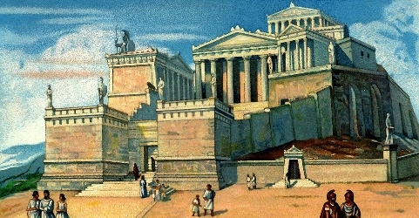
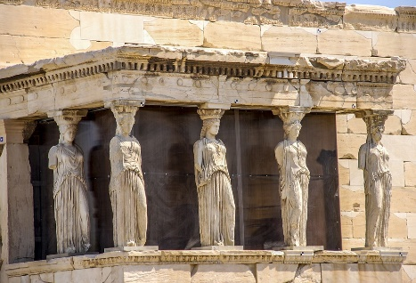
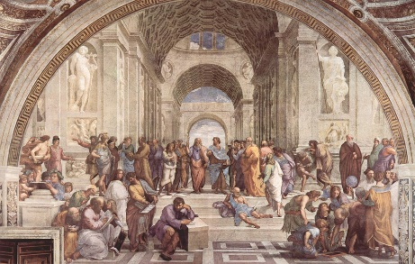
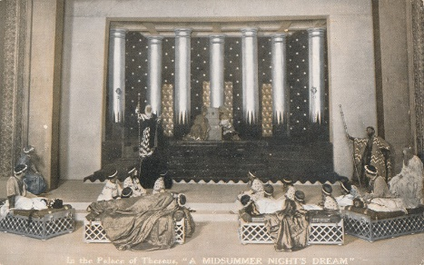
- 49 stones into 7 rooms.
- 72 stones into 9 rooms.
- 40 stones into 5 rooms.
- 60 stones into 5 rooms.
- 120 stones into 10 rooms.
- 132 stones into 12 rooms.
- 81 stones into 9 rooms.
- 48 stones into 8 rooms.
- 36 stones into 9 rooms.
- 32 stones into 8 rooms.
- 25 stones into 5 rooms.
- 21 stones into 3 rooms.
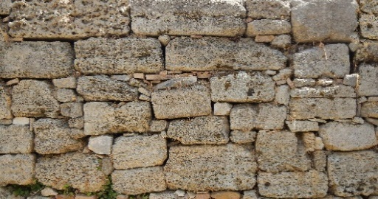
Ferdinand
- 66 stones into 6 rooms.

