A cast are preparing to put on a performance of Romeo and Juliet but first, they need to get the numbers in order…
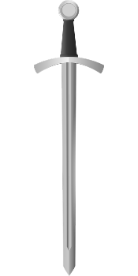
Act 1, Scene 1 - Montague V Capulet brawl
In the first minute of the fight, swords were swung a total of 436 times.
In the second minute of the fight, swords were swung a total of 331 times.
In the third minute of the fight, swords were swung a total of 415 times.
In the fourth minute of the fight, swords were swung a total of 442 times.
In the fifth minute of the fight, swords were swung a total of 397 times.
Order the minute that had the least sword swings to the minute that had the most (write, ‘third minute’).
………………………… ………………………… ………………………… ………………………… …………………………

Act 1, Scene 2 – The Invitation
Peter is asked to deliver invitations to the Capulet feast for Paris to try and win Juliet’s heart.
He takes them to 4 different districts in Verona: Veronetta, Valdonega, Borgo Roma
And San Zeno.
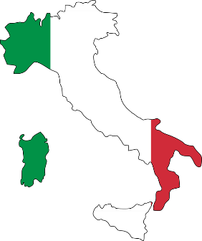
To Veronetta, Peter delivers 189 invitations.
To Valdonega, Peter delivers 191 invitations.
To Borgo Roma, Peter delivers 188 invitations.
To San Zeno, Peter delivers 198 invitations.

Order the districts. Start with the district that had most invitations delivered.

……………………… ……………………… ……………………… ………………………

Act 1, Scene 3, - The Feast – help the cooks to order the food items
- ………………………………………

- ………………………………………

- ………………………………………

- ………………………………………

- ………………………………………

- ………………………………………

- ……………………………………...

- ………………………………………

- ………………………………………

- ………………………………………
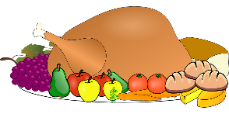
from: 1. Dishes that they need the most of -
10. Dishes that they need the least of

Slices of almond cake 897

Portions of raspberry pudding 682

Bowls of gooseberry fool 719

Bowls of mixed cooked greens 907

Fresh bread rolls 812

Bowls of oxtail soup 504

Roasted venison 754

Boiled mutton 681

Baked pies 779

Oysters 876

