National Curriculum objective:
Describe the changes as humans develop to old age.
Pupils should draw a timeline to indicate stages in the growth and development of humans. They should learn about the changes experienced in puberty.

Working Scientifically:
- recording data and results of increasing complexity using scientific diagrams and labels, classification keys, tables, scatter graphs, bar and line graphs using test results to make predictions to set up further comparative and fair tests
- reporting and presenting findings from enquiries, including conclusions, causal relationships and explanations of and degree of trust in results, in oral and written forms such as displays and other presentations identifying scientific evidence that has been used to support or refute ideas or arguments

Context
Love as a Cause of Suffering
Twelfth Night is a romantic comedy, and romantic love is the play’s main focus. Despite the fact that the play offers a happy ending, in which the various lovers find one another and achieve wedded bliss, Shakespeare shows that love can cause pain. Many of the characters seem to view love as a kind of curse, a feeling that attacks its victims suddenly and disruptively. Various characters claim to suffer painfully from being in love, or, rather, from the pangs of unrequited love.
Viola and Sebastian are portrayed as teenagers. Puberty occurs during teenage years and includes both physical and emotional changes. Puberty is a time of rapid brain development and affects the way teenagers interact with others, their identity and how they express emotions.

Lesson 1
To describe the changes as humans develop to old age.
- Match and create a human timeline with the who, what and when cards (Activity 1a/1b)
- Discuss where Viola and Sebastian would find on that timeline
- Describe the stages of human development

Lesson 2
To explain how babies grow.
- Look at baby Viola and Sebastian- what do we know about babies? Create a mind map/describing frame. (Activity 2)
- Create a scatter graph with the data (Activity 3 and Activity 4)
- Write findings

Lesson 3
To describe and explain the main changes that occur during puberty.
- Go through true and false statements. (Activity 5)
- Complete the Venn diagram looking at differences between boys and girls. (Activity 6)
- Discuss differences between boys and girls (focus on Viola and Sebastian)

Lesson 4
To describe changes that take place in old age.
- Go through myths and facts about old age. (Activity 7)
- Complete the table of physical and other changes- focus on old age (Activity 8)
- Discuss your findings.

Lesson 5
To understand gestation periods.
- Analyse data for life expectancies (Activity 9)
- Research gestation periods and create top trump cards. (Activity 10)
- Complete challenge question. (Activity 11)

Activity 1a

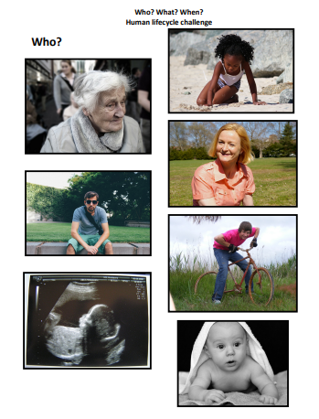
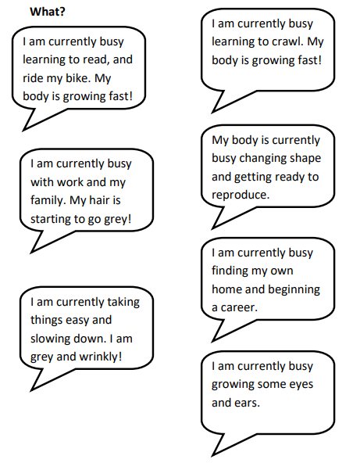

Activity 1b
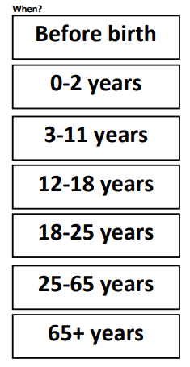

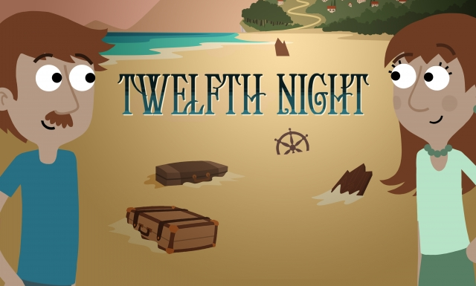

Where would Sebastian and Viola fit on the timeline?

Viola's exact age is never mentioned in the Shakespeare play Twelfth Night; however, she is most often played by a young woman and is portrayed to be in her teens.

Activity 2
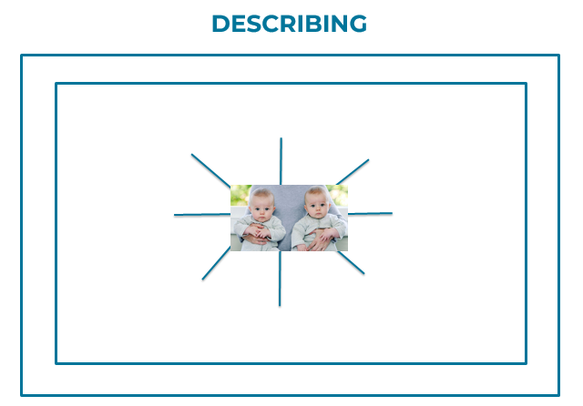
What do we know about babies?

Activity 4
Create a scatter diagram plotting length against mass.
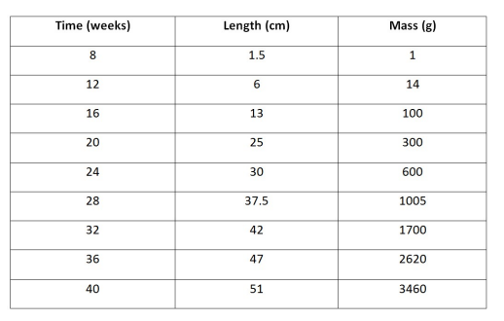
What does the graph line look like? What does this tell us?

Activity 5
True or false statements
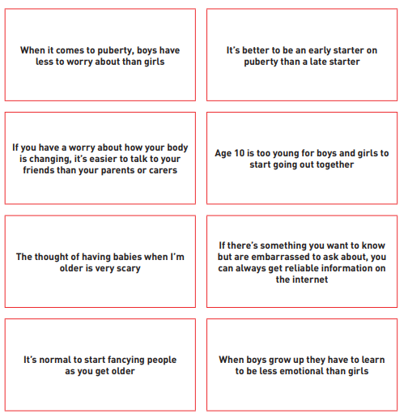

Activity 6-
Difference between Viola and Sebastian
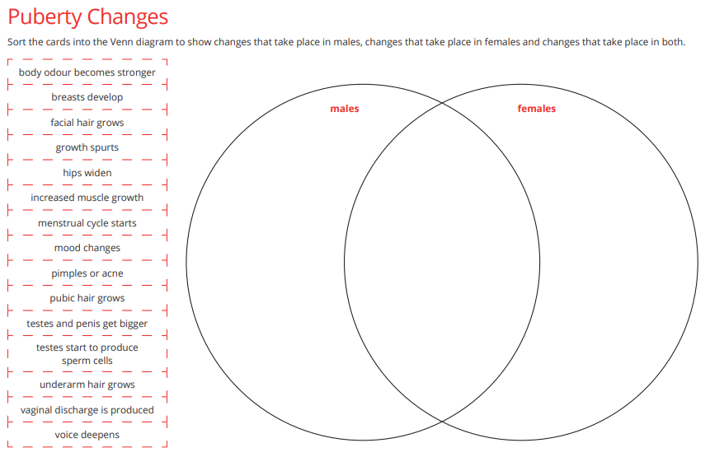

Activity 7
Myths and facts- old age
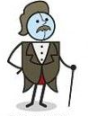
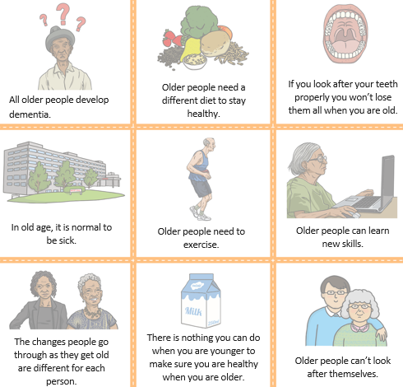

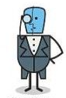

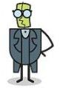
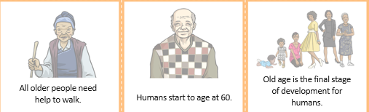

Activity 8
Table of physical and other changes –
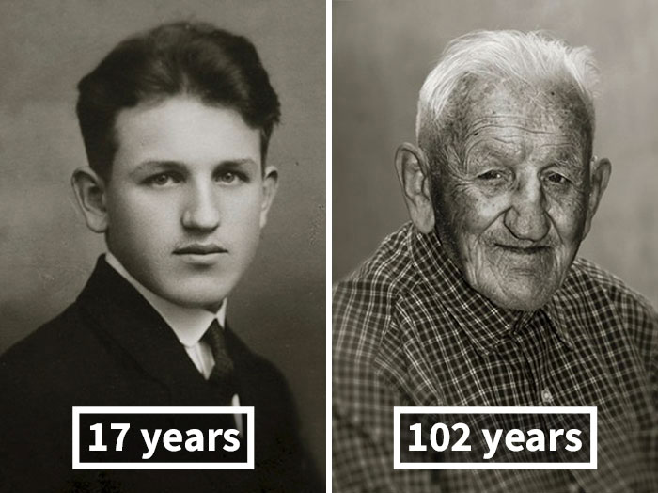
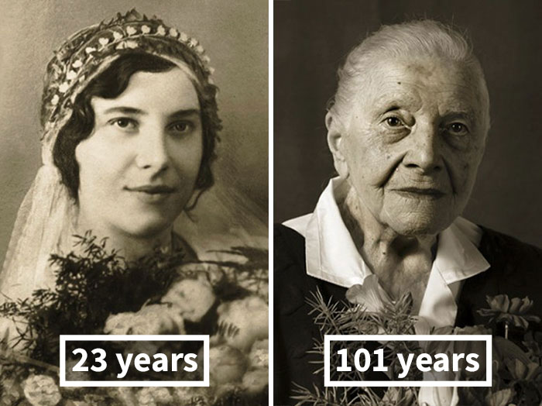

Physical changes | Other changes

Activity 9
Analyse data for life expectancy- what do you notice?
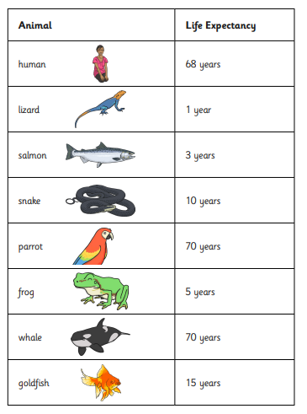

Findings?

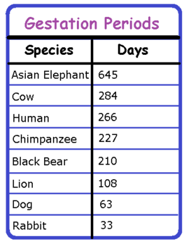
Activity 10

Activity 11
