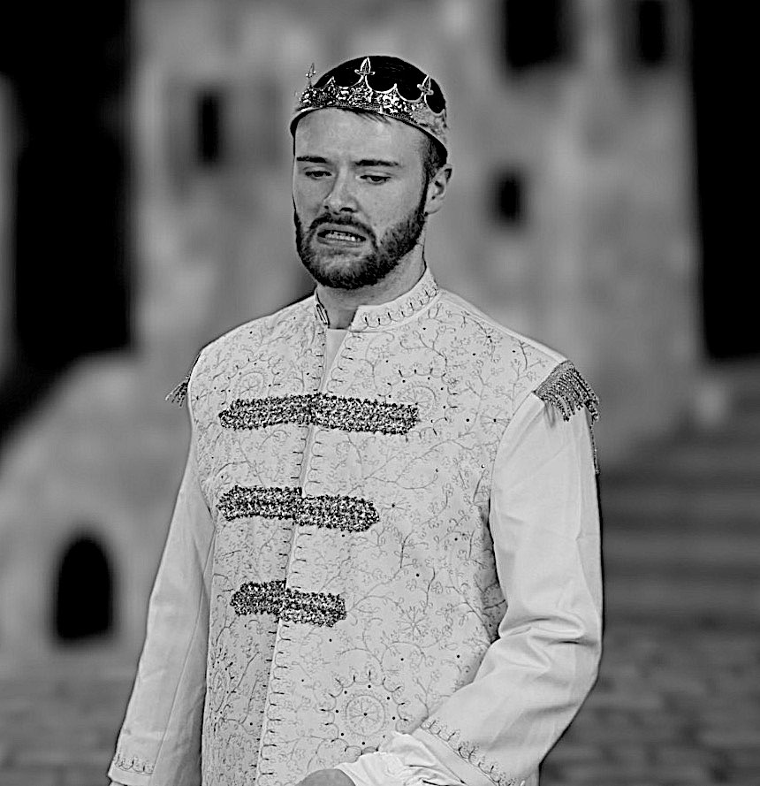
Week 1: Newspaper Report
Yesterday evening, a huge brawl broke out in Verona between members of the Capulet and Montague households. Prince Escalus had to personally intervene to stop the vicious fight.

It is believed that the dispute started following an altercation between servants from the opposing families. According to eye-witnesses, Sampson, a Capulet servant, was spotted biting his thumb at a passing group of Montagues. This provocative act caused an argument between the groups of men and swords were soon drawn.

PRINCE’S PAIN PERSISTS!
Prince Escalus is reported to be furious with the men who started the fight.
Sources suggest that Benvolio, Lord Montague’s nephew, made attempts to break up the fight by asking the men to put their swords away. However, Tybalt, Lord Capulet’s nephew, soon arrived and threatened to kill Benvolio, which did nothing to resolve the tense situation. Not long after, at about 6pm, Lord Montague and Lord Capulet arrived with their wives and started to threaten each other. Both were seen to be holding their swords. It was not until the arrival of Prince Escalus that the fighting stopped.
Grace Fortuna, a maid, was passing by when the Prince arrived on the scene. “He was very angry with both sides. I’ve never seen him lose his temper like that! He said that anyone who caused another disturbance to the streets of Verona would pay for it with their lives.”
It is well known that these two conflicting families are often to blame for the violence on our streets. Prince Escalus has tried for many years to resolve the situation to ensure that Verona is a safe place to live. However, as yesterday’s events show, there is still much work to be done.

Context: Act 1

Having heard of the ‘ancient grudge’ between ‘two households, both alike in dignity’ in the play’s prologue, Act 1 introduces us to the main characters, and shows how the 'new mutiny’ plays out in the streets of Verona.

Act 1 opens with a confrontation between servants from the opposing Capulet and Montague households.

Gregory: I will frown as I pass by, and let them take it as they list.

Sampson: Nay, as they dare. I will bite my thumb at them, which is a disgrace to them, if they bear it. (bites his thumb).

This is a very insulting gesture and the conversation between the groups of men soon escalates into a fight. Benvolio (Romeo’s cousin) tries to stop the brawl but Tybalt (Juliet’s cousin) is determined to attack. Eventually, Prince Escalus manages to stop the fight by threatening to punish both families for disturbing the peace of Verona:

If ever you disturb our streets again,
Your lives shall pay the forfeit of the peace.

Lord and Lady Montague then find out from Benvolio that their son, Romeo, is sad because he is in love with Rosaline, but she does not love him back.

We are then introduced to a new character, Paris, who wishes to marry Juliet. Her father, Lord Capulet, thinks she is too young, but he still suggests that Paris tries to woo her at the Capulet ball, which is taking place that evening.

Romeo and Benvolio then come across a messenger who has invitations for other guests of the ball. Upon discovering that Rosaline is invited, Romeo wants to go to the ball. Benvolio suggests that he should instead find someone new to love.

That evening, Romeo and Benvolio arrive at the ball, wearing masks to disguise themselves (as being Montagues, they would not be welcome at a Capulet party). Romeo soon sees Juliet and falls in love with her. Tybalt hears Romeo’s voice and recognises him to be a Montague. He wishes to confront Romeo but is told not to by Lord Capulet because Romeo is well regarded and Lord Capulet does not wish the party to be ruined.

Romeo searches for Juliet and they soon kiss. However, it is not long until they both find out that they are from opposing families:

Juliet: My only love sprung from my only hate!

Over the course of the week, the children will be writing a newspaper report on the Capulet’s ball from the society pages of a newspaper (the section of the newspaper which reports on local, national and international social events).

Lesson 1

LI: To know the features of a newspaper report.
National Curriculum Links

Reading
Pupils should be taught to:
- apply their growing knowledge of root words, prefixes and suffixes both to read aloud and to understand the meaning of new words that they meet

Writing
Pupils should be taught to plan their writing:
- noting and developing initial ideas, drawing on reading and research where necessary

Starter:
Show children pictures of a selection of different newspapers and ask them to discuss with a partner anything they would expect to see in a newspaper (e.g. an eye-catching headline, paragraphs, direct speech). Children share their ideas as the teacher makes a list on a flipchart (children should be able to refer to this list later in the lesson.) This will help the children link what they already know about newspapers with their new learning, and this will support those children who are less sure of the features of newspaper reports.

Main Teaching:
(This part of the lesson should be done where there is space for the children to work in groups on the floor).

N.B. Prior to this lesson, you will need to stick an A3 sized newspaper report (using the models provided) onto large pieces of flipchart paper.

Put the children into mixed ability groups of 5. Each group should be given one of the newspaper reports and some post-it notes.

Each group should then read through their newspaper report. They should then pick out any features that they think all newspaper reports would have (e.g. headline, orientation sentence, paragraphs). They should write each feature on a different post-it note and stick their post-it notes on the flip-chart paper around the example. Encourage groups who are struggling to use the list created at the start of the lesson.

Once the groups have been given enough time to find as many features as they can, ask the class to share their findings. Do they now want to add any more features to the list made at the beginning of the lesson? After this class discussion, each group should swap pieces of paper with a group who have a different newspaper report. They should repeat the activity with their new example and do the following:

- Add in any features they think the other group has missed
- Put ONE tick next to any features they agree with
- If they do not agree with a feature, they should leave it blank but not remove it

Now the children have looked at two different models in detail with their group, they will be working individually. They should now walk sensibly around the room and look at the post-it notes that have been written around the newspaper reports. If they agree with a feature, they should put ONE tick next to it. If they see a feature they do not agree with, they should leave it blank.

At the end of this activity, collect all the post-it notes that have been ticked lots of times and stick them onto a board at the front of the classroom.

Write STUCTURE on one side of the board and LANGUAGE on the other side of the board. Ask the children to help you sort the post-it notes onto the correct side of the board.

Review the features the class have come up with and ask them if they think any are missing. Draw out the missing features with reference to the examples the children have read.

Use the discussions from the lesson, draw out the success criteria for a newspaper report, divided into language and structural features. Display on your working wall display for the children to refer to for the rest of the week.

Below is a list of key features of newspaper reports to support your teaching of this text type:

Structural features
Headline Picture/photograph with caption Orientation paragraph (who, what, where, when) Further paragraphs giving more detail

Language features
Passive language. A catchy headline (alliteration, word play, short and snappy)
Direct speech Time fronted adverbials (Not long after... Later on... At about 11pm...)
Mainly past tense (apart from the headline which is present tense)

Punctuation
Parenthesis to add extra detail

Lesson 2 (drama activity)

LI: To know the key events of the Capulet ball.
National Curriculum Links

Reading
Pupils should be maintain positive attitudes to reading and an understanding of what they read by:
- continuing to read and discuss an increasingly wide range of fiction, poetry, plays, non-fiction and reference books or textbooks
- preparing poems and plays to read aloud and to perform, showing understanding through intonation, tone and volume so that the meaning is clear to an audience

Spoken Language
- Use spoken language to develop understanding through speculating, hypothesising, imagining and exploring ideas.
- Participate in discussions, presentations, performances, roleplay/improvisations and debates

Warm up:
Tell the children the names of the main characters who attend the ball. For each character, show the children an action and tell them a quotation from the play that gives more information about the character (see writing in bold to put quotations in context). They should repeat each action and quotation back to you until they have memorised each one. Once they have learnt them, they need to do the action and say the quotation each time you say the name of the character. You could also switch this around – you do the action and say the quotation, and they have to say the name of the character.

Encourage them to use expression in their voices and large actions. (N.B. you will need to think of a simple action for each character). Praise children who are doing this well and ask them to demonstrate to the class.

Lord Capulet: Come, musicians, play!
He is throwing a party and he wants it to be fantastic.

Lady Capulet: The lady of the house
She is the lady of the house (Lord Capulet’s wife).

Romeo: I ne'er saw true beauty till this night!
Romeo forgets Rosaline when he sees Juliet.

Juliet: My only love sprung from my only hate!
Juliet is devastated when she realised Romeo is a Montague.

Tybalt (Juliet’s cousin): Fetch me my rapier!
Tybalt asks for his sword when he realised Romeo is at the party.

Benvolio (Romeo’s cousin): Away, be gone.
Like usual, Benvolio is trying to keep the peace and suggests him and Romeo leave the party.

Captain Paris: What say you to my suit?
Paris wants to marry Juliet.

Main Drama Activity:
Part 1: Scripted Scene

(This part of the lesson should be done in the school hall so the children have enough space to act out the scene).

Assign everyone in the class with one of the following roles:

Lord Capulet (1 child)
Lady Capulet (1 child)
Romeo (1 child)
Juliet (1 child)
Tybalt - Juliet’s cousin (1 child)
Tybalt’s page (1 child)
Benvolio - Romeo’s cousin (1 child)
Captain Paris (1 child)
Servants - serving drinks and food (8 children)
Musicians (6 children)
Party guests (8 children)

With the children, set up a freeze frame for the beginning of party. Ask them where they think their character would be standing and what they would be doing. Use the following questions to aid discussion:

- Who should be in the middle of the stage? Why?
- How is your character feeling?
- How can you show you are a guest with your body language?
- How can you show you are a servant?
- What would the musicians be doing?

Once everyone is in position, the child playing Lord Capulet should say:
“Let the feasting begin!” The class should then mime (no talking) what they think their character would be doing at the party.

You should then start to feed lines from the play and the child playing that part should repeat back the line, using expression and body language to show how their character us feeling:

1) When Romeo sees Juliet for the first time.

Romeo (to a servant): What lady is that which doth enrich the hand
Of yonder knight?

Servant: I know not sir.

Romeo: She doth teach the torches to burn bright!

2) When Tybalt hears Romeo’s voice.

Tybalt: This, by his voice, should be a Montague.
(to his PAGE) Fetch me my rapier, boy.

Lord Capulet: Why, how now, kinsman? Wherefore storm you so?

Tybalt: Uncle, this is a Montague, our foe!

Lord Capulet: Content thee, gentle coz. Let him alone.

Part 2: Hot-seating

Now that the children have acted out and understand what happened at the party, explain that the children will be acting as journalists doing some research for a newspaper report they are writing about the Capulet ball.

Pick someone to act as a guest from the party. This person should sit on a chair at the front of the class, while the rest of the class (the journalists) sit on the floor facing them. The journalists will be asking the guest questions about the party and will need to write down the responses they hear.

The teacher should first model asking questions to the guest (e.g. What interesting things happened at the party? Who was the best dressed? Were there any unexpected guests?) and then the ‘journalists’ should start to think of their own questions.

After a few questions, pick a different child to act as the guest.

Make sure that children are recording the responses of the guest in their books as these will be used as quotations in their newspaper report later in the week. Ask the child acting as the guest to pause after speaking so the children have time to record what is being said.

Lesson 3

LI: To write an effective headline and orientation paragraph.
National Curriculum Links

Writing
Pupils should be taught to draft and write by:
- selecting appropriate grammar and vocabulary, understanding how such choices can change and enhance meaning
- using further organisational and presentational devices to structure text and to guide the reader

Starter:
In partners, children should think of as many words as they can based on the following pictures:
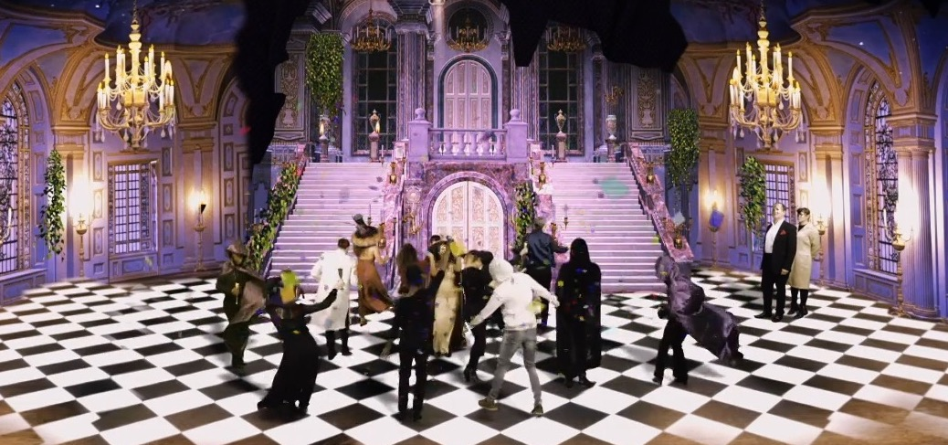

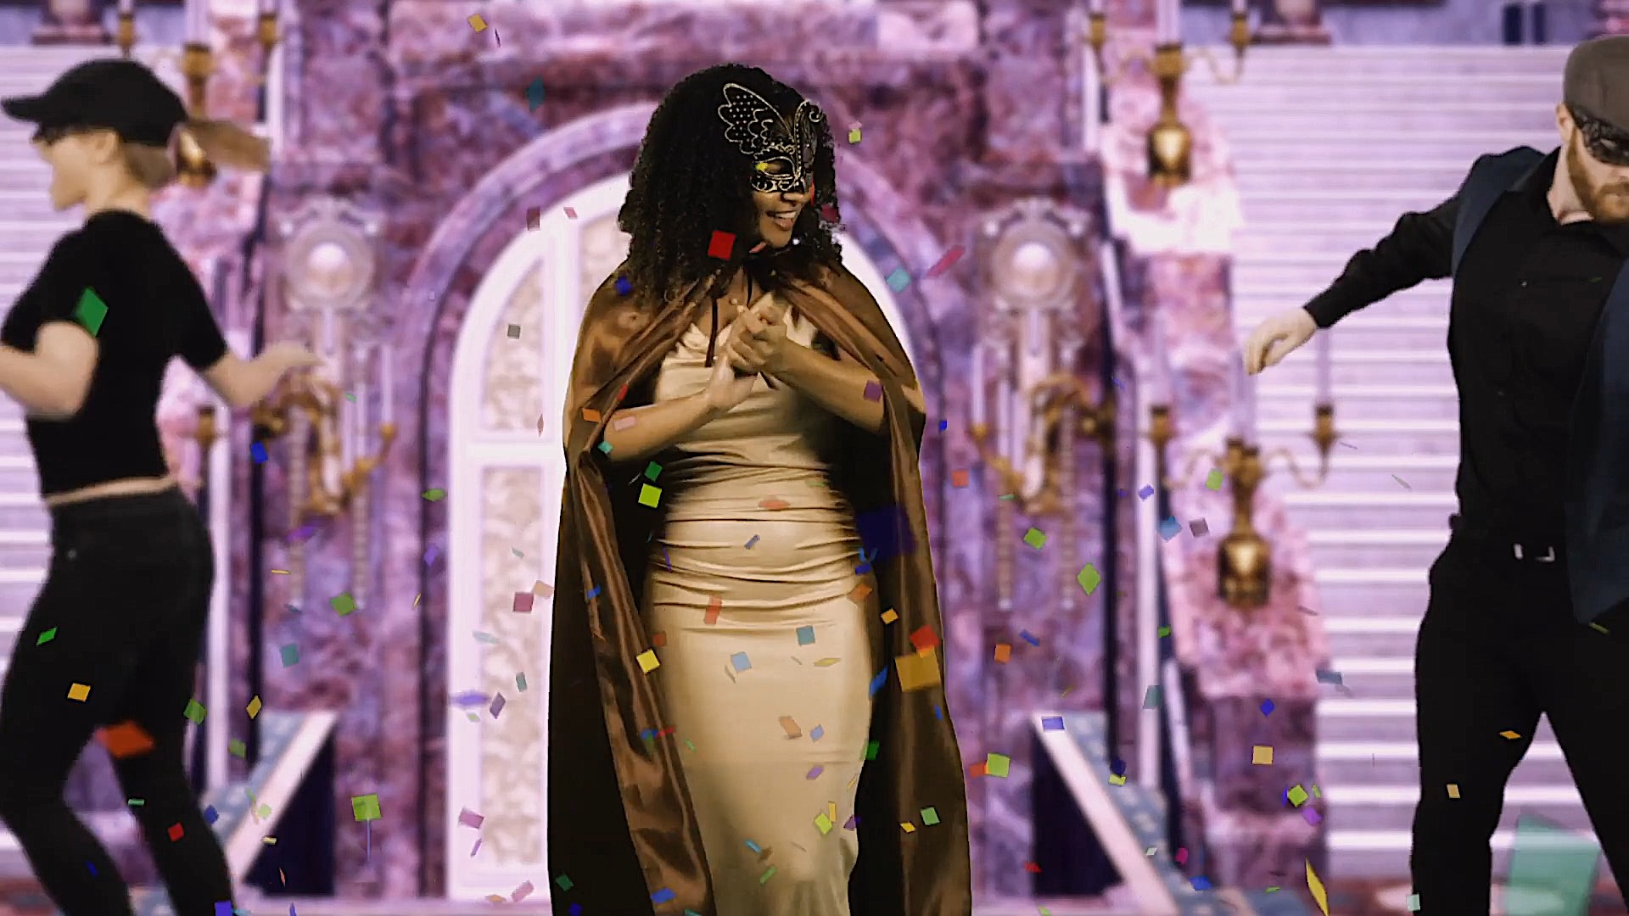

Ask children to share the words they have come up with and record on the whiteboard. Model using a thesaurus to find synonyms to some words (such as party). Children work with a partner to find synonyms for some of the words on the list. Share with each other and add new words to whiteboard.

These words will be used as a word bank to help the children with writing their headline.

Main Teaching:

Part 1: Headline

Show children examples of headlines from newspapers and ask them discuss what makes a good headline:

- Short and snappy
- Eye-catching
- Alliteration
- Rhyme
- Present tense
- Puns

Use the following link for examples of headlines to share with the children:

https://schools.firstnews.co.uk/blog/journalistic-writing/newspaper-headlines-ks2/

Model using the word bank to think of catchy headline about the Capulet ball. Children work in mixed ability pairs to think of their own headline and record in their books.

Part 2: Orientation Paragraph

Then ask the children what the first paragraph of a newspaper is called (the orientation paragraph). Explain that it is a simple paragraph with only one or two sentences which briefly tells the read what happened, when it happened, where it happened and who was involved. Tell the children that it is an important paragraph because it tells the reader what the rest of the article is about and helps them decide if they want to read on or not.

Children should then work with a partner to have an opportunity to practise writing a clear and simple orientation paragraph using the following keys facts:

When: Monday evening
Who: Tybalt and Lucian (a servant from the house of Montague)
What: fighting
Where: in the market square

Children share their orientation paragraphs with the class. Highlight good examples/address any misconceptions.

Having practised writing a paragraph in pairs, the children should now write their own orientation paragraph for their newspaper report on the Capulet ball, using the following success criteria to support them:

- Past tense
- Only one or two sentences
- State the key facts (4 Ws)
- Some details to arouse the reader’s interest

E.g. Yesterday evening, Lord and Lady Capulet welcomed over two hundred guests to their home for a magnificent masked ball.

Ask children to share their orientation paragraphs. Other children to say whether it is a successful orientation paragraph with reference to the success criteria.

Lesson 4

LI: To use appropriate sentence starters when writing a newspaper article.
National Curriculum Links

Writing
Pupils should be taught to draft and write by:
- selecting appropriate grammar and vocabulary, understanding how such choices can change and enhance meaning
- using further organisational and presentational devices to structure text and to guide the reader
SPAG
- Use passive verbs to affect the presentation of information in a sentence
- Use commas to clarify meaning or avoid ambiguity in writing

Starter:
Display the example of the newspaper report from lesson 1 (Prince’s Pain Persists) and ask the children to work in pairs to pick out sentence starters that they could ‘magpie’ to use in their own newspaper article (e.g. It has been reported that... Sources suggest...)

Children share the sentence starters they have identified and teacher records them on the whiteboard.

Main Teaching:

Part 1: The Passive Voice

Remind children on the work they have done in SPAG lessons on the passive voice (i.e. when the subject of the sentence has the action ‘done’ to it). You might like to play this short clip as a reminder:

https://www.bbc.co.uk/bitesize/topics/z4hrt39/articles/zkttng8

Discuss how newspaper articles often use the passive voice to make the writing sound more formal and inpersonal.

Show children a selection of sentence starters and ask them to sort them into those that use the active voice and those that use the passive voice:
It has been reported that...
Many people think...
Sources suggest...
I believe that...
It has been confirmed that...
It is thought that...
I think that...
Ask children to say which sentence starters they think are passive and which ones they think are active, explaining their reasons. Then ask them which ones they could use in their report and give their reasons.

Promote discussion using the following questions:
- Is ‘I think that...’ formal enough?
- What could be used instead?
- Does the passive voice have to be used in every sentence?

Part 2: Time Fronted Adverbials

Now ask the children to think back to the drama activity when they acted out the ball in lesson 2. What were the main events of that evening?

- Lots of important people attended the party hosted by the Capulets e.g. Paris
- Juliet was admired by many young men
- Unknown masked guests arrived
- Tybalt seen arguing with Lord Capulet
- Juliet kissed unknown man

Remind children that, in the next paragraphs, they need to report what happened at the ball, using time fronted adverbials to help them structure their paragraph. Show the children the following list and ask them to suggest others:

- Later on...
- At approximately 6pm...
- Not long after...

Make sure that both the formal sentence starters (including the passive ones) from the beginning of the lesson and the time fronted adverbials are displayed somewhere in the classroom to help the children write the next section of the newspaper.

Now model/share writing the first few sentences of the next paragraph, giving more detail about the events of the night. Ask children to help you once you have modelled the first sentence.

For example:

Many important members of Verona’s ruling class were among the lucky individuals invited to attend the lavish ball. Sources suggest that Paris, one of Prince Escalus’ kinsmen, attended the party, hoping to seek the favour of Lord Capulet’s daughter, Juliet.

The celebrations seemed to be running smoothly until about 6pm. Not long before the banquet started, two masked guests were seen to arrive through a side entrance.

Ask the children what they need to include in their writing to make it successful (past tense, passive and formal language, time fronted adverbials, further details about the party, carefully chosen adjectives to interest the reader) and then ask the children to write the next few paragraphs of their own report.

Editing: At the end of the lesson, the children should read their paragraph to a partner to help them edit their work. They should look out for missing words and punctuation as well as making sure their writing makes sense.

Lesson 5

LI: To use speech marks correctly to report direct speech.
National Curriculum Links

Writing
Pupils should be taught to draft and write by:
- selecting appropriate grammar and vocabulary, understanding how such choices can change and enhance meaning
- using further organisational and presentational devices to structure text and to guide the reader
SPAG
- Use relative clauses beginning with who, which, where, when, whose, that or with an implied (ie omitted) relative pronoun

Starter:
Show children the following sentences and ask them to put in the missing commas. Make sure the children know that commas are used to add extra detail to a sentence (parenthesis):

Juliet Lord Capulet’s daughter wore a silky white dress.

Paris who is one of Prince Escalus’ kinsmen also attended the ball.

Romeo the son of Lord Montague was seen leaving the ball with his cousin Benvolio.

Main Teaching:
Ask children to look back at the notes they made at the end of the drama lesson earlier in the week. Explain that they should pick two quotations that they are going to include in their next paragraph (one positive one and one quotation which suggests that not everything was as it should have been at the party):

Ask a few children to record their two quotations on their individual whiteboard and then ask some children to share the examples they have chosen.

e.g. It was one of the best nights of my life! The Capulets definitely know how to throw a party!

I saw Tybalt looking very angry at one point. He seems to be annoyed at a mysterious masked man. I even saw him arguing with Lord Capulet!

Then ask the children to think of an appropriate name for each of their guests and their relationship to the hosts. They should also record this on their whiteboard.

e.g. Marcus John – Lord Capulet’s best friend

Maria Harris – Lady Capulet’s cousin

The children are now ready to write their paragraph with eye-witness accounts, using the information on their whiteboards to help them.

Model using commas to give extra detail about each guest (parenthesis) and using speech marks around what was said by each guest.

For example:

Marcus John, a close friend of Lord Capulet, said that he had an amazing time at the ball. “It was one of the best nights of my life! The Capulets definitely know how to throw a party!” However, although many guests seemed to enjoy themselves, some sources suggest that not everyone was having such a good time. Maria Harris, Lady Capulet’s cousin, explained that Tybalt did not seem to be enjoying the party. “I saw Tybalt looking very angry at one point. He seems to be annoyed at a mysterious masked man. I even saw him arguing with Lord Capulet!”

Having modelled a few sentences of this paragraph, draw out the success criteria (commas for parenthesis, speech marks, conjunction to suggest not all was perfect at the party e.g. however, although, despite) and then ask children to write their own eyewitness paragraph.

Once the children have written and checked this paragraph, ask some to share their newspaper articles so far.

Finally, ask the class how they think the article needs to end. For example, they could ask readers if anyone has any information about the masked men who seemed to annoy Tybalt:

E.g. Did you attend the Capulet’s ball? Do you know who the mysterious masked men were? If so, please get in contact with The Verona Times by writing to us.

Children use modelled example to finish their own newspaper.

Publishing

Once they have edited and checked their whole article, they should publish their reports in an afternoon session, adding appropriate pictures and captions.
