Act 3, Scene 1 starts with Benvolio and Mercutio debating who is more hot-tempered. Then Mecutio is killed by Tybalt. The cast of a Romeo and Juliet play are acting out this scene. They need to work out how the fight props look on stage. They want to give their audience a brochure detailing what happens in each scene and want to use a shield and a sword as images on the page about Act 3, Scene 1. Help their graphic designer to see which orientation the images look best in by reflecting and translating them…
Translate the shield into quadrant 1 and reflect it into quadrant 4
Translate the sword into quadrant 3 and reflect it into quadrant 4

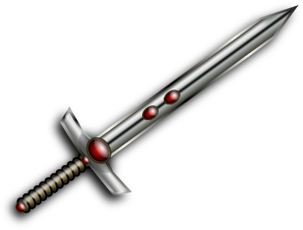
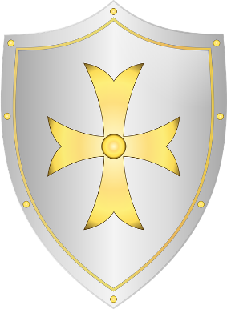
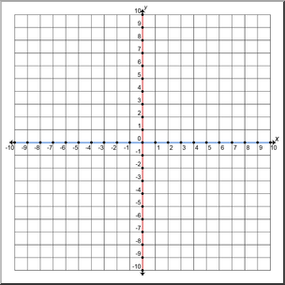
Quadrant 4
Quadrant 3
Quadrant 2
Quadrant 1
Quadrant 4
Quadrant 3
Quadrant 1
Quadrant 2

