Capulet’s Extension
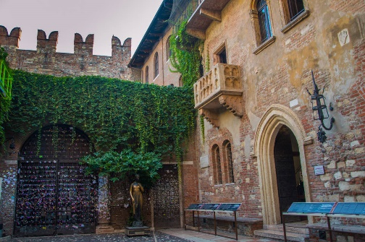
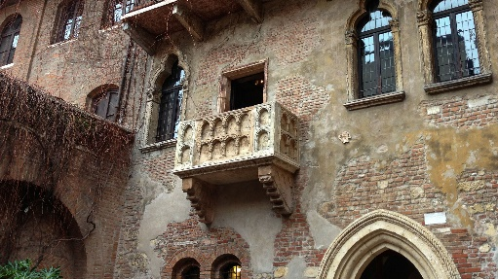
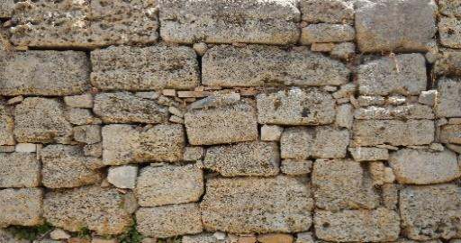
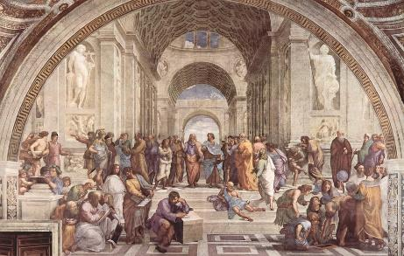
Capulet has decided that he wants a larger place to host more parties so he decides to build an extension. Help the builders distribute the stones to the palace where each new room will be.
72 stones into 9 rooms
120 stones into 10 rooms
27 stones into 3 rooms
40 stones into 5 rooms
49 stones into 7 rooms
66 stones into 6 rooms
60 stones into 5 rooms
132 stones into 12 rooms
81 stones into 9 rooms
48 stones into 8 rooms
36 stones into 9 rooms
32 stones into 8 rooms
25 stones into 5 rooms
21 stones into 3 rooms

